
BOOK ALERT
(New Arrivals-Books)

( AUGUST 2025)



.

Library
Indian Institute of Public Administration
New Delhi

Book Alert is a monthly service offered by

the Library, Indian Institute of Public

Administration. It contains bibliographical

details of latest books added to the library

during the period.

COMPILED BY

SUNITA GAUTAM



Indian Institute of Public Administration,
I.P. Estate, Ring Road, New Delhi-110002

1.

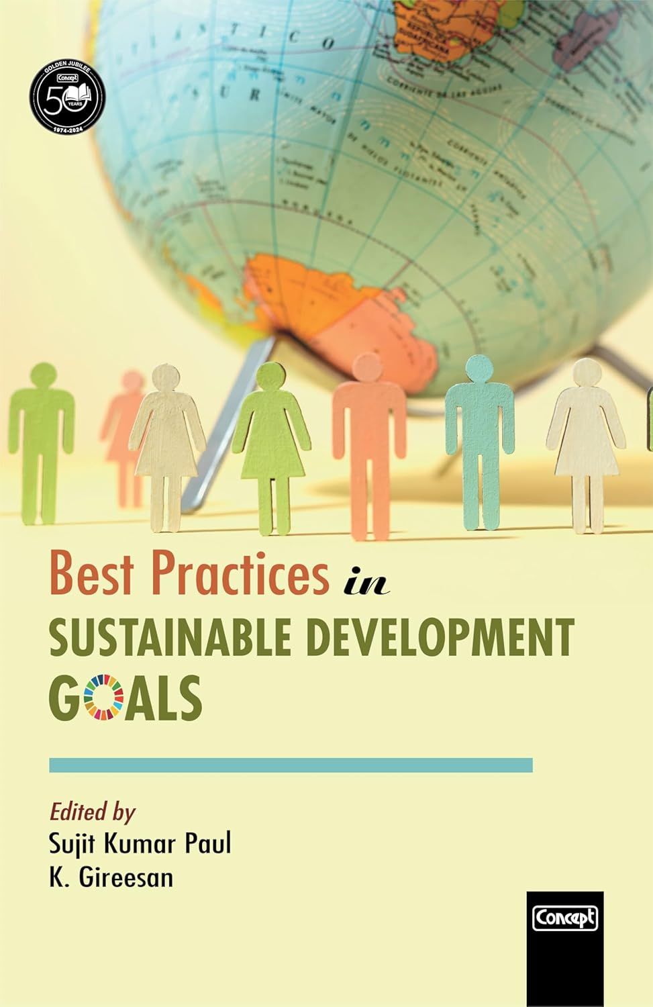

Best practices in sustainable development goals

Author: Sujit Kumar Paul and K. Gireeson
Publisher: New Delhi: Concept, 2025
Description: 362p.
Accession No. Gr 25655

Best Practices in Sustainable Development Goals is a book that showcases the models, approaches, and experiences from different parts of the world.

This edited book captures some of the best practices in SDGs from the global, the regional, the national and the local, with inputs from number of institutions, organizations and individuals who are working with and “working for sustainable development”

.

2.
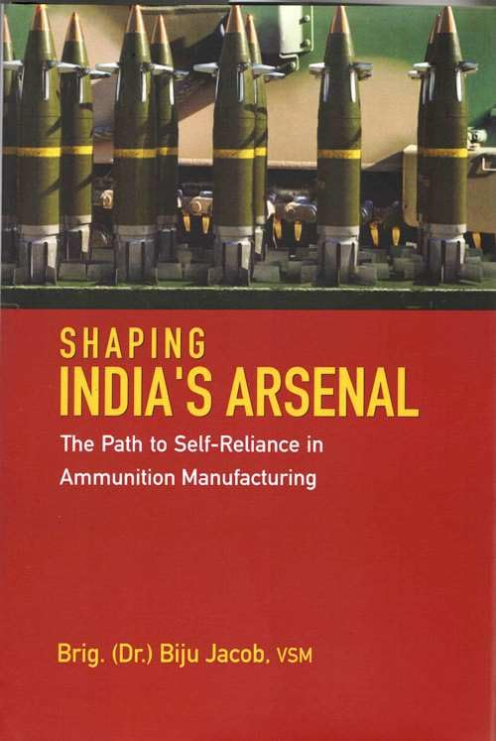

Shaping India’s Arsenal: the path to self- reliance in ammunition manufacturing

Author: Biju Jacob Granville Austin
Publisher: New Delhi: Pentagon Press, 2025
Description: 252p.
Accession No. GR25626-25627

In an era marked by geopolitical uncertainty, this insightful book addresses one of the nation’s most pressing challenges—reducing dependence on foreign defence imports.

It delves into the critical landscape of ammunition technology, exploring the historical, strategic, and policy hurdles that have shaped India`s defence posture and emphasizing the urgent need for self-reliance to bolster national security and strategic autonomy.

3.

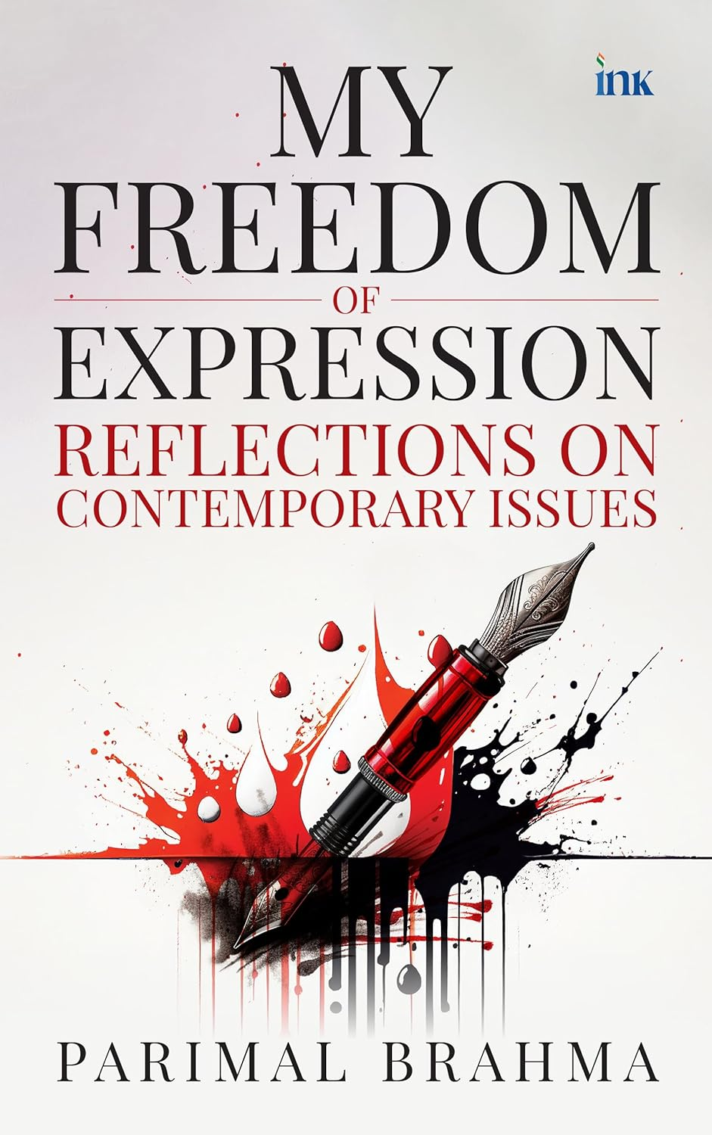

My freedom of expression

Author: Parimal Brahma
Publisher: Noida: Blueone Ink, 2024
Description: 254 p.
Accession No. Gr25625

The author picked some of contemporary’s most contentious topics, such as global warming, scientific marvels, the mysteries of life and the universe, cultural and religious superstitions, illusions and prejudices in the practise of science, and the importance of religion in society, and dissected them one by one with a rationalist knife.

So what his writings essentially do is show a mirror to society. By being both accessible and arresting at once, the book deserves a place in everyone’s library

4.

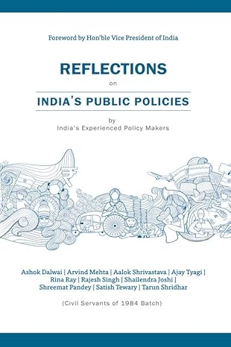

Reflections on India’s public policies

Author: Ashok Dalwai
Publisher: Noida: Bluerose One, 2023
Description: 337p.
Accession No. GR25623

5.

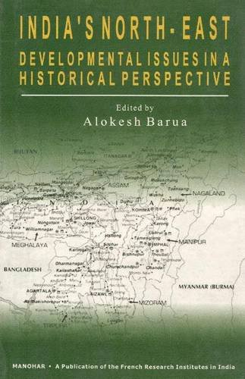

India`s North-East: Developmental Issues in a Historical Perspective

Author: Alokesh Barua
Publisher: New Delhi: Manohar, 2005
Description 474 p.
Accession No. Gr25570

6.

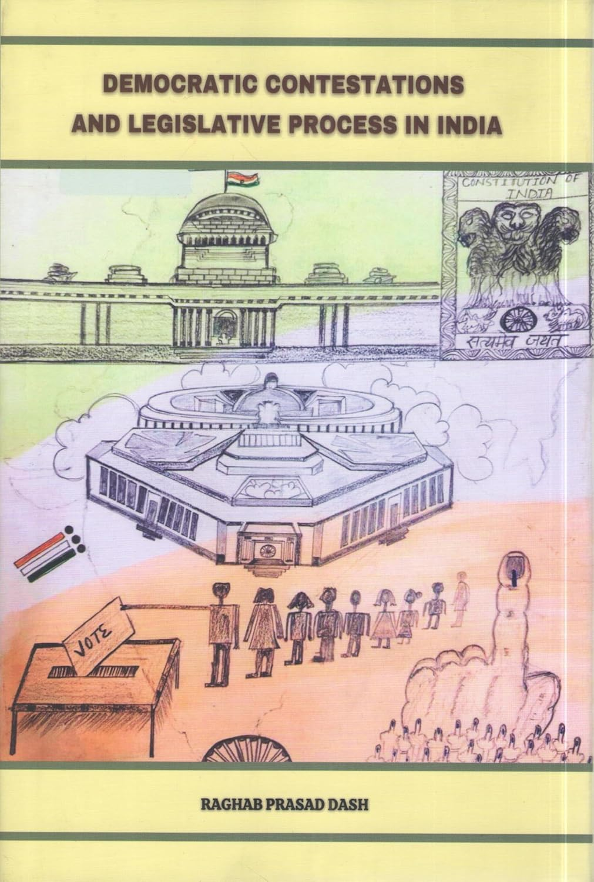

Democratic contestations and legislative process in India

Author: Raghab Prasad Dash
Publisher: New Delhi: Book Age, 2025
Description: 266p.
Accession No. 89400

In 'Democratic Contestations and Legislative Process in India', Raghab Dash dwells on the contested domain of the executive-legislature relations in the context of law making in India and focuses on four facets of contestations, viz. ligislation agenda control and management, Private Mambers' Legislation, Delegated Legislation and Executive through promulgation of ordinance.

7.

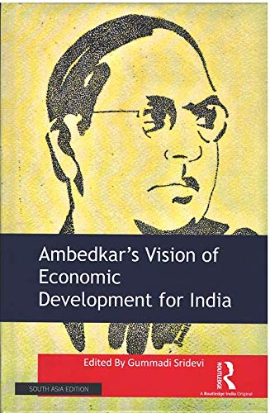

Ambedjar’s vision of economic development for India

Author: Gummadi Sridevi
Publisher: New York: Routledge, 2020
Description: 235p.
Accession No. 89401

This book discusses Ambedkar’s engagements with the issues of social justice, economic development and caste enclosure. It highlights his significant contributions in the field of trade, public Finance and monetary economics, Indian Agriculture, education, among others, and examines their relevance in contemporary India.

8.

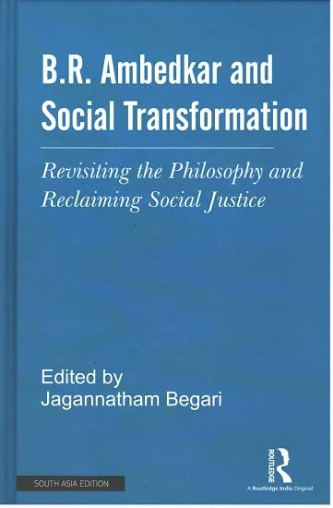

B.R. Ambedkar and social transformation

Author: Jagannatham Begari
Publisher: New York: Routledge, 2022
Description: 251p.
Accession No. 89402

This book revisits the philosophy of B.R Ambedkar in the context of the present socio-economic-political realities of India. It examines the philosophical and theoretical interventions of Ambedkar, as well as his egalitarian principles of equality, liberty, fraternity and morality.

9.

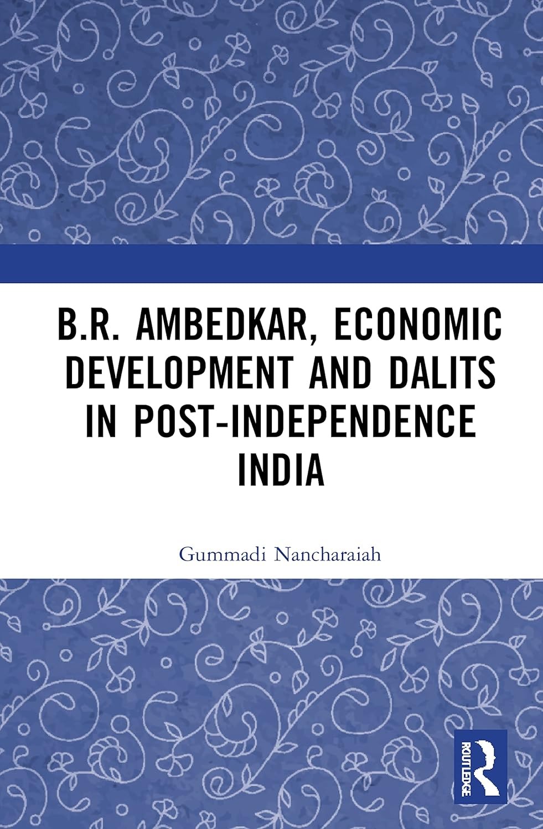

B.R. Ambedkar, economic development and dalits in post- independence in India

Author: Pramath Raj Sinha
Publisher: New York: Routledge, 2022
Description: 129p.
Accession No. 89403

This book examines Ambedkar the economist. It foregrounds his economic ideas within the context of post-independence India. The volume:
· Focuses on the economic writings of Ambedkar and looks at his views on caste and its economic implications, monetary and fiscal systems, as well as exchange rate and trade;
· Discusses issues like land reforms and agrarian change, poverty, higher education and human rights from a Dalit perspective;
· Examines the relevance of Ambedkar’s economic ideas for contemporary India.

10.

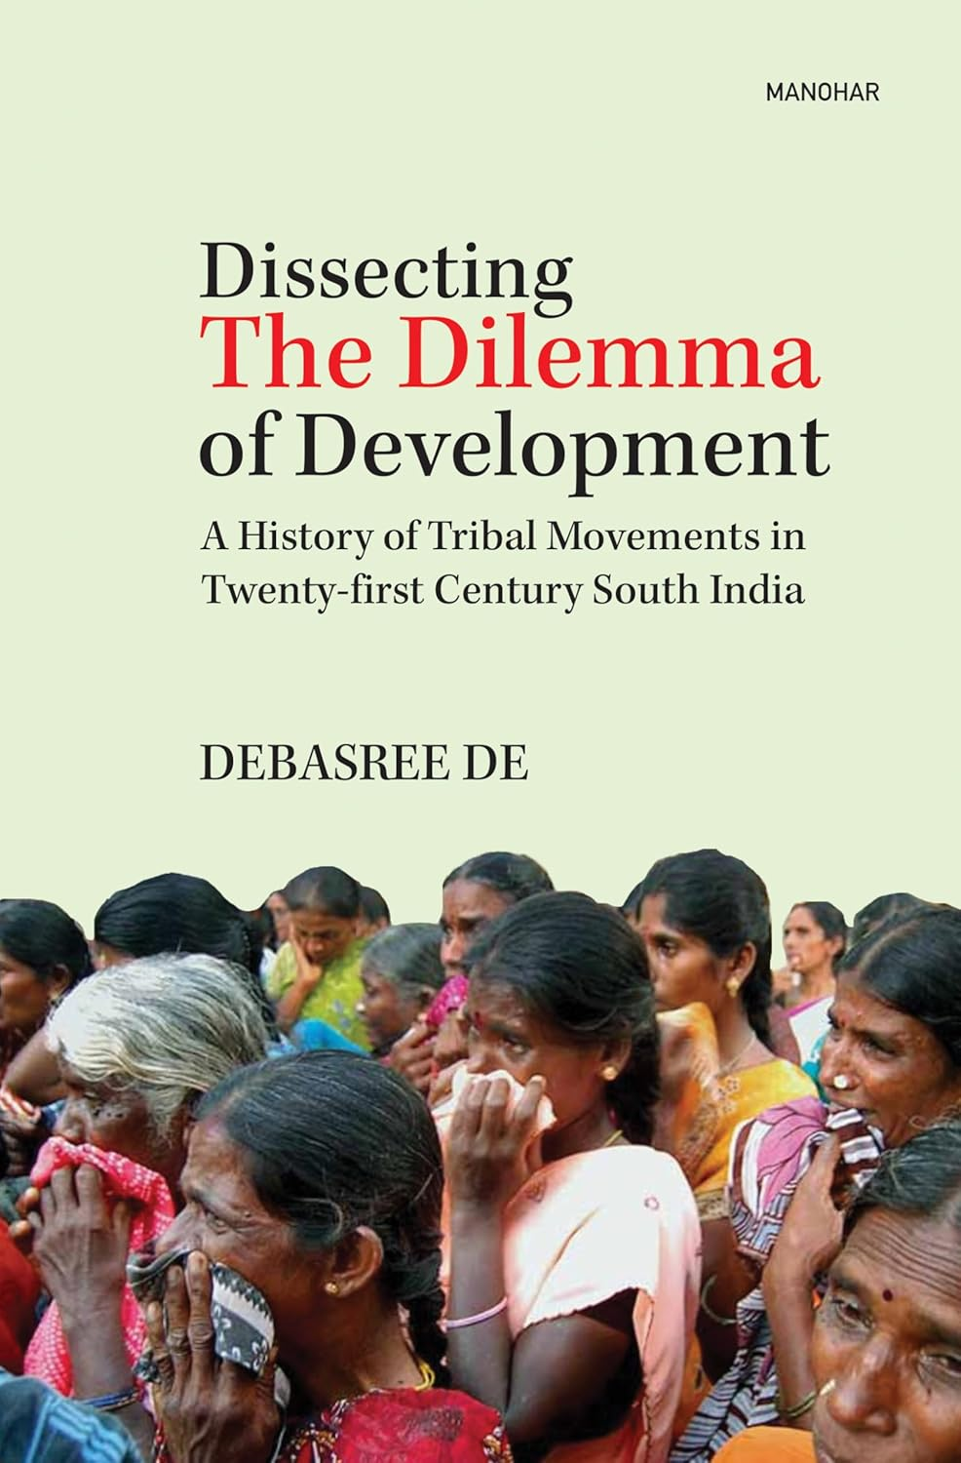

Dissecting the dilemma of development

Author: Debashree De
Publisher: New Delhi: Manohar, 2025
Description: 230p.
Accession No. 89404

The growing discontent among the tribes of south India and their incessant protests have been studied and documented in the present book. Andhra Pradesh, Karnataka, Kerala, and Tamil Nadu – these four states have been dealing with unabated tribal unrest since Independence.

The problems, injustices and deprivations caused by industrialization, mining, dam building and other so-called ‘development’ projects have been analyzed with myriad examples from different tribal communities according to their sufferings and demands.

11.
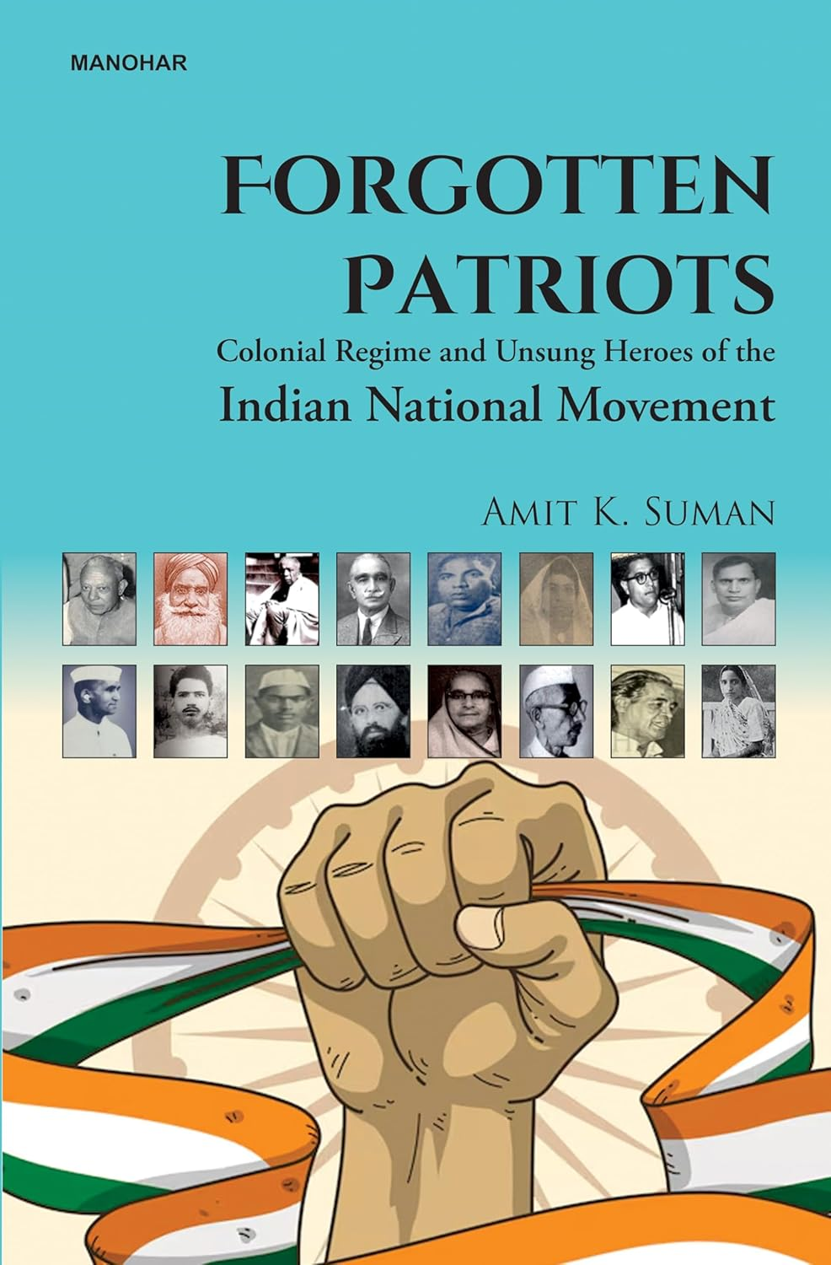

Forgotten patriots: colonial regime and unsung heroes of th Indian National Movement

Author: Amit K. Suman
Publisher: New Delhi: Manohar,2025
Description: 352p.
Accession No. 89405

Forgotten Patriots challenges the dominant historiographical narrative of India’s struggle for independence, which is often centred around iconic figures, such as Mahatma Gandhi, Jawaharlal Nehru, and Subhas Chandra Bose.

This work shifts focus to the unsung heroes – ordinary men and women from diverse socio-economic, regional, and cultural backgrounds – whose contributions were equally instrumental in dismantling the British colonial rule.

12.

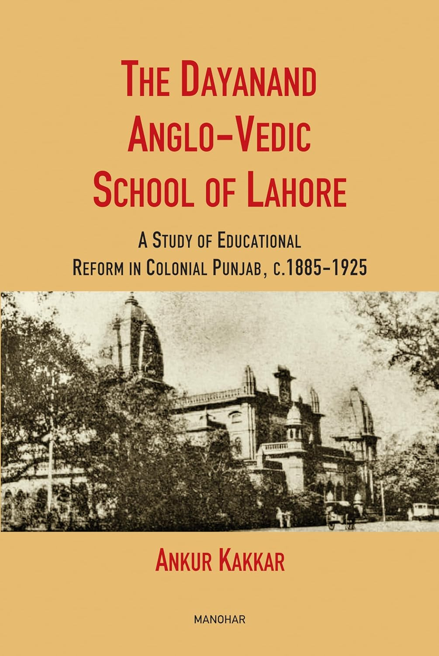

The Dayanand Anglo-vedic school of Lahore

Author: Ankur Kakkar
Publisher: New Delhi: Manohar, 2025
Description: 310p.
Accession No. 89406

This book attempts to resolve the predicament of categorizing the D.A.V. movement as ‘modern’ or ‘traditional’. It also examines the successes and failures of the D.A.V. movement, and throws light on how it shaped the socio-political landscape of India in the early twentieth century.

13.



National power and the structure of foreign trade

Author: Albert O’ Hirschman
Publisher: London: Univ. of California
Description: 172p.
Accession No. 89407

This study begins with a brief survey of economic thought on the relationship between foreign trade and national power, from the Mercantilists on.

Using well-known concepts of economic analysis, it proceeds to show under what conditions and by means of what policies this instrument is likely to attain its highest efficiency. The principles of power policy thus deduced theoretically are then compared with the actual practices followed by German trading methods in recent years.

14.

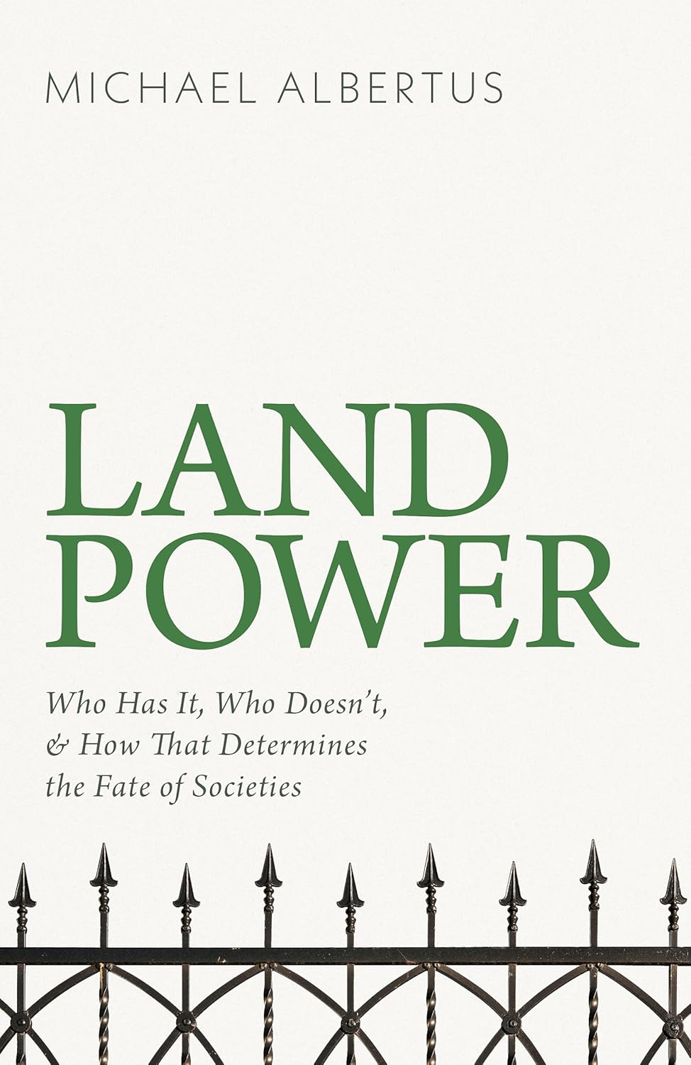

Land power: who has it, who doesn’t, and how that determines the fate of societies

Author: Michael Albertus
Publisher: London: Basic Books, 2025
Description: 321p.
Accession No. 89408

For millennia, land has been a symbol of wealth and privilege. But the true power of land ownership is even greater than we might think - in Land Power, political scientist Michael Albertus shows that who owns the land determines whether a society will be equal or unequal, whether it will develop or decline, and whether it will safeguard or sacrifice its environment.

15.

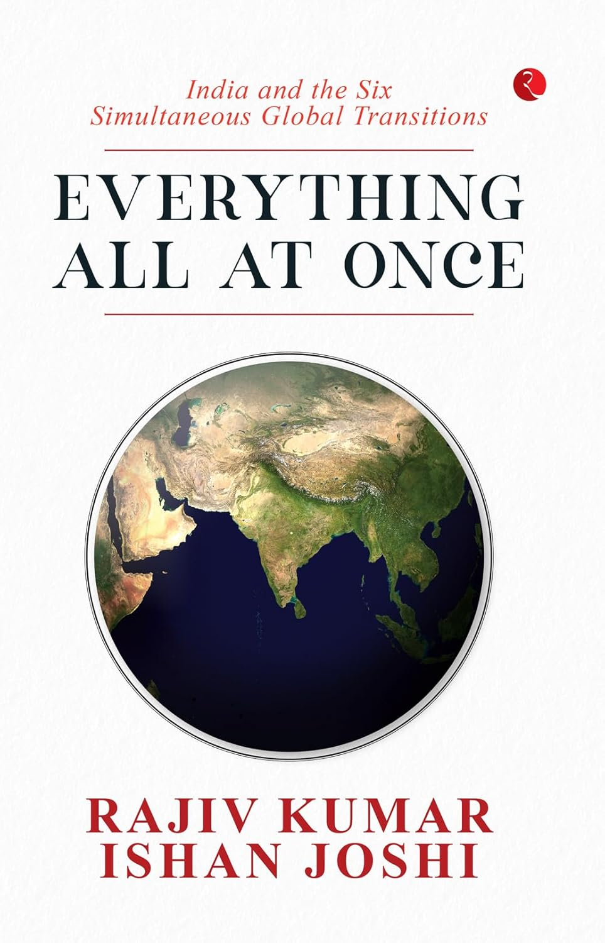

Everything all at once: India and the six simultaneous global transitions

Author: Rajiv Kumar and Ishan Joshi
Publisher: New Delhi: Rupa, 2025
Description: 239p.
Accession No. 89409

In Everything All At Once: India and the Six Simultaneous Global Transitions, Rajiv Kumar and Ishan Joshi suggest how India’s national goals could be defined and lay out the difficult but inescapable steps which will be required to achieve them. New Delhi has a historic opportunity to shape the ongoing transitions to its advantage. But the challenges are massive. Business-as-usual just won’t do if we want to see India as Viksit Bharat in the next 25 years.

16.



Klara and the Sun

Author: Kazuo Ishiguro

Publisher: London: Faber, 2021

Description: 340p.

Accession No. 89410

From her place in the store, Klara, an Artificial Friend with outstanding observational qualities, watches carefully the behaviour of those who come in to browse, and of those who pass in the street outside.
In Klara and The Sun, Kazuo Ishiguro looks at our rapidly changing world through the eyes of an unforgettable narrator to explore a fundamental question: what does it mean to love?

17.

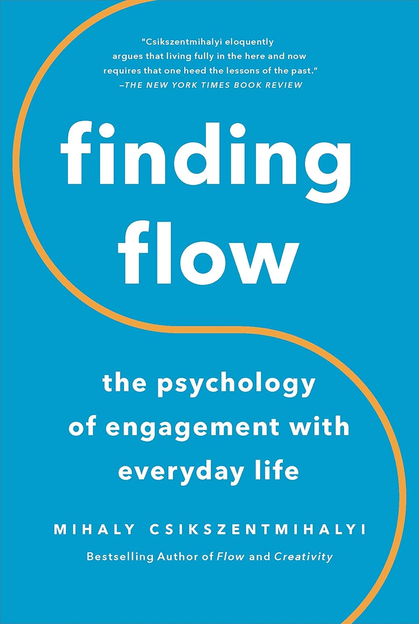

Finding flow: the psychology of engagement with everyday life
Author: Mihaly Csikszentmihalyi
Publisher: New York: Basic Books, 2021
Description: 181p.
Accession No. 89411

What are we missing? To answer this question, Csikszentmihalyi studied thousands of people, and he found the key. People are happiest when they challenge themselves with tasks that demand a high degree of skill and commitment, and which are undertaken for their own sake. Instead of scrolling on your phone, play the piano.

Take a routine chore and figure out how to do it better, faster, more efficiently. In short, learn the hidden power of complete engagement, a psychological state the author calls flow. Though they appear simple, the lessons in Finding Flow are life-changing.

18.

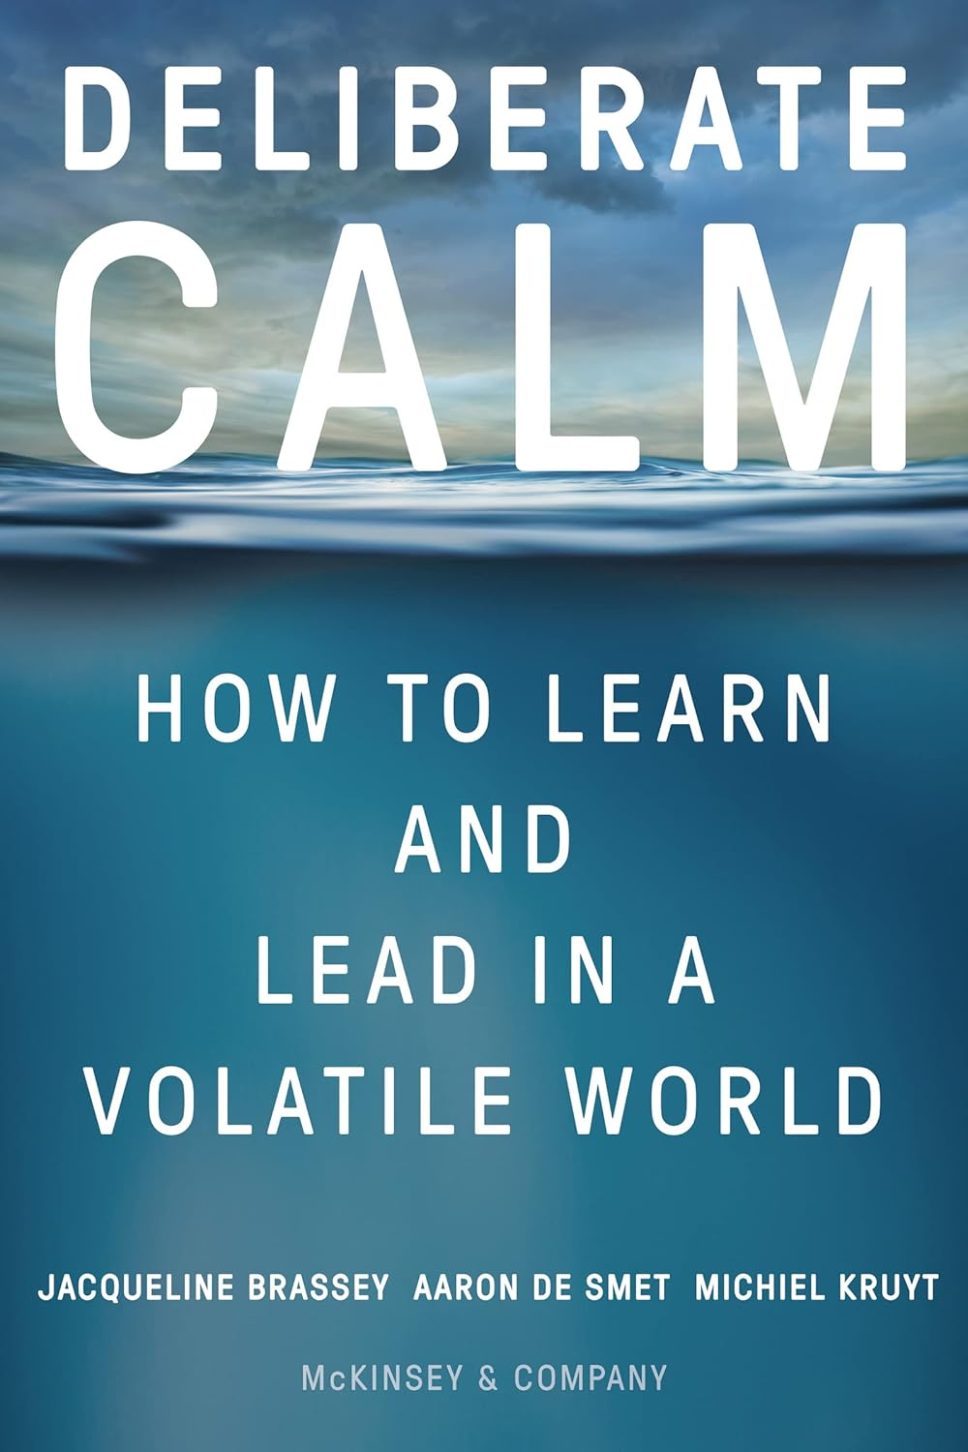

Deliberate calm: how to learn and lead in a volatile world

Author: Jacqueline Brassey
Publisher: New York: Harper Collins, 2022
Description: 318p.
Accession No. 89412

Enter Deliberate Calm, which combines cutting-edge neuroscience, psychology, and consciousness practices, along with the authors’ decades of experience with leaders around the globe.

By practicing Dual Awareness, which integrates internal and external experiences, leaders can become resilient and respond to challenges with intentional choice instead of being limited to old models of success. With Deliberate Calm, anyone can lead and learn with awareness and choice to realize their full potential, even in times of uncertainty, complexity, and change.

19.



The wisdom of Yoga: a seeker’s guide to extraordinary living

Author: Stephen Cope

Publisher: New York: Bantam Books, 2006

Description: 316p.

Accession No. 89413

For modern spiritual seekers and yoga students alike, here is an irreverent yet profound guide to the most sophisticated teachings of the yoga wisdom tradition–now brought to contemporary life by a celebrated author, psychotherapist, and leading American yoga instructor.

Leavened with wit and passion, The Wisdom of Yoga is a superb companion and guide for anyone seeking enhanced creativity, better relationships, and a more ethical and graceful way of living in the world.

20.

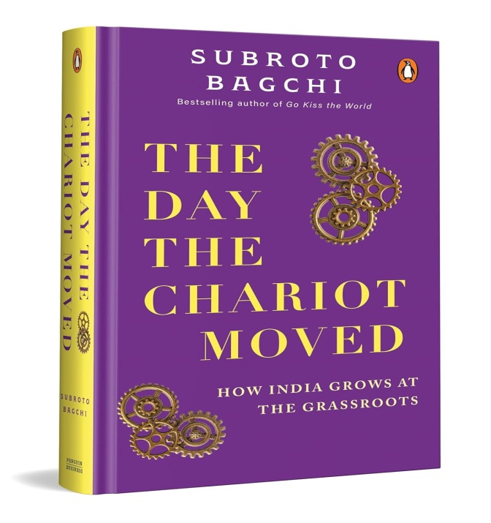

The day the chariot moved: how India grows at the grassroots

Author: Subroto Bagchi
Publisher: Gurugram: Penguin, 2025
Description: 371 p.
Accession No. 89414

The Day the Chariot Moved is a tribute to people who make permanent change happen in one lifetime. A unique book on the imperatives for institutional leadership that is relevant across sectors, it humanizes the development agenda for policymakers in the government.

It makes change agents from the social sector rethink their conventional approach and makes corporate leaders understand the complexities of making large-scale change. The stories in this book, told in a language that grips you, will help you understand the many notions of development.

