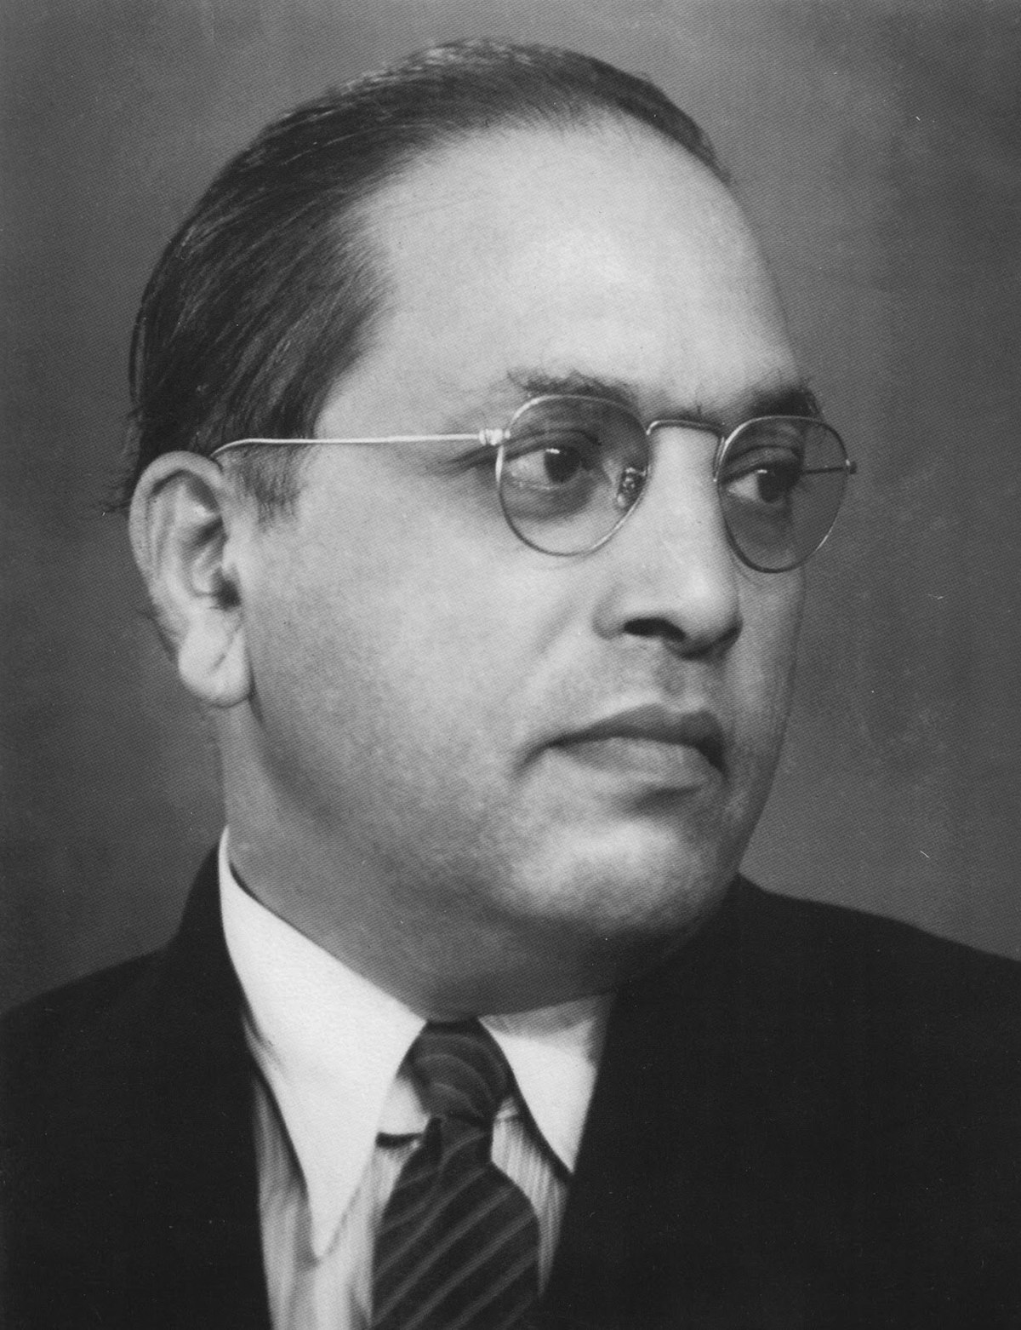
A Study
08
Fall
on
‘Inspection of Beneficiaries and Evaluation of Schemes of NBCFDC in the State of Rajasthan’


Conducted by
Dr. Neetu Jain
Dr. Ambedkar Chair in Social Justice
Indian Institute of Public Administration (IIPA)
I. P. Estate, Ring Road,
New Delhi-110002
Sponsored by

National Backward Classes Finance and Development Corporation
Ministry of Social Justice & Empowerment, Government of India

Inspection of beneficiaries and evaluation of schemes of NBCFDC in the State of Rajasthan

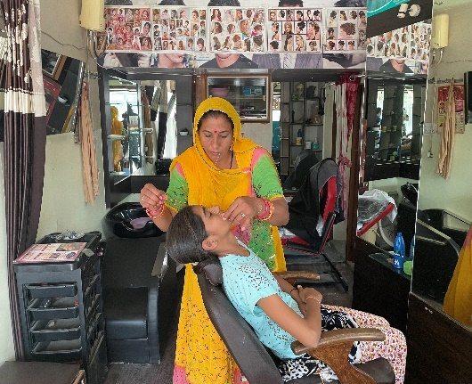

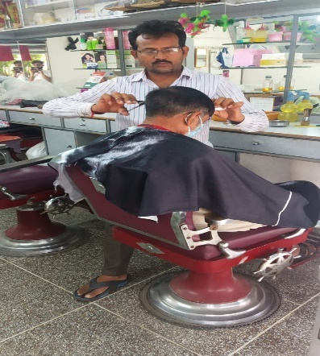
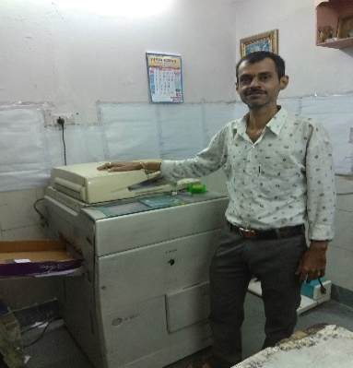

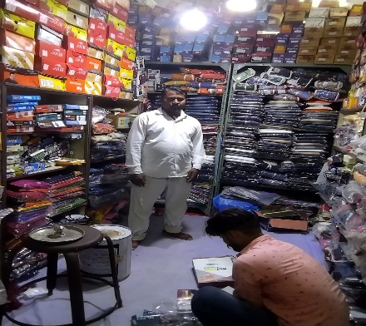
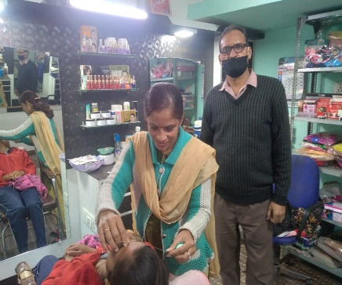
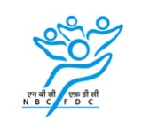

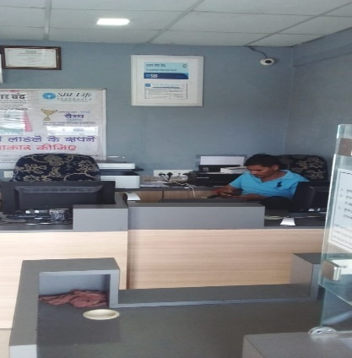
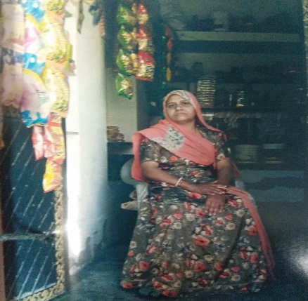

FOREWORD
Social Inclusion is a process by which efforts are made to ensure equal opportunities for all, regardless of their background, so that they can achieve full potential in life. It aims to achieve an inclusive society and uphold the principles of equality and equity. It is in this context the vision, mission and activities of National Backward Classes Finance & Development Corporation (NBCFDC) assume importance.
The NBCFDC has been established with an objective to promote economic and developmental activities for the benefit of Backward Classes. The mission is to promote self-employment ventures, skill development training and grant concessional finance to the eligible members of the Backward Classes. NBCFDC by extending loans through the State Channelizing Agencies (SCAs) and Self-Help Groups assist in wide range of income-generating activities for Backward Classes.
The present study- ‘Inspection of beneficiaries and evaluation of schemes of NBCFDC in the State of Rajasthan’ is with reference to SCA viz Rajasthan Other Backward Classes Finance & Development Cooperative Corporation Ltd. The study shows that NBCFDC scheme had a positive socio-economic impact on the lives of the respondents. The beneficiaries after availing the loan are meaningfully employed and their involvement in the social activities got enhanced. The outcome of the present study may help to fine-tune the NBCFDC schemes and strengthen the empowerment of Backward Classes in the State of Rajasthan.
I compliment Dr. Neetu Jain, Faculty In charge, Dr. Ambedkar Chair in Social Justice for undertaking the study and documenting the report for wider circulation. I thank NBCFDC, Ministry of Social Justice & Empowerment, Government of India for entrusting the study to Indian Institute of Public Administration.

Surendra Nath Tripathi
Director General (IIPA)

CONTENTS

 | Foreword  Abbreviations  Acknowledgement  Declaration  Executive Summary | iii  v  vi  vii  viii
Chapter No. | Title | Page No.
Chapter - I | Introduction: NBCFDC and its Financing Schemes | 1
Chapter - II | Research Methodology | 11
Chapter - III | Data Collection and Analysis | 19
Chapter - IV | Findings | 46
Chapter - V | Brief Report on the State Channelizing Agency | 65
Chapter - VI | Recommendations | 69
Chapter- VII | Success Stories | 81
Appendix: | Questionnaire | 111

LIST OF ABBREVIATIONS

Abbreviation | Explanation
GIA | Grants-in-aid
TL | Term Loan
MFI | Micro Finance Institution
MFS | Micro Finance Scheme
MoU | Memorandum of Understanding
MSY | Mahila Samriddhi Yojana
NBCFDC | National Backward Classes Finance and Development Corporation
SCA | State Channelizing Agency
OBC | Other Backward Classes

ACKNOWLEDGEMENTS
We are extremely grateful to Sh. Virendra Kumar, Union Minister of Social Justice and Empowerment for their encouragement and inspiration provided to us. We are highly indebted to Shri Rajnish Kumar Jenaw, Managing Director, NBCFDC ,New Delhi for reposing faith in Dr. Ambedkar Chair in Social Justice, IIPA by entrusting the responsibility of the study.

Dr. Ambedkar Chair in Social Justice, Indian Institute of Public Administration (IIPA) is deeply indebted to Dr. Ambedkar Foundation, Ministry of Social Justice & Empowerment, Government of India for sponsoring the Chair. The present study on ‘Inspection of Beneficiaries and Evaluation of Impact of Schemes of NBCFDC in Rajasthan’, undertaken as a part of Chair’s activities for the year 2021-22 is sponsored by National Backward Class Financial Development Corporation (NBCFDC), New Delhi.

We express our profound gratitude to Shri S. N. Tripathi, Director General, IIPA for his constant support and guidance provided for the activities of the Chair. He is a great source of inspiration and keeps providing his creative insights and extend full cooperation towards the smooth functioning of the Chair.

We acknowledge the guidance and support we received from Mr Sujoy. P.John, Chief Manager, NBCFDC and Shri Naresh Kumar, Assistant Manager, Planning, NBCFDC, New Delhi who guided us at every stage of the study. We thank officers of Rajasthan Other Backward Classes Finance & Development Cooperative Corporation Ltd., Jaipur for their support.

We are also thankful to Shri Amitabh Ranjan, Registrar, IIPA for providing the required resources and due support to carry out the study effectively. Lastly, we are thankful to Research Officer Ms. Tanushka Sharma and Mr. Anil for helping us in collection of data and for sharing all the responsibilities involved in the timely conduct and completion of this study. We hope that the study report would meet all the requirements envisaged in the terms of reference of the study and give a more effective direction to the cause of the study.
DECLARATION

It is declared that the Research Study Report entitled “Inspection of Beneficiaries & Evaluation of Impact of Schemes of NBCFDC in Rajasthan” is based on the original research by the undersigned and that it is exclusively submitted to the National Backward Classes Finance and Development Corporation (NBCFDC), New Delhi done by Dr. Ambedkar Chair, IIPA, New Delhi. The undersigned also declares that this Research Report has neither been presented before, nor published earlier.

Dr. Neetu Jain
Faculty-In-Charge
Dr. Ambedkar Chair in Social Justice,
Indian Institute of Public Administration,
New Delhi

Executive Summary

BACKGROUND
National Backward Classes Finance & Development Corporation (NBCFDC) is a Government of India Undertaking under the aegis of Ministry of Social Justice and Empowerment. NBCFDC was incorporated under Section 25 of the Companies Act 1956 (Now under Section 8 of companies Act, 2013) on 13th January 1992 as a Company not for profit but with an objective to promote economic and developmental activities for the benefit of Backward Classes and to assist the poorer section of these classes in skill development and self-employment ventures.
NBCFDC provides financial assistance through State Channelizing Agencies (SCAs) nominated by the State Governments/UTs. NBCFDC also provides Micro Financing through SCAs/ Self Help Groups (SHGs). The Corporation provides a wide range of income generating activities to assist the poorer section of these classes in skill development and self-employment ventures. The NBCFDC offers a bunch of loan schemes to cater to the needs of the society. The NBCFDC provides finance in different states through different State Channelizing Agencies. In the state of Rajasthan, the state channelizing agency is Rajasthan Other Backward Classes Finance & Development Cooperative Corporation Ltd.
NBCFDC is spending a hefty amount for the socio-economic upliftment of the marginal group but it is imperative to evaluate whether the target group has actually attained desired benefits or not. Further, it is also worthwhile to note whether the schemes for funding through various loans i.e., Term Loan, Micro Finance and Mahila Samridhi Yojna launched by NBCFDC are effective on practical ground or they require any kind of modification for being more suitable to the needy section. Therefore, the present study is required for evaluating schemes; Term Loan, Micro Finance, and Mahila Samridhi Yojna of NBCFDC in the State of Rajasthan. We have firm belief that the outcomes of the present study will assist in fine-tuning the NBCFDC schemes and enhance the empowerment process of backward classes in the State of Rajasthan.

STATEMENT OF PROBLEM
NBCFDC spends a lot of amount to provide financial assistance for different projects of backward classes like establishing small business such as tailoring business, dairy farming, carpentry, poultry farm, agricultural activities etc. NBCFDC has launched many schemes through which state channelizing agencies offer loans to backward class. Since it carries a huge cost, it is essential to know:
- Whether there is any improvement in the socio-economic status of target group in Rajasthan or not?
- What is the impact of different schemes of NBCFDC over the beneficiaries in Rajasthan?
The present study makes an attempt to get answer of these questions. Therefore, it evaluates the implementation of different schemes of NBCFDC in the State of Rajasthan.

OBJECTIVES OF THE STUDY

The primary objectives of the present study are as follows:
- To analyse whether there is any difference in the occupational level of beneficiaries before and after availing loan.
- To analyse whether there is any difference in the income level of beneficiaries before and after availing loan.
- To analyse whether there is any difference in the expenditure level of beneficiaries before and after availing loan.
- To examine the impact of loan schemes over socio-economic status of the beneficiaries.
- To analyse the perception of beneficiaries towards State Channelizing Agencies.
- To analyse the perception of beneficiaries towards different schemes of NBCFDC.
- To propose suggestions / recommendations for the possible improvement in the delivery mechanism.

RESEARCH METHODOLOGY
To achieve the above-mentioned objectives an explorative study comprising of qualitative as well as quantitative approach has been conducted that aims at exploring the impact of different loan schemes in the State of Rajasthan. The study analysed the impact of three different loan schemes i.e. Term Loan, Micro Finance Scheme and Mahila Samriddhi Yojna over the beneficiaries. Beneficiaries were taken from 33 districts of Rajasthan. These were the beneficiaries who have taken these three loans over two Years period i.e., 2018-19, 2019-20. Satisfaction level of beneficiaries on different aspects and with schemes of NBCFDC was taken into account. Sample size was 600 beneficiaries.

SUMMARY OF FINDINGS
From the above study, following insights can be drawn about the demographics and satisfaction level of the beneficiaries:
- 73% beneficiaries availing loan were males and 27% were females.
- Around 60% of the beneficiaries were having joint family and 40% beneficiaries were having nuclear family.
- 58% of the beneficiaries were having a family size of 4-5. 23% beneficiaries were having a family size of 0-3 and 19% beneficiaries were having family size of 5 and more
- 25% beneficiaries are illiterate, 30% are 8th pass, 20% are 10th pass, 13% are 12th pass, 1% are Diploma holders, 7% are Graduates, 4% are Post Graduates
- Around 69% of the beneficiaries belonged to rural areas and 31% belonged to urban areas.
- All the beneficiaries are married except one in Jodhpur who is unmarried.
- Majority of the beneficiaries i.e. 79% have savings account and 21% have Jan Dhan account.
- 93% of the beneficiaries have their own house.
- Around 69% beneficiaries could not provide employment to others.
- Most of the beneficiaries i.e. 94% did not receive any skill training during last 6 months.
- 38% people are not aware about other schemes of NBCFDC. It indicates that there is a big scope regarding familiarising people about other schemes of NBCFDC.
- Most of them i.e. 84% are satisfied with the loan scheme.
- Almost half of the beneficiaries are satisfied with the Guidance and support provided by SCA
- Almost half of the beneficiaries are satisfied with the Interest rate of the loan.
- About 16% number of beneficiaries have crossed the income eligibility criteria i.e. above less than Rs. 3.00 lac.
- The annual family income of beneficiary before loan was Rs. 5137/- and Annual average family income after loan was Rs.8179/- in the report. Hence it is concluded from the results that there is an increase of 79% in the annual average family income of beneficiaries after they availed the NBCFDC loan.
- From the results it is found that before obtaining loan from NBCFDC the average family annual income is Rs.61654/- and after availing loan from NBCFDC the average annual family monthly income Rs.98154/-. It is concluded that NBCFDC loan given an additional annual income of Rs.36500/- for the beneficiaries.
- About 547 (91%) beneficiaries have utilized the amount for the intended purpose. Remaining 9% utilized the amount for the other purpose.
- The analysis of repayment schedule revealed that 39% of the beneficiaries were regular in repaying the loan amount. 54% were irregular in repayment of loan and 7% were defaulters in repayment of loan, due to reasons such as losses in Business, lack of skill or other reasons.
- About 6% beneficiaries have taken Entrepreneurship Training to avoid business failure.
- No. of days taken by the SCA for disbursement of loan i.e. upto 4 months 9%, 4-6 months 29% and above 6 months 62%.
- A few beneficiaries i.e. only 5 % are dissatisfied with the loan sanctioning and disbursement system.
- Majority of the beneficiaries i.e 85% seem to be satisfied with the behaviour of the employees during the lending process.
- A few beneficiaries i.e 3% are dissatisfied with the size of monthly instalments.
- Most of the beneficiaries i.e 85 % are satisfied with the repayment period.
- Beneficiaries seem to be satisfied with the period for the approval of loan.
- Beneficiaries learnt about Schemes of NBCFDC from the sources such as Advertisement, Friends, Family, SCA official, Website and Other beneficiaries
- Beneficiaries created following asset out of the loan amount:
- Purchased animals such as Cow, Buffalo and Goat
- Open shops such as beauty parlour, salon, mobile shop, general provision store (kirana or parchoon), electronic repairing shop, hardware shop, dry clean shop, tea, bartan shop, E-mitra shop.
- Purchased land
- Purchased house
- Purchased machine such as sewing machine, wooden machine.
- Purchased goods such as electronic items, fancy items, artificial jewelry, sunari work related, cement related, stationary related, tent house, photo framing, toys items, pottery items.
- Purchased products such as tube well, vehicle for DJ.
- Vegetable Hawker.
- Around 50 % of the beneficiaries have experienced moderate increase in providing better education to their children because of the loan amount.
- Around 46 % of the beneficiaries have experienced moderate increase in getting better housing because of the loan amount.
- Around 47 % of the beneficiaries have experienced moderate increase in their social and financial status because of the loan amount.
- Around 46 % of the beneficiaries have experienced moderate increase in better access to health care facilities because of the loan amount.
- Around 47 % of the beneficiaries have experienced moderate increase in better access to financial resources or improvement in standard of living because of the loan amount.
- Around 67% beneficiaries created assets from the loan amount. It was found that people have their own interpretation of the term ‘Asset’ especially in Indian Context. They majorly understand its meaning in terms of ‘purchasing land’ or any other article such as ‘jewellery or immovable property or vehicle which stays with them for a longer duration. However, we have found that beneficiaries invested the loan amount in refurbishing their salons, shops and purchasing articles for the same as well.
- The result of the study revealed that over all, there was a positive socio-economic impact of NBCFDC schemes on the lives of respondents which in turn provided a number of benefits to them such as increased involvement in social activities, better access to health and education, improvement in social status and also recognition and empowerment. The positive changes in economic status resulted in better access to financial resources, decreased family indebtedness and improved lifestyles.
- As far as change in economic status of beneficiaries before and after taking the loan is concerned, it is clear that 16 % of the beneficiaries were able to increase their annual income above 3 lakhs which is around 25,000 per month. There were beneficiaries whose annual income was much less than Rs. 3 lakh before availing loan. Many beneficiaries mentioned their monthly income in the range of Rs. 5000 to 20,000 per month which means an annual income of Rs. 60,000 to 2,40,000 which is still lesser than Rs 3 lakh per annum. According to the beneficiaries a monthly income of Rs 20,000 gives them decent living to fulfil their basic needs at least in a rural area as cost of living is not much there.
- After taking Term loan there is 56% variation or 56% increase in the annual income of the beneficiaries. Similarly after taking loan under MSY, there is 62% variation or 62% increase in annual income of the beneficiaries. Similarly after taking loan under MFS, there is 59% variation or 59% increase in annual income of the beneficiaries. Overall, combined together there is 59% variation or 59% increase in annual income of all the beneficiaries. Therefore, it can be concluded that schemes of NBCFDC have significant impact on the lives of beneficiaries as they not only helped increasing their income but also helped in raising their standard of living by providing them the financial autonomy and better access to financial resources.
- However, due to the Corona virus Pandemic many beneficiaries in a few districts did not receive their DBTs and could not avail the benefits of the scheme. In this context, it is necessary to revisit the scope and reach of NBCFDC schemes.
- It has been observed that most of the beneficiaries in their feedback have requested to enhance the loan amount as they were not having proper value of articles etc. to be mortgaged for availing the required loan amount to set up their business, even the NBCFDC have schemes of higher loan amount.

RECOMMENDATIONS
For SCA
  - It is noted that majority of the beneficiaries of the Rajasthan other Backward Classes Finance & Development Cooperative Corporation Ltd for the two schemes General Term Loan and Micro Finance Schemes were males. As similar trend is observed in many districts, SCA, Jaipur should take initiative to make more women aware of the schemes of NBCFDC. SCA needs to improve awareness mechanism for creating awareness in all the districts.

  - Most of the respondents have linkage of Mobile and Aadhar number but SCA must ensure complete adherence to the norms.

  - SCA should conduct special advertisement campaign to popularise the schemes of NBCFDC as some respondents expressed dissatisfaction regarding the information furnished by SCA officials.

  - SCA should have regular programmes to create awareness about different financing schemes particularly for the unemployed youth. SCA may work with employment agencies for advertising the schemes of NBCFDC and can place hoardings at employment agencies.

  - When respondents were enquired about their awareness level regarding other schemes of NBCFDC, the study observed that around 62% of the beneficiaries of Rajasthan Other Backward Classes Finance & Development Cooperative Corporation were aware about other schemes of NBCFDC whereas around 38% of the beneficiaries were not aware about other schemes. Analysis of different districts revealed that the level of awareness about other schemes of NBCFDC is very poor in some districts . Hence, efforts should be made to create awareness about the schemes of NBCFDC as there is lot of scope for the same.

  - The analysis of repayment schedule revealed that 39% of the beneficiaries were regular in repaying the loan amount. Therefore, measures should be taken to bring 61% (irregular or defaulter) of the beneficiaries into this category of ‘ regular’.
  - Some resource persons in some districts have expressed their dissatisfaction with the query handling mechanism of SCA, Rajasthan. Therefore, Rajasthan SCA officials should ensure healthy and cooperative query handling mechanism whereby the doubts and queries of beneficiaries could be resolved within 2 working days. They must also seek feedback from their clients for the possible improvement in their framework.

  - Many beneficiaries and district resource persons are of the view that online direct application is confusing. Most applicants are not much educated or computer/ ICT literate to understand the online procedure. Therefore, they usually get in touch with the ‘agents’ who charge them hefty amounts as part of registration fees. This could be made eazy by hiring an administrative clerk at the office of assistant director, so that applicants bring all the required documents to office; and thereby the online process of application should be carried out from the end of the government offices only.

For NBCFDC

- The results call for launching of different women centric schemes by NBCFDC. A proper gap analysis must be done regarding the expectation of women in the region and the actual delivery intended by these schemes. The new schemes should be designed keeping in mind the current market trends and should be reviewed periodically.

- Assistance should be provided for forward linkages. For example, a person who avails loan for carpentry should also be provided necessary training and financial assistance on how to package, brand and sell the produce at competitive rates in the market.

- In view of the growing population of the backward classes in all the districts, it is advisable to increase the volume of the financial assistance. Many beneficiaries submitted that the loans sanctioned to them under the three schemes i.e., Term Loan, Micro Finance Scheme and Mahila Samriddhi Yojna of NBCFDC were insufficient to cater to their needs. Further, based on the budget of the project proposal, or business plan, the General Term Loan (GTL) amount should be increased depending upon the market value of the document of immovable property submitted by the beneficiary.

- The beneficiaries were of the opinion that the rate of interest of the loan amount should be reduced to bring down the list of defaulters. Most of the people who avail loan are from poor background and hence find it difficult to repay loan. It is pertinent to mention that economy of the country has been badly affected in pandemic, with inconsistent income caused by multiple lockdowns throughout the year. Therefore, this situation has made impossible or difficult for them to repay their monthly loan installments.

- As data indicates around 70% beneficiaries could not provide employment to others. It means that not much employment has been generated through the scheme. Out of 600 beneficiaries, around 30% beneficiaries contributed to employment generation. To uplift the economy, it is advisable that NBCFDC should give special preference to those ventures which generate further employment.

- NBCFDC should promote Skill Development Training. It is observed that business failure is one of the prominent reasons for irregularity in the repayment of loan. Therefore, possible help should be provided for training and nurturing local skills particularly in women centric business activities.

- The beneficiaries were looking forward to insurance for their group members and their business (Animals).

- Since the awareness level regarding other schemes of NBCFDC is not good, NBCFDC must place big hoardings of their schemes in the premises of SCA. Further an advertising pamphlet may be given to all beneficiaries at the time of sanctioning the loan so that they can be acquainted with the other schemes.

- The analysis of repayment schedule revealed the mismatch of agreed and actual payment schedule. NBCFDC should scrutinise the schedule at periodic intervals so as to curb the possibility of non-performing assets.

- Many beneficiaries shared that they experienced difficulties in getting the loan. The primary difficulty as mentioned by the beneficiaries was – ‘different legal formalities to be complied with’. Since majority of the population of different schemes is not much educated, NBCFDC should make attempt to simplify the procedures. For this training should be imparted to official staff of SCAs and resource persons of the districts to overcome practical difficulties of clients.

- The beneficiaries feel that the process of sanctioning the loan is very lengthy. Some of the respondents even mentioned that they got the sanctioning date after around 6-7 months. NBCFDC should institute mechanism wherein this time for getting the loan can be reduced. The loans must be sanctioned within two months from the date of application and must be disbursed within one month from the date of sanctioning so that the beneficiaries may start their activities in time. Further the format of application and their enclosures should be in a simplified manner which will ease the loan process.

- Since a significant number of beneficiaries in the study were from rural areas, it is suggested that the household income limit should be revised so that maximum people can avail the loan boosting up self-employment avenues.

- The widows and physically challenged members expected special privileges like low rate of interest and subsidy for the loan amount.

- Education is a catalyst for social transformation and social change. It is noted that there were no takers for education loan barring few exceptions. There is need to create awareness to avail the education loan and develop related skills among the beneficiaries so that there is a scope for their employability in different sectors.

- The study finds that the loan amount taken by the studied population is not adequate enough to bring out marked improvement in the lifestyles of beneficiaries. NBCFDC may reconsider increasing the loan amount of the schemes under the present study to experience perceptible change by the beneficiaries in their lives.

- A mobile app can be designed to provide end to end communication (comments, suggestions, query) from the side of the applicant. It will also provide the beneficiaries a hassle-free process of procuring the loan wherein they can get information about receiving the instalments and checking the update and status of their loan For NBCFDC and SCA a location-based tracker could be made available in the app so as to keep a track of the shop/ occupation of the beneficiary. This will also help them spot the defaulter more easily and quickly.

- The responsibility for disbursement of online loan should be given to the district units instead of SCA. This is because majority district units are unable to track the disbursement of instalments, which take more than 12 months to be transferred into the accounts of the beneficiaries. The districts units receive information much later about the transfer of loan in the accounts of beneficiaries. Moreover, this will also reduce the burden of the SCA and hold the district units accountable for their actions.

List of Actionable Points at SCA Level

- It is noted that majority of the beneficiaries of the Rajasthan other Backward Classes Finance & Development Cooperative Corporation Ltd for the two schemes General Term Loan and Micro Finance Schemes were males. As similar trend is observed in many districts, SCA, Jaipur should take initiative to make more women aware of the schemes of NBCFDC. SCA needs to improve awareness mechanism in the State.
- SCA should conduct special advertisement campaign to popularise the schemes of NBCFDC as some respondents expressed dissatisfaction regarding the information furnished by SCA officials.
- SCA should have regular programmes to create awareness about different financing schemes particularly for the unemployed youth. SCA may work with employment agencies for advertising the schemes of NBCFDC and can place hoardings at employment agencies.
- When respondents were enquired about their awareness level regarding other schemes of NBCFDC, the study observed that around 62% of the beneficiaries of Rajasthan Other Backward Classes Finance & Development Cooperative Corporation were aware about other schemes of NBCFDC whereas around 38% of the beneficiaries were not aware about other schemes. Analysis of different districts revealed that the level of awareness about other schemes of NBCFDC is very poor in some districts. Hence, efforts should be made to create awareness about the schemes of NBCFDC.
- The analysis of repayment schedule revealed that 39% of the beneficiaries were regular in repaying the loan amount. 54% were irregular in repayment of loan and 7% were defaulters in repayment of loan, due to reasons such as losses in Business, lack of skill or other reasons. Therefore, measures should be taken to bring 61% (irregular or defaulter) of the beneficiaries into this category of ‘regular’. The analysis of repayment schedule reveals the mismatch of agreed and actual payment schedule. NBCFDC should scrutinise the schedule at periodic intervals, so as to curb the possibility of non-performing assets.
- Some resource persons in some districts have expressed their dissatisfaction with the query handling mechanism of SCA, Rajasthan. Therefore, Rajasthan SCA officials should ensure healthy and cooperative query handling mechanism whereby the doubts and queries of beneficiaries could be resolved within 2 working days. They must also seek feedback from their clients for the possible improvement in their framework.
- Many beneficiaries and district resource persons are of the view that online direct application is confusing. Most applicants are not much educated or computer/ ICT literate to understand the online procedure. Therefore, they usually get in touch with the ‘agents’ who charge them hefty amounts as part of registration fees. This could be made easy by hiring an administrative clerk at the office of assistant director, so that applicants bring all the required documents to office; and thereby the online process of application should be carried out from the end of the government offices only. Therefore, SCA needs to simplify the online procedure for submitting loan application by the prospective beneficiaries.

List of Actionable Points at NBCFDC Level

- The results call for launching of different women centric schemes by NBCFDC. A proper gap analysis must be done regarding the expectation of women in the region and the actual delivery intended by these schemes. The new schemes should be designed keeping in mind the current market trends and should be reviewed periodically.

- Assistance should be provided for forward linkages. For example, a person who avails loan for carpentry should also be provided necessary training matching to their business and financial assistance on how to package, brand and sell the produce at competitive rates in the market.

- In view of the growing population of the backward classes in all the districts, it is advisable to increase the volume of the financial assistance. Many beneficiaries submitted that the loans sanctioned to them under the three schemes i.e., Term Loan, Micro Finance Scheme and Mahila Samriddhi Yojna of NBCFDC, were insufficient to cater to their business needs. Further, based on the budget of the project proposal, or business plan, the General Term Loan (GTL) amount should be increased depending upon the market value of the document of immovable property submitted by the beneficiary.

- The beneficiaries were of the opinion that the rate of interest of the loan amount should be reduced to bring down the list of defaulters. Most of the people who avail loan are from poor background and hence find it difficult to repay loan. It is pertinent to mention that economy of the country has been badly affected in pandemic, with inconsistent income caused by multiple lockdowns throughout the year. Therefore, this situation has made impossible or difficult for them to repay their monthly loan installments.

- As data indicates around 70% beneficiaries could not provide employment to others. Not much employment has been generated through the scheme. Out of 600 beneficiaries, around 30% beneficiaries contributed to employment generation. To uplift the economy, it is advisable that NBCFDC should give special preference to those ventures which generate further employment.

- NBCFDC should promote Skill Development Training. It is observed that business failure is one of the prominent reasons for irregularity in the repayment of loan. Therefore, possible help should be provided for training and nurturing local skills particularly in women centric business activities.
- The beneficiaries were looking forward to insurance for their group members and their business (Animals).

- Since there is a need to improve the awareness level regarding other schemes of NBCFDC, NBCFDC must place big hoardings of their schemes in the premises of SCA. Further an advertising pamphlet may be given to all beneficiaries at the time of sanctioning the loan so that they can be acquainted with the other schemes.

- The analysis of repayment schedule revealed the mismatch of agreed and actual payment schedule. NBCFDC should scrutinise the schedule at periodic intervals, so as to curb the possibility of non-performing assets. Needs to shift to the Actionable points at SCA level.

- Many beneficiaries shared that they experienced difficulties in getting the loan. The primary difficulty as mentioned by the beneficiaries was – ‘different legal formalities to be complied with’. Since majority of the population of different schemes is not much educated, NBCFDC should make attempt to simplify the procedures. For this training should be imparted to official staff of SCAs and resource persons of the districts to overcome practical difficulties of clients.

- The beneficiaries feel that the process of sanctioning the loan is very lengthy. Some of the respondents even mentioned that they got the sanctioned loan even after a period of more than 6 months. NBCFDC should institute mechanism wherein this time for getting the loan can be reduced. The loans must be sanctioned within two months from the date of application and must be disbursed within one month from the date of sanctioning so that the beneficiaries may start their activities in time. Further the format of application and their enclosures should be in a simplified manner which will ease the loan process. It is also suggested that to reduce the time of disbursement, NBCFDC need to keep regular follow up for disbursement of the applied loan amount by the SCA in a timely manner. NBCFDC may ask the SCA to send quarterly report of disbursed loan amount to know the disbursement status, so that timely disbursement to the beneficiaries could be made.
- It has been observed that most of the beneficiaries in their feedback have requested to enhance the loan amount as the sanctioned amount was insufficient to meet their needs. Sometimes setting up a business requires a heavy funding. For getting a higher amount of loan they are required to mortgage some of their valuable articles while the situation is that on account of their poor social- economic conditions they are unable to provide any such valuable article which can be mortgaged.

- Since a significant number of beneficiaries in the study were from rural areas, it is suggested that the household income limit should be revised so that maximum people can avail the loan boosting up self-employment avenues.

- The widows and physically challenged members expected special privileges like low rate of interest and subsidy for the loan amount.

- Education is a catalyst for social transformation and social change. It is noted that there were no takers for education loan barring few exceptions. There is need to create awareness to avail the education loan and develop related skills among the beneficiaries so that there is a scope for their employability in different sectors.

- The study finds that the loan amount taken by the studied population is not adequate enough to bring out marked improvement in the lifestyles of beneficiaries. NBCFDC may reconsider increasing the loan amount of the schemes under the present study to experience perceptible change by the beneficiaries in their lives.

- A mobile app can be designed to provide end to end communication (comments, suggestions, query) from the side of the applicant. It will also provide the beneficiaries a hassle-free process of procuring the loan wherein they can get information about receiving the instalments and checking the update and status of their loan For NBCFDC and SCA a location-based tracker could be made available in the app so as to keep a track of the shop/ occupation of the beneficiary. This will also help them spot the defaulter more easily and quickly.

- The responsibility for disbursement of online loan should be given to the district units instead of SCA. This is because majority district units are unable to track the disbursement of instalments, which take more than 12 months to be transferred into the accounts of the beneficiaries.

- The districts units receive information much later about the transfer of loan in the accounts of beneficiaries. Moreover, this will also reduce the burden of the SCA and hold the district units accountable for their actions.

Limitations of the study

1) Initially when the study was awarded in August, Rajasthan had high number of COVID cases and therefore the process of field visits got delayed. However, when the study team contacted the centers for the visit, they were told to delay their visit on account of Gram Panchayat election which was to be held in the districts of Rajasthan. As a result of this, visit of the study team to various districts got delayed by 15 days.

2) In some districts, study team could meet a small number of beneficiaries at the centre despite the fact that centre officials were informed many times in advance about the visit. In some cases study team hired a taxi to collect data from beneficiaries who were staying 20-30 km away from the centre. The beneficiaries were also hesitant in showing up on the center due to fear of contracting COVID. They believed that anybody who has come from towns could be a carrier of COVID.

3) The study team found it difficult to contact the resource persons in some districts as they did not pick up calls or either disconnected after knowing the objective of the study. They were unwilling to cooperate with the study team citing overload of work and inadequacy of staff in their districts.

4) During the study period, it was learnt that Rajasthan government had organized a month-long campaign ‘Prashasan Shehro ke Sang, Prashasan Gaon ke Sang’ in all the districts of Rajasthan till the month of December. All the resource persons had been assigned duties and were posted in different districts. Therefore, the study team faced lot of the difficulty in coordinating with district coordinators and collecting data.

5) During the collection of data, it was found out in many districts the projected number of beneficiaries as per the Rajasthan SCA did not match the actual beneficiaries in the districts. This was because in many districts the beneficiaries had not received the first (direct benefit transfer) instalment of their loan and hence could not be counted as actual beneficiaries.

CHAPTER - I
INTRODUCTION
NBCFDC AND ITS FINANCING SCHEMES

About National Backward Classes Finance & Development Corporation
National Backward Classes Finance & Development Corporation (NBCFDC) is a Govt. of India Undertaking under the aegis of Ministry of Social Justice and Empowerment. It was incorporated under Section 25 of the Companies Act 1956 on 13th January 1992 as a Company not for profit but with an objective to promote economic and developmental activities of Backward Classes. Presently, it is a Section-8 Company (not for profit) registered under the Companies Act, 2013. The Schemes are implemented through State Channelising Agencies (SCAs) nominated by respective State Government/UT.

Vision
The Corporation has been established with a vision to play a leading role in upliftment of economic status of the target group of Backward Classes.

Mission
The mission is to provide concessional financial assistance to the eligible members of the Backward Classes for Self-employment ventures and Skill Development Training.

Objectives
- To Promote economic and development activities for the benefit of Backward Classes
- To assist, subject to such income and/or economic criteria as may be prescribed by government from time to time, individuals or groups of individuals belonging to Backward Classes by way of loans and advances for economically and financially viable schemes and projects.
- To provide for gainful employment and skill development to the target group.
- To grant concessional finance in selected cases for poor persons belonging to Backward Classes as per an annual income criterion defined from time to time (presently Rs. 3.00 lakh).
- To extend loans to the Backward Classes for pursuing general/professional/vocational/technical education or training at graduate and higher level.
- To assist in the up gradation of technical and entrepreneurial skills of Backward Classes for proper and efficient management of production units.

NBCFDC offers financial assistance through State Channelizing Agencies (SCAs) nominated by the State Governments/UTs. It also provides Micro Financing through SCAs/ Self Help Groups (SHGs).

Activities Financed
The Corporation assists in a wide range of income generating activities under following broad sectors:
- Agriculture and Allied Activities
- Small Business/Artisan and Traditional Occupation
- Transport Sector and Service Sector
- Technical, Vocational and Professional Trades/Courses
- The Channel Partners (SCAs and Banks) are to disburse loans for viable projects as per needs and choice of beneficiaries under above mentioned broad sectors.

Loan Schemes at NBCFDC
The NBCFDC offers a number of loan schemes to cater to the need of the society.

Term Loan Scheme
Under this scheme, loan is provided for a fixed duration. It includes following schemes:
- General Loan
- New Swarnima for Women
- Education Loan

General Loan Scheme
Under this scheme, loan is available for various income generating activities such as agriculture and allied activities, small business/artisan and traditional occupation, transport sector and service sector and technical and professional trades/courses. Members of Backward Classes, as notified by Central Government/State Governments from time to time are eligible to take loan under this scheme. The applicant’s annual family income should be less than Rs. 3.00 Lakh.

Salient Features of the scheme:
- The maximum loan limit per beneficiary is INR 15 Lakh out of which 85% will be financed through NBCFDC and remaining 15% will be financed through Channel Partner/Beneficiary Share.
- Loan is to be repaid in quarterly instalments with maximum 8 years (including the moratorium period of six months on the recovery of principle.
- The rate of interest varies from 6% to 8% depending upon the quantum of loan.

New Swarnima for Women
The scheme has been launched to inculcate the spirit of self- dependence among the women belonging to Backward Classes as notified by the Central/ State Governments from time to time. The annual family income of applicant should be less than Rs. 3.00 Lakh.

Salient Features of the Scheme
- The target group of the scheme is the women of Backward Classes having annual family income less than Rs.3.00 Lakh.
- The beneficiary women is not required to invest any amount of her own on the projects up to cost of Rs.2,00,000/-.
- The rate of interest on the amount of loan is less as compared to the general loan scheme of the Corporation. The rate of interest from NDCFDC to channel partner is 2 % p.a. and from channel partner to beneficiary is 5 % p.a.
- Loan is to be repaid in quarterly instalments with maximum 8 years (including the moratorium period of six months on the recovery of principle)

Education Loan
The primary objective of this scheme is to provide education loan to the students belonging to backward classes for pursuing professional/technical education at graduate and higher level and also to pursue vocational Courses.

Salient Features of the Scheme
- The target group of the scheme covers members of Backward Classes having annual family income less than Rs.3.00 Lakh.
- The applicant should have obtained admission in the courses as specified/approved by NBCFDC eligibility guidelines. The quantum of finance depends upon the nature of course.
- The interest rate for boys is 4% per annum and for girls it is 3.5% per annum.
- The maximum recovery period may be 10 years after the lapse of the moratorium period of 5 years i.e. the loan will be required to be repaid to NBCFDC by the Channel Partner within 15 years of the same being disbursed.
- For Professional courses, 90 percent of the total course expenditure up to maximum amount of Rs 15 Lakh per student for study in India and 85 percent of the total course expenditure up to maximum amount of Rs 20 lakh per student is granted under the scheme. The balance amount shall be borne by the student/SCA. While for Vocational Courses, 90 per cent of the course amount shall be financed under the scheme as ascertained by the Channel partners based on prevailing market conditions and government schemes.

Micro Finance Schemes
It includes schemes targeted to cater to the micro finance needs of women. It comprises following four schemes:

Mahila Samriddhi Scheme
This scheme aims at fulfilling the micro finance needs of women entrepreneurs belonging to the Backward Classes. However, the applicant’s annual family income should be less than Rs. 3.00 Lakh. Here it is pertinent to mention that in any self-help group, 60% of members should be from Backward Classes and remaining 40% members may be from other weaker sections like SC/handicapped/minorities etc. The scheme is to be implemented by Channel Partners in rural and urban areas by way of financing the women beneficiaries either directly or through Self-Help Groups (SHGs).

Salient Features of the Scheme
- Maximum loan limit per SHG is INR15.00 Lakh and the maximum loan limit per beneficiary is INR 1,25,000/-only.
- There can be maximum 20 women as members of one SHG
- The pattern of finance is 95% NBCFDC and 5% from Channel Partner/Beneficiary contribution.
- The interest rate payable on loans from NBCFDC to Channel Partner is 1% per annum whereas that for loans from Channel Partner to SHG/Beneficiary is 4% per annum
- The loan is to be repaid in quarterly instalments within 3.5 Years (including the moratorium period of three months on the recovery of principle.

Micro Finance Scheme
This scheme was launched to cater to the needs of small entrepreneurs belonging to the members of Backward Classes as notified by Central/State Govt. from time to time. The applicant’s annual family income should be less than Rs. 3.00 Lakh. NBCFDC introduced the scheme through nominated Channel Partners (State Channelizing Agencies/Banks).
The scheme is to be implemented by Channel Partners in rural and urban areas by way of financing the beneficiaries either directly or through Self-Help Groups (SHGs) preferably in the areas remained uncovered so far under any of such scheme. But it is desirable to disburse loans through Self-Help Groups (SHGs) by Channel Partners under Micro Finance Scheme. Here SHGs represents a small economically homogenous group of poor people, who have voluntarily formed the group to save and lend common funds to its members as per group decision. In a SHG 60% of members can be from Backward Classes and remaining 40% members may be from other weaker sections like SC/handicapped/minorities etc. Channel Partners may also play a vital role through their field officers, encouraging people of the target group in forming Self-Help Groups and to get financial assistance under Micro Finance Scheme of NBCFDC.

Salient Features of the Scheme
- Maximum loan limit per SHG is INR 15.00 Lakh and the maximum loan limit per beneficiary is INR 1, 25,000/-only.
- There can be maximum 20 members of one self-help group.
- The pattern of finance is 90% NBCFDC and 10% from Channel Partner/Beneficiary contribution.
- The interest rate payable on loans from NBCFDC to Channel Partner is 2% per annum whereas that for loans from Channel Partner to SHG/Beneficiary is 5% per annum.
- The loan is to be repaid in quarterly instalments within 4 Years (including the moratorium period of six months on the recovery of principle).

Small Loan for individual
The Corporation has introduced Small Loan Scheme for the individual for starting small business. The scheme is implemented through Channel Partners (State Channelizing Agencies/Banks) for the members of Backward Classes as notified by Central/State Govt. from time to time. Similar to other schemes, the applicant’s annual family income should be less than Rs. 3.00 Lakh.

Salient Features of the Scheme
- Maximum loan limit per beneficiary is INR 1, 25,000/-only.
- The pattern of finance is 85% NBCFDC and 15% from Channel Partner/Beneficiary contribution.
- The interest rate payable on loans from NBCFDC to Channel Partner is 3% per annum whereas that for loans from Channel Partner to SHG/Beneficiary is 6% per annum.
- The loan is to be repaid within 4 years.

Non-Banking Financial Company-Micro Finance Institution
The Non-Banking Financial Company-Micro Finance Institution (NBFC-MFI) fulfilling the eligibility criteria of NBCFDC may be appointed to act as Channelizing Agency (CA) of NBCFDC in the selected State/UT. The standard norms regarding eligibility of an institution to act as NBFC-MFI include:
- Registered with the RBI,
- 3 years of continuous profit track record,
- Gross Non-Performing Assets less than 2% and net NPA below 0.5%,
- Member of a Credit Bureau,
- Minimum Capacity Assessment Rating of MFR5 by CRISIL or its equivalent etc.

The amount would be lent to the beneficiary of Backward Class community having annual family income less than INR 3.00 Lakh per annum irrespective of rural or urban area. In case of landless agriculture labourers and marginalized farmers, the land holding less than one hectare will be deemed as having annual family income below Rs.1.50 Lakh per annum, land holding between 1-2 hectares will be deemed as having annual family income below Rs.3.00 Lakh per annum.

Salient Features of the Scheme
- Maximum loan limit per SHG is INR15.00 Lakh and the maximum loan limit per beneficiary is INR 1,00,000/-only.
- There can be maximum 20 members of one self-help group.
- The pattern of finance is 90% NBCFDC and 10% from NBFC-MFIs and/or beneficiaries.
- The interest rate payable on loans from NBCFDC to NBFC-MFI is 4% per annum whereas that for loans from NBFC-MFI to beneficiary is 12% per annum
- The loan is to be repaid in quarterly instalments within 4 Years (including the moratorium period of six months on the recovery of principle).
- The Channelizing Agency shall endeavour to cover 40% female beneficiaries in physical as well financial terms.
- NBFC-MFI shall provide the Bank Guarantee and/or Fixed Deposits issued by Scheduled Commercial Banks in the name of “NBFC-MFI account NBCFDC” equivalent to the amount to be disbursed to them as security to NBCFDC.
- NBFC-MFI shall utilize funds within 120 days from the date of release of funds by NBCFDC. Further, it will have to comply with the provisions of NBCFDC pertaining to repayment of loan.

Performance Linked Grants-in-aid Scheme (PLGIA)
The Scheme shall be called the Scheme for Grants-in-aid (GIA) to Channel Partners of National Backward Classes Finance and Development Corporation (NBCFDC). The objectives of the Scheme is to strengthen the infrastructure of Channel Partners in order to improve their delivery mechanism, creating awareness, mobilization of eligible beneficiaries, timely utilization of allocated funds and strengthening the recovery system. All Channel Partners implementing NBCFDC scheme will be eligible except the Channel Partners which are dormant/non-functional or have not drawn funds from NBCFDC for implementing its lending schemes during the last three years.

Salient Features of the Scheme
- All eligible Channel Partners in any State/UT can be funded under the grants-in-aid scheme. The grants-in-aid will be provided on the basis of performance of the Channel Partners, subject to availability of funds.
- The basis of selection for releasing PLGIA is timely submission of Annual Action Plan drawn of allocated funds, timely utilization & submission of utilisation certificate, timely recovery of dues from Channel Partners to NBCFDC.
- The NBCFDC reserves the right to accept or reject the claim without citing any reason.
- GIA is allowed to perform some specific activities like improvement in the delivery mechanism, hiring of vehicles for loan recovery during recovery, outsourcing of staff for Data Entry Operator and Recovery staff and training to officials of channel partners.
- Under the PLGIA scheme, 100% assistance will be provided to Channel Partners by NBCFDC.
- The Channel Partners are responsible to comply with all guidelines for evaluating the PLGIA proposal, consolidating the utilization certificate and furnish to NBCFDC within 90 days of receipt of GIA.

CHAPTER – II
RESEARCH METHODOLOGY

According to the Indian Constitution, Other Backward Classes (OBCs) are described as "socially and educationally backward classes". The Indian constitution and legal framework calls for initiating all possible steps that could ensure the socio-economic well-being of OBCs in India. The socio-economic well-being uplifts the deprived sections of the society. The Government of India has initiated many measures to empower the weaker sections and extending financial assistance is one of such steps.
The NBCFDC provides finance assistance to OBCs in different schemes of NBCFDC through its respective State Channelizing Agencies (SCAs)/Channel Partners. In the State of Rajasthan, name of SCA is Rajasthan Backward Finance & Development Cooperative Corporation Ltd. Financial assistance is provided to OBC beneficiaries through SCA. This agency is serving OBCs through various schemes of NBCFDC.

Rajasthan State Backward Finance & Development Cooperative Ltd. was established on 28 March 1980, for the economic upliftment of Scheduled Caste people living below the poverty line. The name of the corporation has been revised to Rajasthan Scheduled Castes & Scheduled Tribes Finance & Development Corporation Ltd on 24 September 1983, so that the Scheduled Tribe people can also avail the benefits of the schemes. The main function of the corporation is to help the SC/ST people, specially-abled and members of the cleaning staff of Rajasthan in their economic development so that their livelihood and standard of living can be improved. For this, the corporation provides loans and financial assistance (grants) for cattle and agriculture development, supply and storage of agricultural commodities, establishment of small and cottage industries, establishment of industrial units and for other such activities, so that the members of these classes can be economically uplifted and regional zones can also be developed

NEED AND IMPORTANCE OF THE STUDY
Indian constitution upholds equity principle. Each and every individual must be treated equally and there shouldn’t be any discrimination on the basis of caste, creed or religion. Despite initiatives and legislative measures by Government of India to ensure socio-economic parity of all citizens, the number of deprived and marginalised sections has not reduced considerably. It is essential that people belonging to these sections are provided some financial assistance to improve their economical, educational, occupational and social status. The provision of micro finance enables weaker sections to establish their own ventures and earn their livelihood in a decent manner.
NBCFDC has launched many schemes to promote financial empowerment of OBCs in different states and Rajasthan is no exception. It is spending a huge amount for the socio-economic up-liftment of the marginalised groups. In this context, it is imperative to evaluate whether the schemes launched by NBCFDC are effective or require modification for being more useful to the needy sections. Therefore, the present study intends to evaluate the three schemes of NBCFDC i.e. Term Loan, Micro Finance Scheme, and Mahila Samriddhi Yojna in the State of Rajasthan.

STATEMENT OF PROBLEM
NBCFDC provides financial assistance for different activities of backward classes like tailoring, dairy farming, carpentry, poultry farming, agricultural activities etc. The study evaluates the implementation of different schemes of NBCFDC by basically addressing two questions:
- What is the impact of schemes; Term Loan, Micro Finance Scheme and Mahila Samriddhi Yojna of NBCFDC over the beneficiaries in Rajasthan?
- Whether there is any improvement in the socio-economic status of target group in Rajasthan or not?

OBJECTIVES OF THE STUDY
The primary objectives of the present study include:
- To examine whether there is any difference in terms of occupation, level of income and expenditure of beneficiaries before and after availing loan.
- To examine the impact of loan schemes over socio-economic status of the beneficiaries.
- To analyse the perception of beneficiaries towards State Channelising Agencies.
- To analyse the perception of beneficiaries towards different schemes of NBCFDC.
- To make suggestions / recommendations for the possible improvement in the delivery mechanism.

RESEARCH METHODOLOGY
The study analysed the impact of different loan schemes over the beneficiaries. It followed quantitative and qualitative research approaches whereby the satisfaction level of beneficiaries from 33 districts of Rajasthan were taken into account. The details about the research methodology is as follows:

Data
- Nature of Data: Primary Data
- Data Collection: The Data has been collected through formulated Questionnaire
- Study Period: Two Year i.e., 2018-19 & 2019-20

Universe
The State of Rajasthan, India

Population
Since the study is aimed at evaluating the schemes of NBCFDC in Rajasthan, the state Rajasthan is the universe for the study. It should be noted that the state of Rajasthan is divided into following thirty-three districts:
Ajmer, Alwar, Banswara, Baran, Barmer, Bharatpur, Bhilwara, Bikaner, Bundi, Chittorgarh, Churu, Dausa, Dholpur, Dungarpur, Hanumangarh, Jaipur, Jaisalmer, Jalore, Jhalawar, Jhunjhunu, Jodhpur, Karauli, Kota, Nagaur, Pali, Pratapgarh, Rajsamand, Sawai Madhopur, Sikar, Sirohi, Sri Ganganagar, Tonk, Udaipur

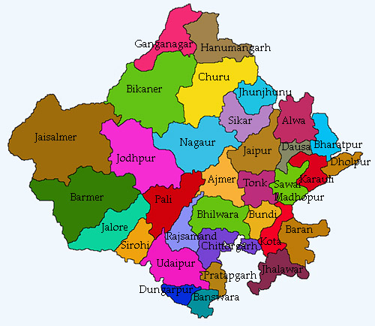

Figure-2.1

Sampling
- Sample Size
All the beneficiaries availing benefits of loan under the three schemes i.e. Term Loan, Micro Finance Scheme, and Mahila Samriddhi Yojana of NBCFDC through State Channelizing Agency, Rajasthan Other Backward Classes Finance & Development Cooperative Corporation Ltd. were the target of study. As discussed in the project proposal, and in consultation with NBCFDC, the study considered a total of 600 beneficiaries from the 33 districts of Rajasthan, availing the benefits of these schemes.

Sampling for Rajasthan
In case of SCA of Rajasthan, it was observed that out of 33 districts of Rajasthan, in three districts i.e., Bikaner, Dholpur and Pratapgarh there were no beneficiaries during the study period. Therefore, these three districts were not considered for the study. Total beneficiaries in remaining 30 districts were 2535. The distribution of the population across different years is enunciated below:

Figure 2.2: Year-wise Breakup of Beneficiaries of SCA- Rajasthan

Source: Reseracher’s Compilation

As shown in the above Figure, the numbers of beneficiaries were highest in the second year i.e. 2019-20. Maximum beneficiaries were from Sawai Madhopur district. The district-wise proportion of total beneficiaries of three schemes of NBCFDC in Rajasthan has been shown in Figure below:
Figure 2.3: District-wise Beneficiaries in Rajasthan

Table 2.1: Sample Distribution Across Different Years and Districts
Districts | Year (2018-19) |  |  | Total | Year (2019-20) |  |  | Total
 | TL | MSY | MFS |  | TL | MSY | MFS
Ajmer | 1 | 2 | 2 | 5 | 5 | 10 | 1 | 16
Alwar | 0 | 0 | 0 | 0 | 9 | 1 | 1 | 11
Banswara | 6 | 0 | 0 | 6 | 51 | 1 | 21 | 73
Baran | 3 | 0 | 1 | 4 | 30 | 0 | 8 | 38
Barmer | 0 | 0 | 5 | 5 | 0 | 20 | 62 | 82
Bharatpur | 43 | 3 | 7 | 53 | 38 | 1 | 0 | 39
Bhilwara | 0 | 0 | 0 | 0 | 6 | 5 | 2 | 13
Bundi | 4 | 0 | 0 | 4 | 14 | 0 | 0 | 14
Chittorgarh | 3 | 0 | 0 | 3 | 14 | 0 | 1 | 15
Churu | 14 | 12 | 11 | 37 | 0 | 0 | 2 | 2
Dausa | 29 | 4 | 2 | 35 | 81 | 0 | 21 | 102
Dungarpur | 2 | 5 | 0 | 7 | 10 | 1 | 0 | 11
Shriganganagar | 2 | 1 | 12 | 15 | 0 | 1 | 3 | 4
Hanumangarh | 5 | 2 | 1 | 8 | 12 | 2 | 3 | 17
Jaisalmer | 80 | 3 | 22 | 105 | 80 | 5 | 7 | 92
Jaipur | 21 | 1 | 4 | 26 | 10 | 1 | 0 | 11
Jalore | 0 | 0 | 0 | 0 | 15 | 0 | 1 | 16
Jhalawar | 0 | 0 | 0 | 0 | 0 | 1 | 9 | 10
Jhunjhunu | 85 | 5 | 12 | 102 | 0 | 0 | 0 | 0
Jodhpur | 82 | 8 | 14 | 104 | 0 | 7 | 12 | 19
Karauli | 87 | 3 | 17 | 107 | 100 | 9 | 12 | 121
Kota | 0 | 0 | 0 | 0 | 39 | 4 | 5 | 48
Nagaur | 31 | 3 | 10 | 44 | 169 | 16 | 26 | 211
Pali | 51 | 0 | 19 | 70 | 62 | 12 | 11 | 85
Rajasmand | 0 | 0 | 0 | 0 | 0 | 3 | 14 | 17
Sawai Madhopur | 92 | 17 | 25 | 134 | 446 | 18 | 46 | 510
Sikar | 0 | 5 | 5 | 10 | 0 | 2 | 0 | 2
Sirohi | 2 | 0 | 0 | 2 | 8 | 0 | 0 | 8
Tonk | 0 | 0 | 0 | 0 | 21 | 3 | 6 | 30
Udaipur | 28 | 0 | 4 | 32 | 0 | 0 | 0 | 0
Total | 671 | 74 | 173 | 918 | 1220 | 123 | 274 | 1617

Sampling for SCA in Rajasthan
The study analyses the responses of 600 beneficiaries out of the 2535 beneficiaries for the three schemes viz Term Loan, Micro Finance Scheme and Mahila Samriddhi Yojana in Rajasthan. This amounts to 23% of the population size. However, the bifurcation of data as per the proposed study is divided into 400 beneficiaries for General Term Loan (GLT), 100 beneficiaries for Micro Finance Scheme (MFS) and 100 beneficiaries for Mahila Samriddhi Yojana(MSY) for two years i.e 2018-19 and 2019-2020. Notably, in many districts for the years 2019-2020 due to Covid- 19, Direct Benefit Transfers of the Loan amount was not given. The scheme-wise breakup of the population for two years i.e., 2018-19 and 2019-20 is as follows:

Table: 2.2. Year-wise breakup of beneficiaries of three schemes in 33 districts of Rajasthan
Schemes | 2018-2019 | 2019-2020
TL | 671 | 1220
MSY | 74 | 123
MFS | 173 | 274

Figure 2.4: Scheme-wise Break-up of Total Beneficiaries in two years

CHAPTER III
DATA COLLECTION AND ANALYSIS

Data Analysis
A structured questionnaire was administered to beneficiaries. The data collected from different beneficiaries was analysed to get socio-economic information, scheme related information, satisfaction from the different facilities / services extended by SCAs and impact of different schemes on beneficiaries. To explore the information regarding satisfaction level, the respondents have been asked to rate their satisfaction level from different services / facilities extended by the State Channelizing Agency (SCA) of Rajasthan to them. They have been asked to rank their satisfaction level for the different parameters including loan scheme, assistance and guidance provided by SCA, interest rates, loan sanctioning system, disbursement system, behaviour of the employees during the lending process, size of monthly instalments, repayment period, time taken for loan approval, easy query handling and overall services. The beneficiaries have been asked to rank their satisfaction level at 5-point Likert scale where 1 expresses the highly dissatisfaction level, 2 denotes that they are dissatisfied, 3 shows that neither they are satisfied to the specific service nor they are dissatisfied. The satisfaction has been expressed through 4 and respondents were asked to mark 5 if they are highly satisfied on a specific variable.
Similarly, the impact of different schemes on beneficiaries has been evaluated. The respondents have been asked to rank the increment level of some specific variables on account of availing the loan scheme of NBCFDC. The selected variables include better schooling of the children, social recognition in the society, participation in organized activities, better access to the health facilities, food consumption pattern, clothing status, better access of financial resources, and asset creation. The beneficiaries were asked to mark 1 if they have experienced notable decrease, 2 moderate decrease, 3 unchanged, 4 moderate increment and 5 if they think that there is a notable increment in the variable after availing the loan scheme.
The responses of various beneficiaries have been recorded in excel sheet and the same have been analysed through MS-Excel and SPSS software. Pie charts, histograms, bar diagrams and tables have been used to depict the results. Averages, standard deviation, and percentage have been used to analyse the responses.
Following table indicates sample size of beneficiaries collected by the Study Team from each district of Rajasthan:
Table 3.1: District-wise Sample size of beneficiaries
Districts | No. of Beneficiaries
Ajmer | 23
Banswara | 14
Baran | 41
Barmer | 59
Bundi | 19
Chittorgarh | 5
Churu | 5
Dausa | 17
Dungarpur | 11
Hanumangarh | 10
Jaiselmer | 110
Jhunjhunu | 26
Jodhpur | 31
Karauli | 25
Kota | 12
Nagaur | 86
Pali | 76
Sikar | 10
Sirohi | 10
Udaipur | 10
Total | 600

Figure 3.1: District-wise number of beneficiaries in sample

Figure 3.2: District-wise beneficiaries availing Term Loan

Above Chart gives the number of beneficiaries in each district availing loan under ‘Term Loan’.

Figure 3.3: District-wise beneficiaries availing MFS

Above Chart gives the number of beneficiaries in each district availing loan under’ Micro Finance Scheme’.

Figure 3.4: District-wise beneficiaries availing MSY

Above Chart gives the number of beneficiaries in each district availing loan under Mahila Samridhi Yojna.

Percentage distribution of beneficiaries Gender-Wise across Districts
Table 3.2: Gender wise distribution of beneficiaries across different districts (in %)

Districts | Male | Male% | Female | Female%
Ajmer | 13 | 2.988505747 | 10 | 6.060606
Banswara | 7 | 1.609195402 | 7 | 4.242424
Barmer | 43 | 9.885057471 | 16 | 9.69697
Baran | 40 | 9.195402299 | 1 | 0.606061
Bundi | 18 | 4.137931034 | 1 | 0.606061
Chittorgarh | 4 | 0.91954023 | 1 | 0.606061
Churu | 3 | 0.689655172 | 2 | 1.212121
Dausa | 16 | 3.67816092 | 1 | 0.606061
Dungarpur | 8 | 1.83908046 | 3 | 1.818182
Hanumangarh | 7 | 1.609195402 | 3 | 1.818182
Jaisalmer | 88 | 20.22988506 | 22 | 13.33333
Jhunjhunu | 11 | 2.528735632 | 15 | 9.090909
Jodhpur | 24 | 5.517241379 | 7 | 4.242424
Karoli | 16 | 3.67816092 | 9 | 5.454545
Kota | 8 | 1.83908046 | 4 | 2.424242
Nagore | 54 | 12.4137931 | 32 | 19.39394
Pali | 47 | 10.8045977 | 29 | 17.57576
Sikar | 10 | 2.298850575 | 0 | 0
Sirohi | 8 | 1.83908046 | 2 | 1.212121
Udaipur | 10 | 2.298850575 | 0 | 0
TOTAL | 435 |  | 165

Table 3.3: Percentage distribution of all beneficiaries Gender-Wise

S. No | Sex | Percentage
1 | Female | 27.50%
2 | Male | 72.50%

Above table indicates 72.5% beneficiaries availing loan were males.

Figure 3.5: Percentage distribution of beneficiaries gender-wise

Table 3.4: Percentage distribution of beneficiaries as per nature of family across Districts

 | Number of Beneficiaries |  | Percentage of Beneficiaries
Districts | Joint Family | Nuclear Family | Joint Family | Nuclear Family
Ajmer | 21 | 2 | 6.15835777 | 0.772200772
Banswara | 14 | 0 | 4.10557185 | 0
Barmer | 55 | 4 | 16.1290323 | 1.544401544
Baran | 40 | 1 | 11.7302053 | 0.386100386
Bundi | 9 | 10 | 2.63929619 | 3.861003861
Chittorgarh | 4 | 1 | 1.17302053 | 0.386100386
Churu | 2 | 3 | 0.58651026 | 1.158301158
Dausa | 1 | 16 | 0.29325513 | 6.177606178
Dungarpur | 4 | 7 | 1.17302053 | 2.702702703
Hanumangarh | 1 | 9 | 0.29325513 | 3.474903475
Jaisalmer | 15 | 95 | 4.39882698 | 36.67953668
Jhunjhunu | 11 | 15 | 3.22580645 | 5.791505792
Jodhpur | 10 | 21 | 2.93255132 | 8.108108108
Karoli | 9 | 16 | 2.63929619 | 6.177606178
Kota | 10 | 2 | 2.93255132 | 0.772200772
Nagore | 67 | 19 | 19.6480938 | 7.335907336
Pali | 54 | 22 | 15.8357771 | 8.494208494
Sikar | 10 | 0 | 2.93255132 | 0
Sirohi | 1 | 9 | 0.29325513 | 3.474903475
Udaipur | 3 | 7 | 0.8797654 | 2.702702703
TOTAL | 341 | 259

Table 3.5: Overall family nature- wise distribution
S.no | Nature of Family | Percentage
1 | Joint | 59.83%
2 | Nuclear | 40.16%

Figure 3.6: Percentage distribution of beneficiaries as per nature of family

It is clear from the above figure that around 60% of the beneficiaries were having joint family.

Table 3.6: Distribution of beneficiaries as per family size across districts

Districts | 0-3 | 4-5 | 5 and more
Ajmer | 3 | 14 | 6
Banswara | 6 | 8 | 0
Barmer | 8 | 45 | 6
Baran | 4 | 36 | 1
Bundi | 8 | 6 | 6
Chittorgarh | 1 | 3 | 1
Churu | 1 | 3 | 1
Dausa | 4 | 10 | 3
Dungarpur | 3 | 6 | 2
Hanumangarh | 4 | 5 | 1
Jaisalmer | 6 | 52 | 6
Jhunjhunu | 3 | 16 | 7
Jodhpur | 9 | 15 | 7
Karoli | 6 | 13 | 6
Kota | 5 | 6 | 1
Nagore | 9 | 48 | 29
Pali | 4 | 48 | 24
Sikar | 0 | 1 | 9
Sirohi | 3 | 6 | 1
Udaipur | 3 | 6 | 0

Figure: 3.7: District-wise family size of beneficiaries

Table 3.7: Family size of all the beneficiaries

Size of family | Percentage | No. of Beneficiaries
0-3 | 0.2316 | 139
4-5 | 0.575 | 345
5 and more | 0.1933 | 116

Figure 3.8: Percentage distribution of all the beneficiaries as per family size

It is clear from the above figure that 58% of the beneficiaries were having a family size of 4-5.

Table 3.8: Distribution of beneficiaries as per the educational level

Educational Status | Number of Beneficiaries | Percentage of Beneficiaries
Illiterate/ Ability to Sign | 150 | 25%
Up to 8th | 177 | 29.50%
Up to 10th | 121 | 20.16
Up to 12th | 82 | 13.33
Diploma | 4 | 0.66
Graduate | 45 | 7.50%
Post Graduate | 21 | 3.50%
Total | 600

Figure 3.9: Percentage distribution of beneficiaries as per the educational level

From the above data, we can infer that only 11% beneficiaries are graduate and post graduate. 25% beneficiaries are illiterate and around 30% are 8th pass.

Table 3.9: Distribution of beneficiaries region-wise across Districts

Districts | Rural | Urban
Ajmer | 18 | 5
Banswara | 14 | 0
Barmer | 49 | 10
Baran | 35 | 6
Bundi | 16 | 3
Chittorgarh | 5 | 0
Churu | 2 | 3
Dausa | 17 | 0
Dungarpur | 8 | 3
Hanumangarh | 6 | 4
Jaisalmer | 78 | 32
Jhunjhunu | 21 | 5
Jodhpur | 6 | 25
Karoli | 25 | 0
Kota | 3 | 9
Nagore | 70 | 16
Pali | 27 | 49
Sikar | 8 | 2
Sirohi | 1 | 9
Udaipur | 5 | 5

Figure 3.10: District wise distribution of beneficiaries based on their regions

Table 3.10: Distribution of Beneficiaries region-wise
Region Wise | No. of beneficiaries | Percentage
Urban | 186 | 31%
Rural | 414 | 69%

Figure 3.11: Percentage wise distribution of beneficiaries region-wise

It can be stated that around 69% of the beneficiaries belonged to rural areas.

Figure 3.12: Marital status of beneficiaries in different districts

Figure 3.12, indicates that all the beneficiaries are married except one in Jodhpur who is unmarried.

Figure 3.13: Beneficiaries Account Type

Majority of the beneficiaries i.e. 79% have savings account and 21% have Jan Dhan account.

Table 3.11: Type of Residence of beneficiaries

Type of Residence | Number of Beneficiaries
Own House | 556
Rental House | 44

Figure 3.14: Residence Type of beneficiaries

It can be stated that 93% of the beneficiaries have their own house.

Table 3.12: Occupation of beneficiaries before loan
Occupation Before Loan | Number of Beneficiaries
Agri | 43
Dairy | 57
Job | 4
Labour | 99
Self Employed | 162
Shop | 169
Unemployed | 22
None | 44

Figure 3.15: Occupation of beneficiaries before loan

Table 3.13: Occupation of beneficiaries after loan

Occupation After Loan | Number of Beneficiaries
Agri | 12
Dairy | 81
Self Employed | 215
Shop | 257
Others | 5

Figure 3.16: Percentage Distribution of Occupation of beneficiaries after loan

Table 3.14: Number of beneficiaries providing employment to others

Provided Employment to others | Number of Beneficiaries
Yes | 187
No | 413

Figure 3.17: Percentage of beneficiaries providing employment to others

Above data indicates that around 69% beneficiaries could not provide employment to others.

3.14 a. Details of Asset Created by the beneficiaries:

Details of assets created is under:-
- Purchased animals such as Cow, Buffalo and Goat
- Open shops such as beauty parlour, salon, mobile shop, general provision store (kirana or parchoon), electronic repairing shop, hardware shop, dry clean shop, tea, bartan shop, E-mitra shop.
- Purchased land
- Purchased house
- Purchased machine such as sewing machine, wooden machine.
- Purchased goods such as electronic items, fancy items, artificial jewellery, sunari work related, cement related, stationary related, tent house, photo framing, toys items, pottery items., Computer, Plot, Bike, House Equipments, Hair Saloon Equipment
- Purchased products such as tube well, vehicle for DJ.
- Vegetable Hawker.

405 (67.5 %) beneficiaries created asset. 85 (14.16%) beneficiaries did not answer the question. 110 (18.33%) beneficiaries answered in negative.

Figure 3.18: Entrepreneurship Training received by the beneficiaries to start their choice of business.

Most of the beneficiaries i.e 94% did not receive any skill training during last 6 months

Table 3.15: Awareness level of beneficiaries about other schemes of NBCFDC (Number)

Awareness About other Schemes of NBCFDC | No. of Beneficiaries
Yes | 365
No | 219

Figure 3.19: Awareness level of beneficiaries about other schemes of NBCFDC (%)

It is clear from the above data that 38% people are not aware about other schemes of NBCFDC. It indicates that there is a big scope regarding familiarising people about other schemes of NBCFDC.

3.15 a. Source of information about NBCFDC Schemes
Beneficiaries learnt about Schemes of NBCFDC from the following sources:
- Advertisement
- Friends
- Family
- SCA official
- Website
- Other beneficiaries

Table 3.16: No. of beneficiaries as per status of Loan Repayment

Status of Loan Repayment | Number of Beneficiaries | %
Regular | 229 | 39
Irregular | 313 | 54
Defaulter | 43 | 7

Figure 3.20: Percentage of beneficiaries as per status of Loan Repayment

The data indicates that only 39% people are regular in paying their instalments in time. 54% are irregular and 7% are defaulters in paying the instalments.

3.16 a. Satisfaction Level of Beneficiaries with different aspects of SCA

Figure 3.21: Loan Scheme

The above chart indicates that most of them are satisfied with the loan scheme.

Figure 3.22: Assistance and Guidance provided by SCA

Almost half of the beneficiaries are satisfied with the Guidance and support provided by SCA

Figure 3.23: Interest Rate

Almost half of the beneficiaries are satisfied with the Interest rate of the loan.

Figure 3.24: Loan sanctioning and distribution system

From the chart it is clear that hardly a few beneficiaries are dissatisfied with the loan sanctioning and disbursement system.

Figure 3.25: Behaviour of the Employees during the lending process

Majority of the beneficiaries seem to be satisfied with the behavior of the employees during the lending process.

Figure 3.26: Size of monthly Instalments

Hardly a few beneficiaries i.e 3% are dissatisfied with the size of monthly instalments.

Figure 3.27: Repayment Period

Most of the beneficiaries are satisfied with the repayment period.

Figure 3.28: Time taken for Loan approval

Most of the beneficiaries seem to be satisfied with the period for the approval of loan.

Figure 3.29: Easy query handling

Most of the beneficiaries seem to be satisfied with the query handling mechanism.

Figure 3.30: Overall Services

Most of the beneficiaries seem to be satisfied with the overall services provided by SCA.

Chapter: IV
Findings

IMPACT OF NBCFDC SCHEMES ON THE LIVES OF BENEFICIARIES

Following parameters were used to assess the impact of schemes of NBCFDC on the lives of the beneficiaries:

Table 4.1: Better Education of the Children
Impact | No. of Beneficiaries
Notable Decrease | 34
Moderate Decrease | 42
Unchanged | 179
Moderate Increase | 279
Notable Increase | 47
Did not answer | 19
Total | 600

Figure 4.1: Better Education of the Children

It is clear from the above figure that around 46 % of the beneficiaries have experienced moderate increase in providing better education to their children because of the loan amount.

Table 4.2: Better Housing

Impact | No. of Beneficiaries
Notable Decrease | 25
Moderate Decrease | 40
Unchanged | 205
Moderate Increase | 264
Notable Increase | 46
Did not answer | 20
Total | 600

Figure 4.2: Better Housing

It is clear from the above figure that around 46 % of the beneficiaries have experienced moderate increase in getting better housing because of the loan amount.
Table 4.3: Change in Social and Financial Status

Impact Level | No. of Beneficiaries
Notable Decrease | 7
Moderate Decrease | 57
Unchanged | 192
Moderate Increase | 269
Notable Increase | 54
Did not answer | 21
Total | 600

Figure 4.3: Change in Social and Financial Status

It is clear from the above figure that around 45 % of the beneficiaries have experienced moderate increase in their social and financial status because of the loan amount.

Table 4.4: Better access to health facilities

Impact | No. of Beneficiaries
Notable Decrease | 22
Moderate Decrease | 38
Unchanged | 205
Moderate Increase | 268
Notable Increase | 47
Did not answer | 20
Total | 600
Figure 4.4: Better access to health facilities

It is clear from the above figure that around 45 % of the beneficiaries have experienced moderate increase in better access to health care facilities because of the loan amount.

Table 4.5: Better access of financial resources/ standard of living
Impact | No. of Beneficiaries
Notable Decrease | 6
Moderate Decrease | 59
Unchanged | 194
Moderate Increase | 266
Notable Increase | 48
Did not answer | 27
Total | 600

Figure 4.5: Better access of financial resources/ standard of living

It is clear from the above figure that around 44 % of the beneficiaries have experienced moderate increase in better access to financial resources or improvement in standard of living because of the loan amount.

Table 4.6: Asset Creation by the Beneficiaries
Impact | No. of Beneficiaries
Notable Decrease | 11
Moderate Decrease | 58
Unchanged | 262
Moderate Increase | 214
Notable Increase | 35
Did not answer | 20
Total | 600

Figure 4.6: Asset Creation by the Beneficiaries

It is clear from the above figure that around 36 % of the beneficiaries have experienced moderate increase in asset creation because of the loan amount. Reason could be as some of them got the job or started some work in a rented shop etc.

4.6 A. Average Loan Size
Average loan size for Term Loan | Rs. 95,365/-
Average loan size for MSY | Rs. 34,965/-
Average loan size for MFS | Rs. 46,742/-

Loan is given in two instalments to the beneficiaries. In some districts beneficiaries had not received even the first instalment of the loan while in some other cases, beneficiaries had not received the second instalment of the loan.

4.6 B. Utilisation of Loan for Intended Purpose
On being asked whether they have purchased asset out of the loan amount, following response was received from the beneficiaries:
About 547 (91%) beneficiaries have utilized the amount for the intended purpose. Remaining 9% utilized the amount for the other purpose on account of business failures or lack of training or on account of some other pressing need emerged after availing the loan or due to change in their business plan.

Table 4.7: Economic Status before and after taking Loan

Before Loan |  |  | After Loan
Economic Status Before Loan | No. of Ben | % | Economic Status Before Loan | No. of Ben | %
Less than Rs. 3.00 Lac P.A. | 600 |  | Less than Rs 3.00 Lac P.A | 504 | 84%
Above Rs. 3.00 Lac P.A. | N.A. |  | Above Rs 3. 00 Lac P.A. | 96 | 16%
Total |  |  | Total | 600

Above table indicates the change in economic status of beneficiaries before and after taking the loan. It is clear that 16 % of the beneficiaries were able to increase their annual income above 3 lakhs which is around 25,000 per month. There were beneficiaries whose annual income was much less than 3 lakh Rs before availing loan. Many beneficiaries mentioned their monthly income in the range of Rs 5000 to 20,000 per month which means an annual income of Rs 60,000 to 2,40,000 which is still lesser than Rs 3 lakh per annum. According to the beneficiaries a monthly income of Rs 20,000 gives them decent living to fulfil their basic needs atleast in a rural area as cost of living is not much there.

Table 4.8: Overall Variation in Annual Average Family Income before and after taking loan
S. no | Economic Status | Before Loan (1) | After Loan(2) | Change in no. of beneficiaries who crosses the income eligibility criteria (3) | % Variation  ( 3 x100/1)
1 | Less than Rs.3.00 Lac P.A. | 600 | 504 | -96 | -16
2 | Above Rs.3.00 Lac P.A. | 0 | 96 | 96 | 16

Table 4.9: Variation in Annual Average Family Income of beneficiaries before and after taking Term Loan, MFS and MSY

Category of Loan | Before Loan(1) | After Loan(2) | Change in Annual Average of Family Income of beneficiaries | % variation
Term Loan | 72,558 | 113,482 | 40,924 | 56%
MSY | 59,750 | 96,860 | 37,110 | 62%
MFS | 52,655 | 84,120 | 31,465 | 59%
Total | 184,963 | 294,462 | 109,499 | 59%

From the above table it is clear that after taking Term loan there is 56% variation or 56% increase in the annual income of the beneficiaries. Similarly after taking loan under MFS, there is 62% variation or 62% increase in annual income of the beneficiaries. Similarly after taking loan under MSY, there is 59% variation or 59% increase in annual income of the beneficiaries. Overall, combined together there is 59% variation or 59% increase in annual income of all the beneficiaries. Therefore, it can be concluded that schemes of NBCFDC have significant impact on the lives of beneficiaries as they not only helped increasing their income but also helped in raising their standard of living by providing them the financial autonomy and better access to financial resources.

SUMMARY OF FINDINGS
From the above study, following insights can be drawn about the demographics and satisfaction level of the beneficiaries:
- 73% beneficiaries availing loan were males and 27% were females.
- Around 60% of the beneficiaries were having joint family and 40% beneficiaries were having nuclear family.
- 58% of the beneficiaries were having a family size of 4-5. 23% beneficiaries were having a family size of 0-3 and 19% beneficiaries were having family size of 5 and more
- 25% beneficiaries are illiterate, 30% are 8th pass, 20% are 10th pass, 13% are 12th pass, 1% are Diploma holders, 7% are Graduates, 4% are Post Graduates
- Around 69% of the beneficiaries belonged to rural areas and 31% belonged to urban areas.
- All the beneficiaries are married except one in Jodhpur who is unmarried.
- Majority of the beneficiaries i.e. 79% have savings account and 21% have Jan Dhan account.
- 93% of the beneficiaries have their own house.
- Around 69% beneficiaries could not provide employment to others.
- Most of the beneficiaries i.e. 94% did not receive any skill training during last 6 months.
- 38% people are not aware about other schemes of NBCFDC. It indicates that there is a big scope regarding familiarising people about other schemes of NBCFDC.
- Most of them i.e. 84% are satisfied with the loan scheme.
- Almost half of the beneficiaries are satisfied with the Guidance and support provided by SCA
- Almost half of the beneficiaries are satisfied with the Interest rate of the loan.
- About 16% number of beneficiaries have crossed the income eligibility criteria i.e. above less than Rs. 3.00 lac.
- The annual family income of beneficiary before loan was Rs. 5137/- and Annual average family income after loan was Rs.8179/- in the report. Hence it is concluded from the results that there is an increase of 79% in the annual average family income of beneficiaries after they availed the NBCFDC loan.
- From the results it is found that before obtaining loan from NBCFDC the average family annual income is Rs.61654/- and after availing loan from NBCFDC the average annual family monthly income Rs.98154/-. It is concluded that NBCFDC loan given an additional annual income of Rs.36500/- for the beneficiaries.
- About 547 (91%) beneficiaries have utilized the amount for the intended purpose. Remaining 9% utilized the amount for the other purpose.
- The analysis of repayment schedule revealed that 39% of the beneficiaries were regular in repaying the loan amount. 54% were irregular in repayment of loan and 7% were defaulters in repayment of loan, due to reasons such as losses in Business, lack of skill or other reasons.
- About 6% beneficiaries have taken Entrepreneurship Training to avoid business failure.
- No. of days taken by the SCA for disbursement of loan i.e. upto 4 months 9%, 4-6 months 29% and above 6 months 62%.
- A few beneficiaries i.e. only 5 % are dissatisfied with the loan sanctioning and disbursement system.
- Majority of the beneficiaries i.e 85% seem to be satisfied with the behaviour of the employees during the lending process.
- A few beneficiaries i.e 3% are dissatisfied with the size of monthly instalments.
- Most of the beneficiaries i.e 85 % are satisfied with the repayment period.
- Beneficiaries seem to be satisfied with the period for the approval of loan.
- Beneficiaries learnt about Schemes of NBCFDC from the sources such as Advertisement, Friends, Family, SCA official, Website and Other beneficiaries
- Beneficiaries created following asset out of the loan amount:
- Purchased animals such as Cow, Buffalo and Goat
- Open shops such as beauty parlour, salon, mobile shop, general provision store (kirana or parchoon), electronic repairing shop, hardware shop, dry clean shop, tea, bartan shop, E-mitra shop.
- Purchased land
- Purchased house
- Purchased machine such as sewing machine, wooden machine.
- Purchased goods such as electronic items, fancy items, artificial jewelry, sunari work related, cement related, stationary related, tent house, photo framing, toys items, pottery items.
- Purchased products such as tube well, vehicle for DJ.
- Vegetable Hawker.
- Around 50 % of the beneficiaries have experienced moderate increase in providing better education to their children because of the loan amount.
- Around 46 % of the beneficiaries have experienced moderate increase in getting better housing because of the loan amount.
- Around 47 % of the beneficiaries have experienced moderate increase in their social and financial status because of the loan amount.
- Around 46 % of the beneficiaries have experienced moderate increase in better access to health care facilities because of the loan amount.
- Around 47 % of the beneficiaries have experienced moderate increase in better access to financial resources or improvement in standard of living because of the loan amount.
- Around 67 % of the beneficiaries have created assets.
- The result of the study revealed that over all, there was a positive socio-economic impact of NBCFDC schemes on the lives of respondents which in turn provided a number of benefits to them such as increased involvement in social activities, better access to health and education, improvement in social status and also recognition and empowerment. The positive changes in economic status resulted in better access to financial resources, decreased family indebtedness and improved lifestyles.
- As far as change in economic status of beneficiaries before and after taking the loan is concerned, it is clear that 16 % of the beneficiaries were able to increase their annual income above 3 lakhs which is around 25,000 per month. There were beneficiaries whose annual income was much less than Rs. 3 lakh before availing loan. Many beneficiaries mentioned their monthly income in the range of Rs. 5000 to 20,000 per month which means an annual income of Rs. 60,000 to 2,40,000 which is still lesser than Rs 3 lakh per annum. According to the beneficiaries a monthly income of Rs 20,000 gives them decent living to fulfil their basic needs at least in a rural area as cost of living is not much there.
- After taking Term loan there is 56% variation or 56% increase in the annual income of the beneficiaries. Similarly after taking loan under MSY, there is 62% variation or 62% increase in annual income of the beneficiaries. Similarly after taking loan under MFS, there is 59% variation or 59% increase in annual income of the beneficiaries. Overall, combined together there is 59% variation or 59% increase in annual income of all the beneficiaries. Therefore, it can be concluded that schemes of NBCFDC have significant impact on the lives of beneficiaries as they not only helped increasing their income but also helped in raising their standard of living by providing them the financial autonomy and better access to financial resources.
- However, due to the Corona virus Pandemic many beneficiaries in a few districts did not receive their DBTs and could not avail the benefits of the scheme. In this context, it is necessary to revisit the scope and reach of NBCFDC schemes.

RECOMMENDATIONS

List of Actionable Points at SCA Level

- It is noted that majority of the beneficiaries of the Rajasthan other Backward Classes Finance & Development Cooperative Corporation Ltd for the two schemes General Term Loan and Micro Finance Schemes were males. As similar trend is observed in many districts, SCA, Jaipur should take initiative to make more women aware of the schemes of NBCFDC. SCA needs to improve awareness mechanism in the State.
- SCA should conduct special advertisement campaign to popularise the schemes of NBCFDC as some respondents expressed dissatisfaction regarding the information furnished by SCA officials.
- SCA should have regular programmes to create awareness about different financing schemes particularly for the unemployed youth. SCA may work with employment agencies for advertising the schemes of NBCFDC and can place hoardings at employment agencies.
- When respondents were enquired about their awareness level regarding other schemes of NBCFDC, the study observed that around 62% of the beneficiaries of Rajasthan Other Backward Classes Finance & Development Cooperative Corporation were aware about other schemes of NBCFDC whereas around 38% of the beneficiaries were not aware about other schemes. Analysis of different districts revealed that the level of awareness about other schemes of NBCFDC is very poor in some districts. Hence, efforts should be made to create awareness about the schemes of NBCFDC.
- The analysis of repayment schedule revealed that 39% of the beneficiaries were regular in repaying the loan amount. 54% were irregular in repayment of loan and 7% were defaulters in repayment of loan, due to reasons such as losses in Business, lack of skill or other reasons. Therefore, measures should be taken to bring 61% (irregular or defaulter) of the beneficiaries into this category of ‘regular’. The analysis of repayment schedule reveals the mismatch of agreed and actual payment schedule. NBCFDC should scrutinise the schedule at periodic intervals, so as to curb the possibility of non-performing assets.
- Some resource persons in some districts have expressed their dissatisfaction with the query handling mechanism of SCA, Rajasthan. Therefore, Rajasthan SCA officials should ensure healthy and cooperative query handling mechanism whereby the doubts and queries of beneficiaries could be resolved within 2 working days. They must also seek feedback from their clients for the possible improvement in their framework.
- Many beneficiaries and district resource persons are of the view that online direct application is confusing. Most applicants are not much educated or computer/ ICT literate to understand the online procedure. Therefore, they usually get in touch with the ‘agents’ who charge them hefty amounts as part of registration fees. This could be made easy by hiring an administrative clerk at the office of assistant director, so that applicants bring all the required documents to office; and thereby the online process of application should be carried out from the end of the government offices only. Therefore, SCA needs to simplify the online procedure for submitting loan application by the prospective beneficiaries.

List of Actionable Points at NBCFDC Level

- The results call for launching of different women centric schemes by NBCFDC. A proper gap analysis must be done regarding the expectation of women in the region and the actual delivery intended by these schemes. The new schemes should be designed keeping in mind the current market trends and should be reviewed periodically.

- Assistance should be provided for forward linkages. For example, a person who avails loan for carpentry should also be provided necessary training matching to their business and financial assistance on how to package, brand and sell the produce at competitive rates in the market.

- In view of the growing population of the backward classes in all the districts, it is advisable to increase the volume of the financial assistance. Many beneficiaries submitted that the loans sanctioned to them under the three schemes i.e., Term Loan, Micro Finance Scheme and Mahila Samriddhi Yojna of NBCFDC, were insufficient to cater to their business needs. Further, based on the budget of the project proposal, or business plan, the General Term Loan (GTL) amount should be increased depending upon the market value of the document of immovable property submitted by the beneficiary.

- The beneficiaries were of the opinion that the rate of interest of the loan amount should be reduced to bring down the list of defaulters. Most of the people who avail loan are from poor background and hence find it difficult to repay loan. It is pertinent to mention that economy of the country has been badly affected in pandemic, with inconsistent income caused by multiple lockdowns throughout the year. Therefore, this situation has made impossible or difficult for them to repay their monthly loan installments.

- As data indicates around 70% beneficiaries could not provide employment to others. Not much employment has been generated through the scheme. Out of 600 beneficiaries, around 30% beneficiaries contributed to employment generation. To uplift the economy, it is advisable that NBCFDC should give special preference to those ventures which generate further employment.

- NBCFDC should promote Skill Development Training. It is observed that business failure is one of the prominent reasons for irregularity in the repayment of loan. Therefore, possible help should be provided for training and nurturing local skills particularly in women centric business activities.
- The beneficiaries were looking forward to insurance for their group members and their business (Animals).

- Since there is a need to improve the awareness level regarding other schemes of NBCFDC, NBCFDC must place big hoardings of their schemes in the premises of SCA. Further an advertising pamphlet may be given to all beneficiaries at the time of sanctioning the loan so that they can be acquainted with the other schemes.

- The analysis of repayment schedule revealed the mismatch of agreed and actual payment schedule. NBCFDC should scrutinise the schedule at periodic intervals, so as to curb the possibility of non-performing assets. Needs to shift to the Actionable points at SCA level.

- Many beneficiaries shared that they experienced difficulties in getting the loan. The primary difficulty as mentioned by the beneficiaries was – ‘different legal formalities to be complied with’. Since majority of the population of different schemes is not much educated, NBCFDC should make attempt to simplify the procedures. For this training should be imparted to official staff of SCAs and resource persons of the districts to overcome practical difficulties of clients.

- The beneficiaries feel that the process of sanctioning the loan is very lengthy. Some of the respondents even mentioned that they got the loan even after a period of 6 months. NBCFDC should institute mechanism wherein this time for getting the loan can be reduced. The loans must be sanctioned within two months from the date of application and must be disbursed within one month from the date of sanctioning so that the beneficiaries may start their activities in time. Further the format of application and their enclosures should be in a simplified manner which will ease the loan process. It is also suggested that to reduce the time of disbursement, NBCFDC need to keep regular follow up for disbursement of the applied loan amount by the SCA in a timely manner. NBCFDC may ask the SCA to send quarterly report of disbursed loan amount to know the disbursement status, so that timely disbursement to the beneficiaries could be made.

- It has been observed that most of the beneficiaries in their feedback have requested to enhance the loan amount as they were not having proper value of articles etc. to be mortgaged for availing the required loan amount to set up their business, even the NBCFDC have schemes of higher loan amount.

- Since a significant number of beneficiaries in the study were from rural areas, it is suggested that the household income limit should be revised so that maximum people can avail the loan boosting up self-employment avenues.

- The widows and physically challenged members expected special privileges like low rate of interest and subsidy for the loan amount.

- Education is a catalyst for social transformation and social change. It is noted that there were no takers for education loan barring few exceptions. There is need to create awareness to avail the education loan and develop related skills among the beneficiaries so that there is a scope for their employability in different sectors.

- The study finds that the loan amount taken by the studied population is not adequate enough to bring out marked improvement in the lifestyles of beneficiaries. NBCFDC may reconsider increasing the loan amount of the schemes under the present study to experience perceptible change by the beneficiaries in their lives.

- A mobile app can be designed to provide end to end communication (comments, suggestions, query) from the side of the applicant. It will also provide the beneficiaries a hassle-free process of procuring the loan wherein they can get information about receiving the instalments and checking the update and status of their loan For NBCFDC and SCA a location-based tracker could be made available in the app so as to keep a track of the shop/ occupation of the beneficiary. This will also help them spot the defaulter more easily and quickly.

- The responsibility for disbursement of online loan should be given to the district units instead of SCA. This is because majority district units are unable to track the disbursement of instalments, which take more than 12 months to be transferred into the accounts of the beneficiaries.

- The districts units receive information much later about the transfer of loan in the accounts of beneficiaries. Moreover, this will also reduce the burden of the SCA and hold the district units accountable for their actions.

Chapter – V
Brief Report on the State Channelizing Agency

Feedback by District Units/ Resource Persons

- During field visit to many districts and over telephonic conversation with the district resource persons and project managers, the feedback for Rajasthan State Channelizing Agency was sought. They projected their contentment over how SCA was prompt in tackling issues in their districts. However, one major hiccup faced by majority districts was on the issue of disbursement of loan by SCA.

- Many districts revealed that more than 12 months are taken to disburse the first and second instalment of the loan even after constant reminders and visits. A WhatsApp group has been created by SCA where all 33 district resource persons have been added. Many resource persons have complained that constant communication to them also could not fetch any results.

- A few districts like Jaisalmer felt that there was no cooperation between the State Channelizing Agency and the district units. The online process of disbursement of loan does not keep the districts units as a part of the process. They receive the update on who is provided how much loan much later. Many districts resented the idea of centralised payment system and were of the view that it is not very useful. Earlier the district units were in charge of disbursing the instalments and loan and would keep a proper tab, and if something went wrong, they could be held responsible. Now the units feel that in order to make the process more transparent, the complexity of disbursing loan has increased, holding the district resource person responsible and culprits in the eyes of the beneficiaries for not giving their loan amount.

Feedback by Beneficiaries

- The beneficiaries seemed to be contented with the direct benefit transfer of their loan amounts from SCA, but because the SCA usually takes 8-12 months for the disbursement of their loan amounts they have started to lose their trust in the district units and the objective of the scheme.

- Since people are not much educated in few districts like Sikar and Sirohi the process of online registration is difficult and confusing for them. They prefer going to private banks because those banks have agents that can do the process on their part and disburse them the loan amount faster.

Strength of SCA
Loan is being provided to the beneficiaries at a low interest rate.

Beneficiary’s feedback about Performance of SCA
Most of the Beneficiaries i.e around 165 beneficiaries have mentioned the following weakness of SCA which is ‘Lot of time taken by SCA in loan approval and disbursement. This is conveyed in different words by them which is reproduced below:

Most of the Beneficiaries i.e around 165 beneficiaries have mentioned in their feedback information about the SCA regarding time taken by the SCA for disbursement, after sanction of loan. This is conveyed in different words by them which is reproduced below:

- Time is very less for Repayment of Loan
- Loan not disbursed on time
- It takes lot of time to get the loan
- Takes too much time for Loan Disbursement
- Takes too much time for Loan Approval
- DBT of loan takes time
- Loan Sanctioning process takes time. It is a long process and takes more than 6 months.
- Amount of Loan sanctioned is very less. It should be increased.
- We did not get the funds in time when it was direly needed.

Figure 5.1: Average time taken to obtain the loan from SCA after the date of application

According to majority of the beneficiaries, on an average , it took more than 6 months to take loan from SCA after the date of application.

Figure 5.2: Disbursement of Loan

More than half of the beneficiaries received loan offline rather than online.

CHAPTER – VI
RECOMMENDATIONS

The result of the study revealed that over all, there was a positive socio-economic impact of NBCFDC schemes on the lives of respondents. Most of the respondents got gainful employment, which in turn, accrues a number of benefits to them such as increased involvement in social activities, better access to health and education, improvement in social status and also recognition and empowerment. The positive changes in economic status resulted in better access to financial resources, decreased family indebtedness and improved lifestyles.
However, due to the Corona virus Pandemic many beneficiaries in a few districts did not receive their DBTs and could not avail the benefits of the scheme. In this context, it is necessary to revisit the scope and reach of NBCFDC schemes. The study proposes suggestions to SCA and NBCFDC based on the feedback of beneficiaries.

For SCA
  - It is noted that majority of the beneficiaries of the Rajasthan other Backward Classes Finance & Development Cooperative Corporation Ltd for the two schemes General Term Loan and Micro Finance Schemes were males. As similar trend is observed in many districts, SCA, Jaipur should take initiative to make more women aware of the schemes of NBCFDC. SCA needs to improve awareness mechanism for creating awareness in all the districts.

  - Most of the respondents have linkage of Mobile and Aadhar number but SCA must ensure complete adherence to the norms.

  - SCA should conduct special advertisement campaign to popularise the schemes of NBCFDC as some respondents expressed dissatisfaction regarding the information furnished by SCA officials.
  - SCA should have regular programmes to create awareness about different financing schemes particularly for the unemployed youth. SCA may work with employment agencies for advertising the schemes of NBCFDC and can place hoardings at employment agencies.

  - When respondents were enquired about their awareness level regarding other schemes of NBCFDC, the study observed that around 62% of the beneficiaries of Rajasthan Other Backward Classes Finance & Development Cooperative Corporation were aware about other schemes of NBCFDC whereas around 38% of the beneficiaries were not aware about other schemes. Analysis of different districts revealed that the level of awareness about other schemes of NBCFDC is very poor in some districts . Hence, efforts should be made to create awareness about the schemes of NBCFDC as there is lot of scope for the same.

  - The analysis of repayment schedule revealed that 39% of the beneficiaries were regular in repaying the loan amount. Therefore, measures should be taken to bring 61% (irregular or defaulter) of the beneficiaries into this category of ‘ regular’.
  - Some resource persons in some districts have expressed their dissatisfaction with the query handling mechanism of SCA, Rajasthan. Therefore, Rajasthan SCA officials should ensure healthy and cooperative query handling mechanism whereby the doubts and queries of beneficiaries could be resolved within 2 working days. They must also seek feedback from their clients for the possible improvement in their framework.

  - Many beneficiaries and district resource persons are of the view that online direct application is confusing. Most applicants are not much educated or computer/ ICT literate to understand the online procedure. Therefore, they usually get in touch with the ‘agents’ who charge them hefty amounts as part of registration fees. This could be made eazy by hiring an administrative clerk at the office of assistant director, so that applicants bring all the required documents to office; and thereby the online process of application should be carried out from the end of the government offices only.

For NBCFDC

- The results call for launching of different women centric schemes by NBCFDC. A proper gap analysis must be done regarding the expectation of women in the region and the actual delivery intended by these schemes. The new schemes should be designed keeping in mind the current market trends and should be reviewed periodically.

- Assistance should be provided for forward linkages. For example, a person who avails loan for carpentry should also be provided necessary training and financial assistance on how to package, brand and sell the produce at competitive rates in the market.

- In view of the growing population of the backward classes in all the districts, it is advisable to increase the volume of the financial assistance. Many beneficiaries submitted that the loans sanctioned to them under the three schemes i.e., Term Loan, Micro Finance Scheme and Mahila Samriddhi Yojna of NBCFDC were insufficient to cater to their needs. Further, based on the budget of the project proposal, or business plan, the General Term Loan (GTL) amount should be increased depending upon the market value of the document of immovable property submitted by the beneficiary.

- The beneficiaries were of the opinion that the rate of interest of the loan amount should be reduced to bring down the list of defaulters. Most of the people who avail loan are from poor background and hence find it difficult to repay loan. It is pertinent to mention that economy of the country has been badly affected in pandemic, with inconsistent income caused by multiple lockdowns throughout the year. Therefore, this situation has made impossible or difficult for them to repay their monthly loan installments.

- As data indicates around 70% beneficiaries could not provide employment to others. It means that not much employment has been generated through the scheme. Out of 600 beneficiaries, around 30% beneficiaries contributed to employment generation. To uplift the economy, it is advisable that NBCFDC should give special preference to those ventures which generate further employment.

- NBCFDC should promote Skill Development Training. It is observed that business failure is one of the prominent reasons for irregularity in the repayment of loan. Therefore, possible help should be provided for training and nurturing local skills particularly in women centric business activities.

- The beneficiaries were looking forward to insurance for their group members and their business (Animals).

- Since the awareness level regarding other schemes of NBCFDC is not good, NBCFDC must place big hoardings of their schemes in the premises of SCA. Further an advertising pamphlet may be given to all beneficiaries at the time of sanctioning the loan so that they can be acquainted with the other schemes.

- The analysis of repayment schedule revealed the mismatch of agreed and actual payment schedule. NBCFDC should scrutinise the schedule at periodic intervals so as to curb the possibility of non-performing assets.

- Many beneficiaries shared that they experienced difficulties in getting the loan. The primary difficulty as mentioned by the beneficiaries was – ‘different legal formalities to be complied with’. Since majority of the population of different schemes is not much educated, NBCFDC should make attempt to simplify the procedures. For this training should be imparted to official staff of SCAs and resource persons of the districts to overcome practical difficulties of clients.

- The beneficiaries feel that the process of sanctioning the loan is very lengthy. Some of the respondents even mentioned that they got the sanctioning date after around 6-7 months. NBCFDC should institute mechanism wherein this time for getting the loan can be reduced. The loans must be sanctioned within two months from the date of application and must be disbursed within one month from the date of sanctioning so that the beneficiaries may start their activities in time. Further the format of application and their enclosures should be in a simplified manner which will ease the loan process.

- Since a significant number of beneficiaries in the study were from rural areas, it is suggested that the household income limit should be revised so that maximum people can avail the loan boosting up self-employment avenues.

- The widows and physically challenged members expected special privileges like low rate of interest and subsidy for the loan amount.

- Education is a catalyst for social transformation and social change. It is noted that there were no takers for education loan barring few exceptions. There is need to create awareness to avail the education loan and develop related skills among the beneficiaries so that there is a scope for their employability in different sectors.

- The study finds that the loan amount taken by the studied population is not adequate enough to bring out marked improvement in the lifestyles of beneficiaries. NBCFDC may reconsider increasing the loan amount of the schemes under the present study to experience perceptible change by the beneficiaries in their lives.

- A mobile app can be designed to provide end to end communication (comments, suggestions, query) from the side of the applicant. It will also provide the beneficiaries a hassle-free process of procuring the loan wherein they can get information about receiving the instalments and checking the update and status of their loan For NBCFDC and SCA a location-based tracker could be made available in the app so as to keep a track of the shop/ occupation of the beneficiary. This will also help them spot the defaulter more easily and quickly.

- The responsibility for disbursement of online loan should be given to the district units instead of SCA. This is because majority district units are unable to track the disbursement of instalments, which take more than 12 months to be transferred into the accounts of the beneficiaries. The districts units receive information much later about the transfer of loan in the accounts of beneficiaries. Moreover, this will also reduce the burden of the SCA and hold the district units accountable for their actions.

List of Actionable Points at SCA Level

- It is noted that majority of the beneficiaries of the Rajasthan other Backward Classes Finance & Development Cooperative Corporation Ltd for the two schemes General Term Loan and Micro Finance Schemes were males. As similar trend is observed in many districts, SCA, Jaipur should take initiative to make more women aware of the schemes of NBCFDC. SCA needs to improve awareness mechanism in the State.
- SCA should conduct special advertisement campaign to popularise the schemes of NBCFDC as some respondents expressed dissatisfaction regarding the information furnished by SCA officials.
- SCA should have regular programmes to create awareness about different financing schemes particularly for the unemployed youth. SCA may work with employment agencies for advertising the schemes of NBCFDC and can place hoardings at employment agencies.
- When respondents were enquired about their awareness level regarding other schemes of NBCFDC, the study observed that around 62% of the beneficiaries of Rajasthan Other Backward Classes Finance & Development Cooperative Corporation were aware about other schemes of NBCFDC whereas around 38% of the beneficiaries were not aware about other schemes. Analysis of different districts revealed that the level of awareness about other schemes of NBCFDC is very poor in some districts. Hence, efforts should be made to create awareness about the schemes of NBCFDC.
- The analysis of repayment schedule revealed that 39% of the beneficiaries were regular in repaying the loan amount. 54% were irregular in repayment of loan and 7% were defaulters in repayment of loan, due to reasons such as losses in Business, lack of skill or other reasons. Therefore, measures should be taken to bring 61% (irregular or defaulter) of the beneficiaries into this category of ‘regular’. The analysis of repayment schedule reveals the mismatch of agreed and actual payment schedule. NBCFDC should scrutinise the schedule at periodic intervals, so as to curb the possibility of non-performing assets.
- Some resource persons in some districts have expressed their dissatisfaction with the query handling mechanism of SCA, Rajasthan. Therefore, Rajasthan SCA officials should ensure healthy and cooperative query handling mechanism whereby the doubts and queries of beneficiaries could be resolved within 2 working days. They must also seek feedback from their clients for the possible improvement in their framework.
- Many beneficiaries and district resource persons are of the view that online direct application is confusing. Most applicants are not much educated or computer/ ICT literate to understand the online procedure. Therefore, they usually get in touch with the ‘agents’ who charge them hefty amounts as part of registration fees. This could be made easy by hiring an administrative clerk at the office of assistant director, so that applicants bring all the required documents to office; and thereby the online process of application should be carried out from the end of the government offices only. Therefore, SCA needs to simplify the online procedure for submitting loan application by the prospective beneficiaries.

List of Actionable Points at NBCFDC Level

- The results call for launching of different women centric schemes by NBCFDC. A proper gap analysis must be done regarding the expectation of women in the region and the actual delivery intended by these schemes. The new schemes should be designed keeping in mind the current market trends and should be reviewed periodically.

- Assistance should be provided for forward linkages. For example, a person who avails loan for carpentry should also be provided necessary training matching to their business and financial assistance on how to package, brand and sell the produce at competitive rates in the market.

- In view of the growing population of the backward classes in all the districts, it is advisable to increase the volume of the financial assistance. Many beneficiaries submitted that the loans sanctioned to them under the three schemes i.e., Term Loan, Micro Finance Scheme and Mahila Samriddhi Yojna of NBCFDC, were insufficient to cater to their business needs. Further, based on the budget of the project proposal, or business plan, the General Term Loan (GTL) amount should be increased depending upon the market value of the document of immovable property submitted by the beneficiary.

- The beneficiaries were of the opinion that the rate of interest of the loan amount should be reduced to bring down the list of defaulters. Most of the people who avail loan are from poor background and hence find it difficult to repay loan. It is pertinent to mention that economy of the country has been badly affected in pandemic, with inconsistent income caused by multiple lockdowns throughout the year. Therefore, this situation has made impossible or difficult for them to repay their monthly loan installments.

- As data indicates around 70% beneficiaries could not provide employment to others. Not much employment has been generated through the scheme. Out of 600 beneficiaries, around 30% beneficiaries contributed to employment generation. To uplift the economy, it is advisable that NBCFDC should give special preference to those ventures which generate further employment.

- NBCFDC should promote Skill Development Training. It is observed that business failure is one of the prominent reasons for irregularity in the repayment of loan. Therefore, possible help should be provided for training and nurturing local skills particularly in women centric business activities.
- The beneficiaries were looking forward to insurance for their group members and their business (Animals).

- Since there is a need to improve the awareness level regarding other schemes of NBCFDC, NBCFDC must place big hoardings of their schemes in the premises of SCA. Further an advertising pamphlet may be given to all beneficiaries at the time of sanctioning the loan so that they can be acquainted with the other schemes.

- The analysis of repayment schedule revealed the mismatch of agreed and actual payment schedule. NBCFDC should scrutinise the schedule at periodic intervals, so as to curb the possibility of non-performing assets. Needs to shift to the Actionable points at SCA level.

- Many beneficiaries shared that they experienced difficulties in getting the loan. The primary difficulty as mentioned by the beneficiaries was – ‘different legal formalities to be complied with’. Since majority of the population of different schemes is not much educated, NBCFDC should make attempt to simplify the procedures. For this training should be imparted to official staff of SCAs and resource persons of the districts to overcome practical difficulties of clients.

- The beneficiaries feel that the process of sanctioning the loan is very lengthy. Some of the respondents even mentioned that they got the sanctioned loan even after a period of more than 6 months. NBCFDC should institute mechanism wherein this time for getting the loan can be reduced. The loans must be sanctioned within two months from the date of application and must be disbursed within one month from the date of sanctioning so that the beneficiaries may start their activities in time. Further the format of application and their enclosures should be in a simplified manner which will ease the loan process. It is also suggested that to reduce the time of disbursement, NBCFDC need to keep regular follow up for disbursement of the applied loan amount by the SCA in a timely manner. NBCFDC may ask the SCA to send quarterly report of disbursed loan amount to know the disbursement status, so that timely disbursement to the beneficiaries could be made.
- It has been observed that most of the beneficiaries in their feedback have requested to enhance the loan amount as the sanctioned amount was insufficient to meet their needs. Sometimes setting up a business requires a heavy funding. For getting a higher amount of loan they are required to mortgage some of their valuable articles while the situation is that on account of their poor social- economic conditions they are unable to provide any such valuable article which can be mortgaged.

- Since a significant number of beneficiaries in the study were from rural areas, it is suggested that the household income limit should be revised so that maximum people can avail the loan boosting up self-employment avenues.

- The widows and physically challenged members expected special privileges like low rate of interest and subsidy for the loan amount.

- Education is a catalyst for social transformation and social change. It is noted that there were no takers for education loan barring few exceptions. There is need to create awareness to avail the education loan and develop related skills among the beneficiaries so that there is a scope for their employability in different sectors.

- The study finds that the loan amount taken by the studied population is not adequate enough to bring out marked improvement in the lifestyles of beneficiaries. NBCFDC may reconsider increasing the loan amount of the schemes under the present study to experience perceptible change by the beneficiaries in their lives.

- A mobile app can be designed to provide end to end communication (comments, suggestions, query) from the side of the applicant. It will also provide the beneficiaries a hassle-free process of procuring the loan wherein they can get information about receiving the instalments and checking the update and status of their loan For NBCFDC and SCA a location-based tracker could be made available in the app so as to keep a track of the shop/ occupation of the beneficiary. This will also help them spot the defaulter more easily and quickly.

- The responsibility for disbursement of online loan should be given to the district units instead of SCA. This is because majority district units are unable to track the disbursement of instalments, which take more than 12 months to be transferred into the accounts of the beneficiaries.

- The districts units receive information much later about the transfer of loan in the accounts of beneficiaries. Moreover, this will also reduce the burden of the SCA and hold the district units accountable for their actions.

Limitations of the study

1) Initially when the study was awarded in August, Rajasthan had high number of COVID cases and therefore the process of field visits got delayed. However, when the study team contacted the centers for the visit, they were told to delay their visit on account of Gram Panchayat election which was to be held in the districts of Rajasthan. As a result of this, visit of the study team to various districts got delayed by 15 days.

2) In some districts, study team could meet a small number of beneficiaries at the centre despite the fact that centre officials were informed many times in advance about the visit. In some cases study team hired a taxi to collect data from beneficiaries who were staying 20-30 km away from the centre. The beneficiaries were also hesitant in showing up on the center due to fear of contracting COVID. They believed that anybody who has come from towns could be a carrier of COVID.

3) The study team found it difficult to contact the resource persons in some districts as they did not pick up calls or either disconnected after knowing the objective of the study. They were unwilling to cooperate with the study team citing overload of work and inadequacy of staff in their districts.

4) During the study period, it was learnt that Rajasthan government had organized a month-long campaign ‘Prashasan Shehro ke Sang, Prashasan Gaon ke Sang’ in all the districts of Rajasthan till the month of December. All the resource persons had been assigned duties and were posted in different districts. Therefore, the study team faced lot of the difficulty in coordinating with district coordinators and collecting data.

5) During the collection of data, it was found out in many districts the projected number of beneficiaries as per the Rajasthan SCA did not match the actual beneficiaries in the districts. This was because in many districts the beneficiaries had not received the first (direct benefit transfer) instalment of their loan and hence could not be counted as actual beneficiaries.

Chapter – VII
Success Stories
Some Glimpses of Beneficiaries after availing the loan
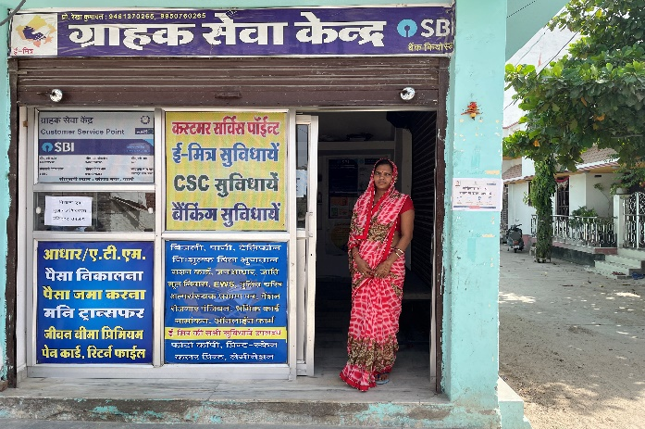

1)

Name of the beneficiary: Rekha
District: Pali
Loan obtaining Year: 2019-2020
Amount sanctioned: 80,000
Annual Income before and after loan: Before Loan: 2,00,000, after loan: 3,50,000
Livelihood earning from the project for how many Members of a family: e-Mitra service/ Computer shop, 3 members

Rekha (Age, 44), Dist, Pali belongs to OBC category. She had got the loan disbursement in 2019 under the Mahila Samriddhi Yojna through online mode. She had taken this loan for opening e-Mitra shop/ Computer shop. She is earning good income through this business. On that basis she has also purchased computers and printers , which has improved her business and social status.

2)
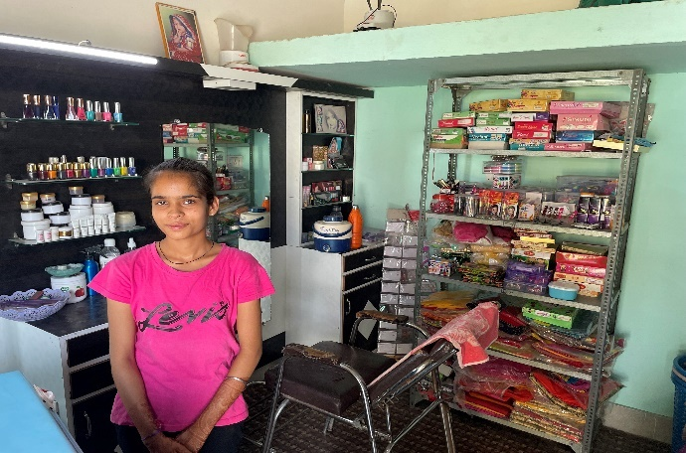

Name of the beneficiary: Rekha Mewada
District: Pali
Loan obtaining Year: 2019-2020
Amount sanctioned: 50,000
Annual Income before and after loan: Before Loan: 70,000, after loan: 1,00,000
Livelihood earning from the project for how many Members of a family: Beauty Parlour, 4 members

Rekha (Age, 42), Dist, Pali belongs to OBC category. She had got the loan disbursement in 2019 under the Mahila Samriddhi Yojna through online mode. She had taken this loan for opening up of a beauty parlor. Her daughter supports her in the business. She is earning good income through this business. On that basis she has rented items for her beauty parlour which has improved her business.

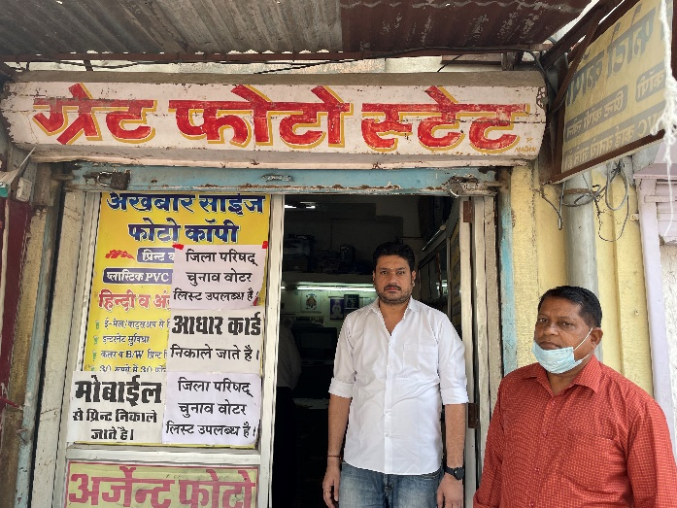

3)

Name of the beneficiary: Praveen Borana
District: Jodhpur
Loan obtaining Year: 2019-2020
Amount sanctioned: 1,00,000
Annual Income before and after loan: Before Loan: 1,00,000, after loan: 2,40,000
Livelihood earning from the project for how many Members of a family: Photocopy Shop, 4 members

Mr. Praven Borana (Age, 33), Dist., Jodhpur belongs to OBC category. He had got the loan disbursement in 2019 under term loan through online mode. He had taken this loan for opening photocopy shop. He is earning good income through this business. He has also given employmen to two people. His business has improved his social status.

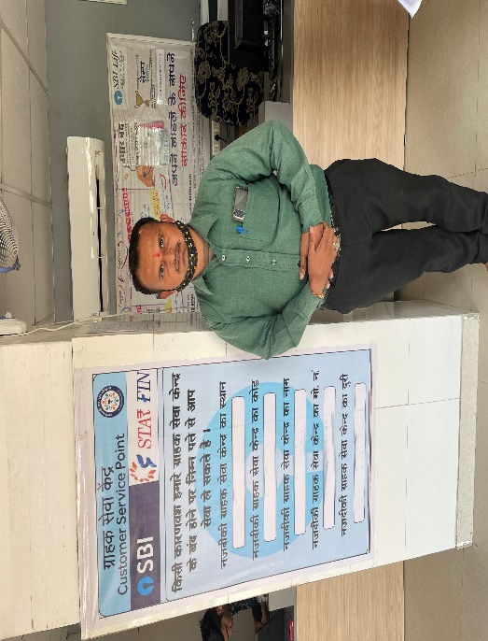

4)

Name of the beneficiary: Suresh Jahagir
District: Jodhpur
Loan obtaining Year: 2018-2019
Amount sanctioned: 60,000
Annual Income before and after loan: Before Loan: 1,50,000, after loan: 2,00,000
Livelihood earning from the project for how many Members of a family: e-Mitra service centre, 3 members

Mr. Suresh Jahangir (Age, 35), Dist., Jodhpur belongs to OBC category. He had got the loan disbursement in 2019 under micro-finance scheme through online mode. He had taken this loan for opening e-Mitra service centre. He is earning good income through this business. His business has improved his social status.

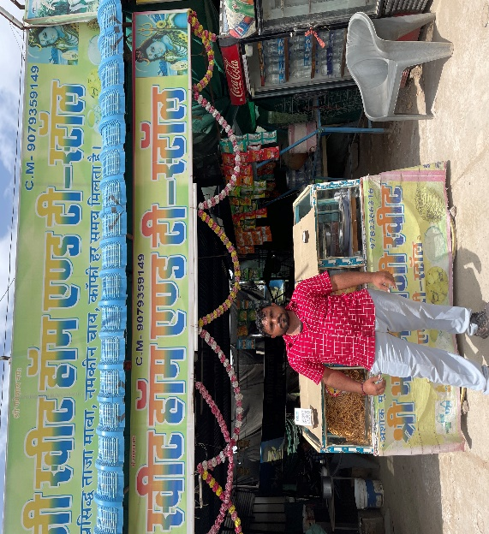
5)

Name of the beneficiary: Ashok
District: Jodhpur
Loan obtaining Year: 2019-2020
Amount sanctioned: 75,000
Annual Income before and after loan: Before Loan: 40,000 after loan: 80,000
Livelihood earning from the project for how many Members of a family: Dhabha Owner, 5 members

Mr. Ashok (Age, 31), Dist., Jodhpur belongs to OBC category. He had got the loan disbursement in 2019 under term loan through online mode. He had taken this loan for opening his own dhabha. He is earning good income through this business. From that income he has purchased a bike for himself and has also given employment to two people. His business has improved his social status.

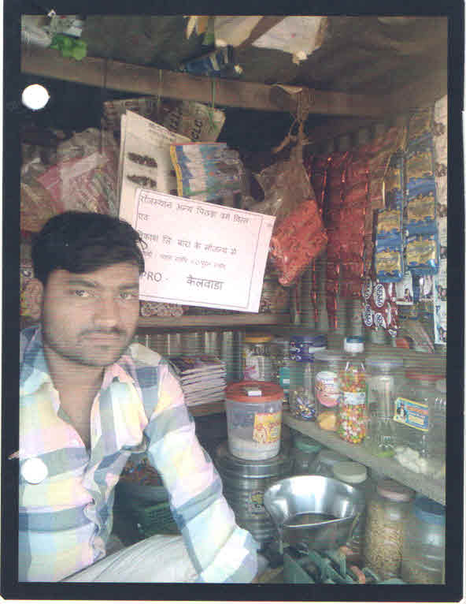
6)

Name of the beneficiary: Pawan
District: Baran
Loan obtaining Year: 2018-2019
Amount sanctioned: 50,000
Name of Project along with description:
Annual Income before and after loan: Before Loan: 25,000, after loan: 50,000
Livelihood earning from the project for how many Members of a family: General Store, 5 members

Mr. Pawan(Age, 35), Dist, Baran belongs to OBC category. He had got the loan disbursement in 2019 under the Micro Finance Scheme through offline mode. He had taken this loan for opening a general store. He is earning good income through this business. On that basis he has also purchased land, which has improved his social status.
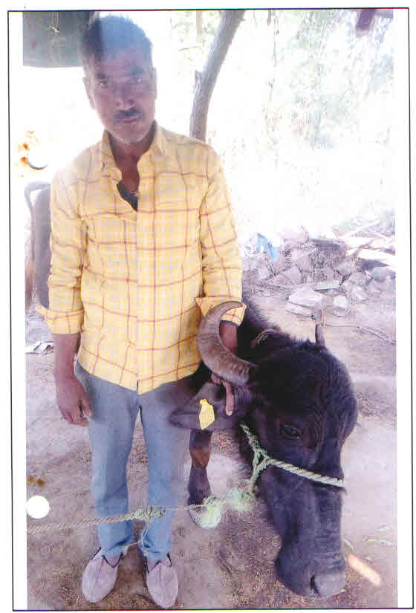

7)

Name of the beneficiary: Ramesh Chand Beragi
District: Baran
Loan obtaining Year: 2018-2019
Amount sanctioned: 40,000
Annual Income before and after loan: Before Loan: 36,000, after loan: 40,000
Livelihood earning from the project for how many Members of a family: Dairy Farming, 4 members

Mr. Ramesh Chand Beragi (Age, 55), Dist, Baran belongs to OBC category. He had got the loan disbursement in 2019 under the Micro-Finance Scheme through offline mode. He had taken this loan for Dairy Farming. He is earning good income through this business. On the basis of the loan received he has buffalo which has helped him grow his business.

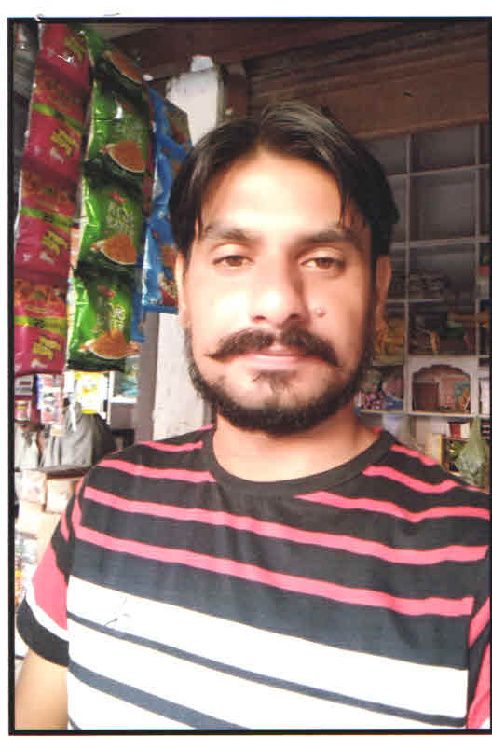
8)

Name of the beneficiary: Bhavlesh Kumar Lahkodiya
District: Karoli
Loan obtaining Year: 2018-2019
Amount sanctioned: 50,000
Annual Income before and after loan: Before Loan: 30,000, after loan: 40,000
Livelihood earning from the project for how many Members of a family: Shop, 3 members

Mr. Bhavlesh Kumar Lakhodiya (Age, 26), Dist., Karoli belongs to OBC category. He had got the loan disbursement in 2018 under the Term Loan through online mode. He had taken this loan for opening a general store. He is earning good income through this business. On the basis of the loan received he purchased items for his shop.

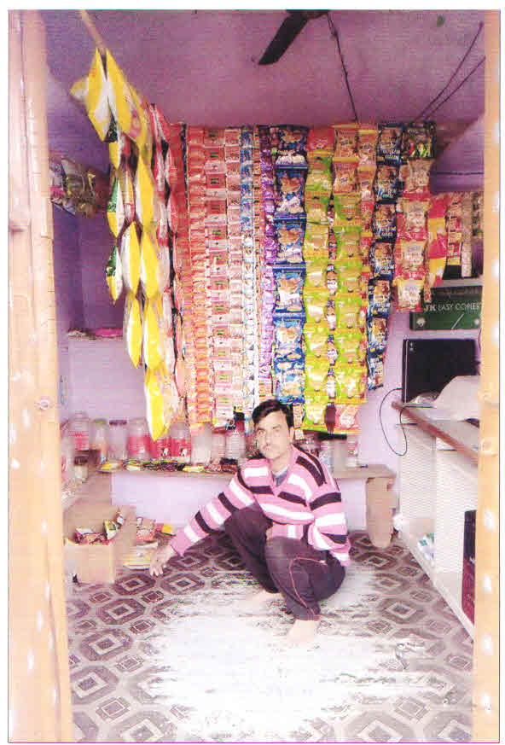

9)

Name of the beneficiary: Rahul
District: Karoli
Loan obtaining Year: 2019-2020
Amount sanctioned: 60,000
Annual Income before and after loan: Before Loan: 20,000, after loan: 40,000
Livelihood earning from the project for how many Members of a family: Grocery Store, 4 members

Mr. Rahul (Age, 28), Dist, Karoli belongs to OBC category. He had got the loan disbursement in 2019 under the Micro-Finance Scheme through online mode. He had taken this loan for opening a grocery store. He is earning good income through this business. On the basis of the loan received he has purchased goods for his store.

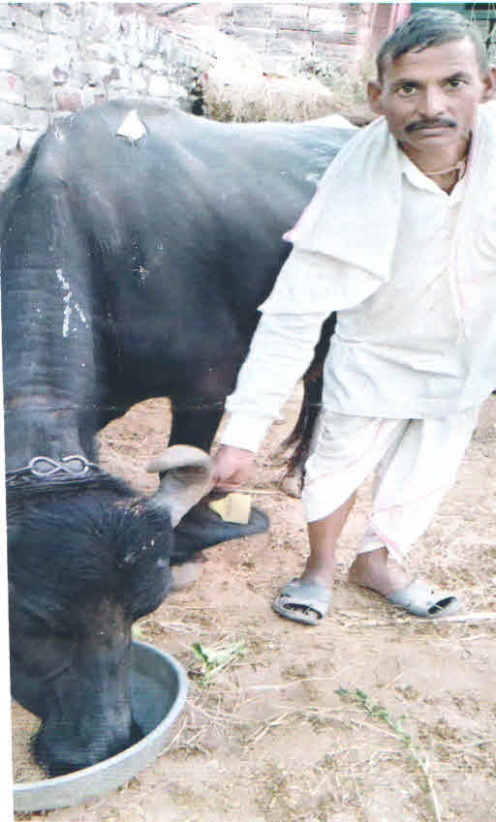

10)

Name of the beneficiary: Puran Prajapat
District: Karoli
Loan obtaining Year: 2019-2020
Amount sanctioned: 60,000
Annual Income before and after loan: Before Loan: 50,000, after loan: 80,000
Livelihood earning from the project for how many Members of a family: Dairy Farming/ Welding, 3 members

Mr. Puran Prajapat (Age, 44), Dist, Karoli belongs to OBC category. He had got the loan disbursement in 2019 under term loan through online mode. He had taken this loan for opening an extra business of selling milk. He is earning good income through this business. On the basis of the loan received he has purchased buffalo for dairy business.
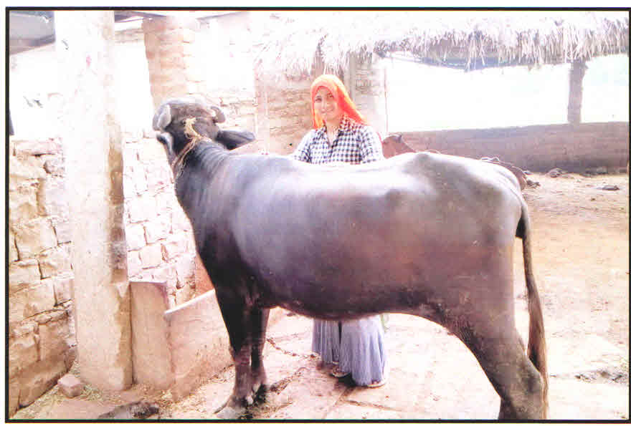

11)

Name of the beneficiary: Aarti
District: Karoli
Loan obtaining Year: 2019-2020
Amount sanctioned: 40,000
Annual Income before and after loan: Before Loan: 54000 after loan: 78000
Livelihood earning from the project for how many Members of a family: Animal Rearing, 4 members

Aarti (Age, 23), Dist, Karoli belongs to OBC category. She had got the loan disbursement in 2019 under Mahila Samriddhi Yojna through online mode. She had taken this loan for starting the business of animal rearing. Due to covid her business is slowly picking up but she has till now got good returns through this business. On the basis of the loan received she has purchased buffalo for the business.

12) .
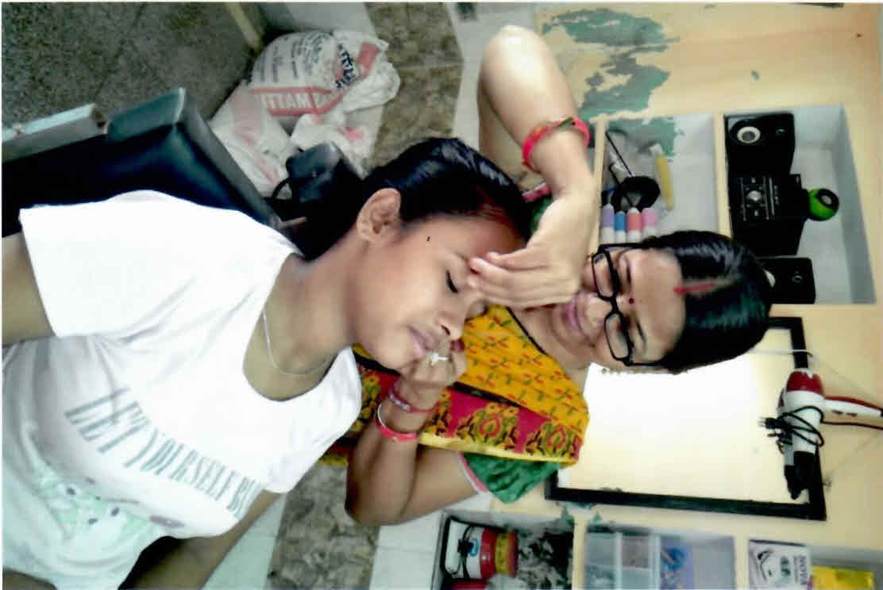

Ms. Yashoda wife of Shri Jitendra in Jodhpur opened her beauty parlour. She was a housewife. Initially there were not many clients but now most of the women of nearby areas are coming to her parlour. As result of it her annual income has gone up. This has led to improvement on her standard of living.

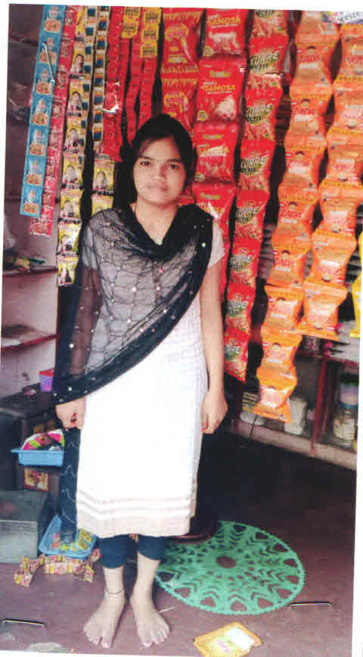
13.

Name of the beneficiary: Laxmi Devi
District: Karoli
Loan obtaining Year: 2018-2019
Amount sanctioned: 60,000
Annual Income before and after loan: Before Loan: 3,60,000, after loan: 4,80,000
Livelihood earning from the project for how many Members of a family: Grocery Store, 5 members

Laxmi Devi (Age, 32), Dist, Karoli belongs to OBC category. She had got the loan disbursement in 2018 under term loan through ofline mode. She had taken this loan for opening a grocery store. She is earning good income through this business. On the basis of the loan received he has purchased goods for his store.

14.
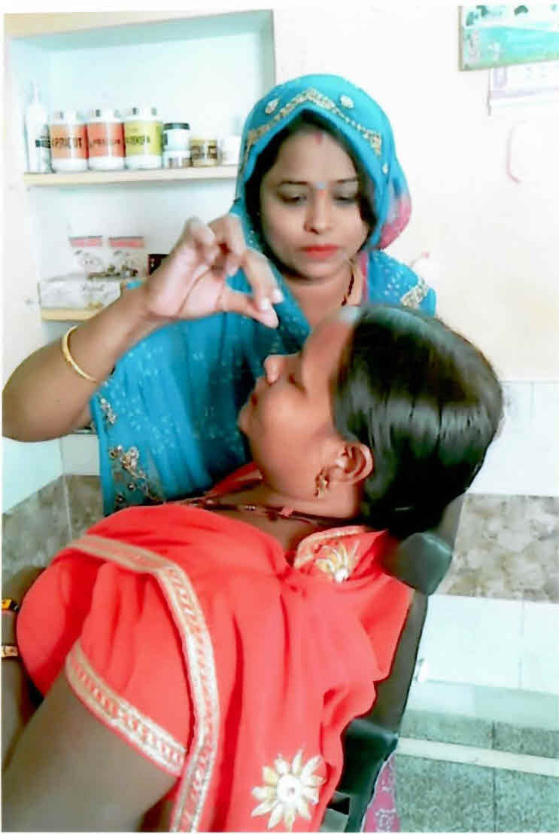

Ms. Neelam wife of Shri Prakash Jain in Jodhpur open her beauty parlour. She was a housewife. Initially there were not many clients but now most of the women of nearby areas are coming to her parlour. As result of it her annual income has gone up. This has led to improvement on her standard of living.

15.
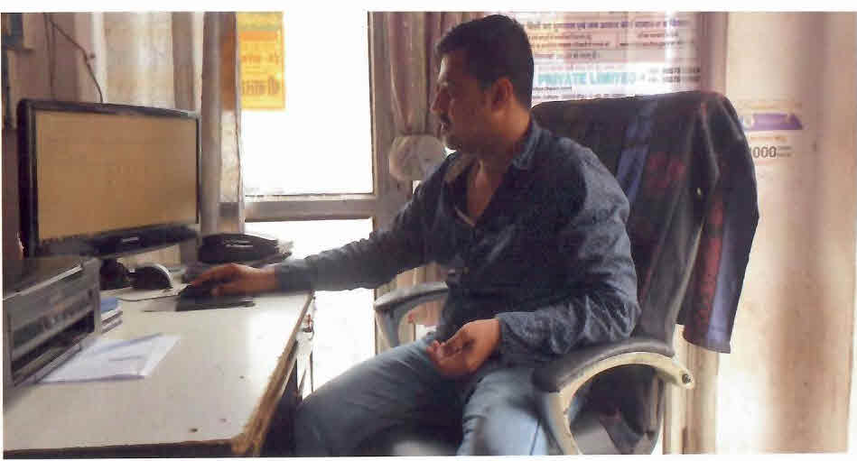

Shri Mohi Tanwar in Jodhpur opened his computer shop. He offers several services to villagers such as taking print out of documents, download and uploading any job application form of the ward of the villages, helping the villagers in surfing important information over Google about different matters in making their aadhar card, paying their electricity and other bills etc.

16.

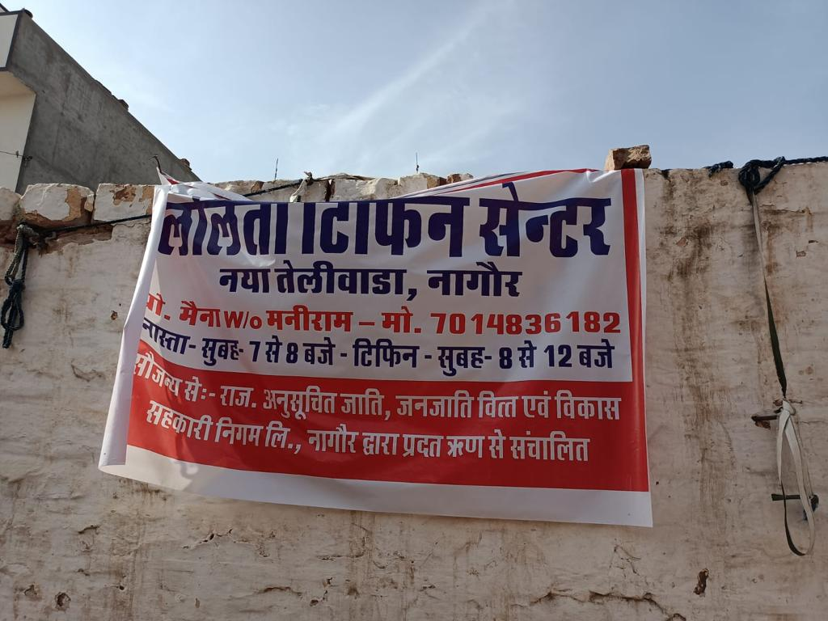

Ms. Lalita Devi wife of Maniram residing in Nagore district of Rajasthan started Lalita Tiffin Center in New Teliwara area of Nagore. This service is available 7 a.m. to 8 a.m. for breakfast in morning and 8 a.m. to 12 noon for lunch. Villagers are getting benefit of this tiffin service. It has enhanced confidence of Ms. Lalita along with enhancing her standard of living and annual family income.

17.
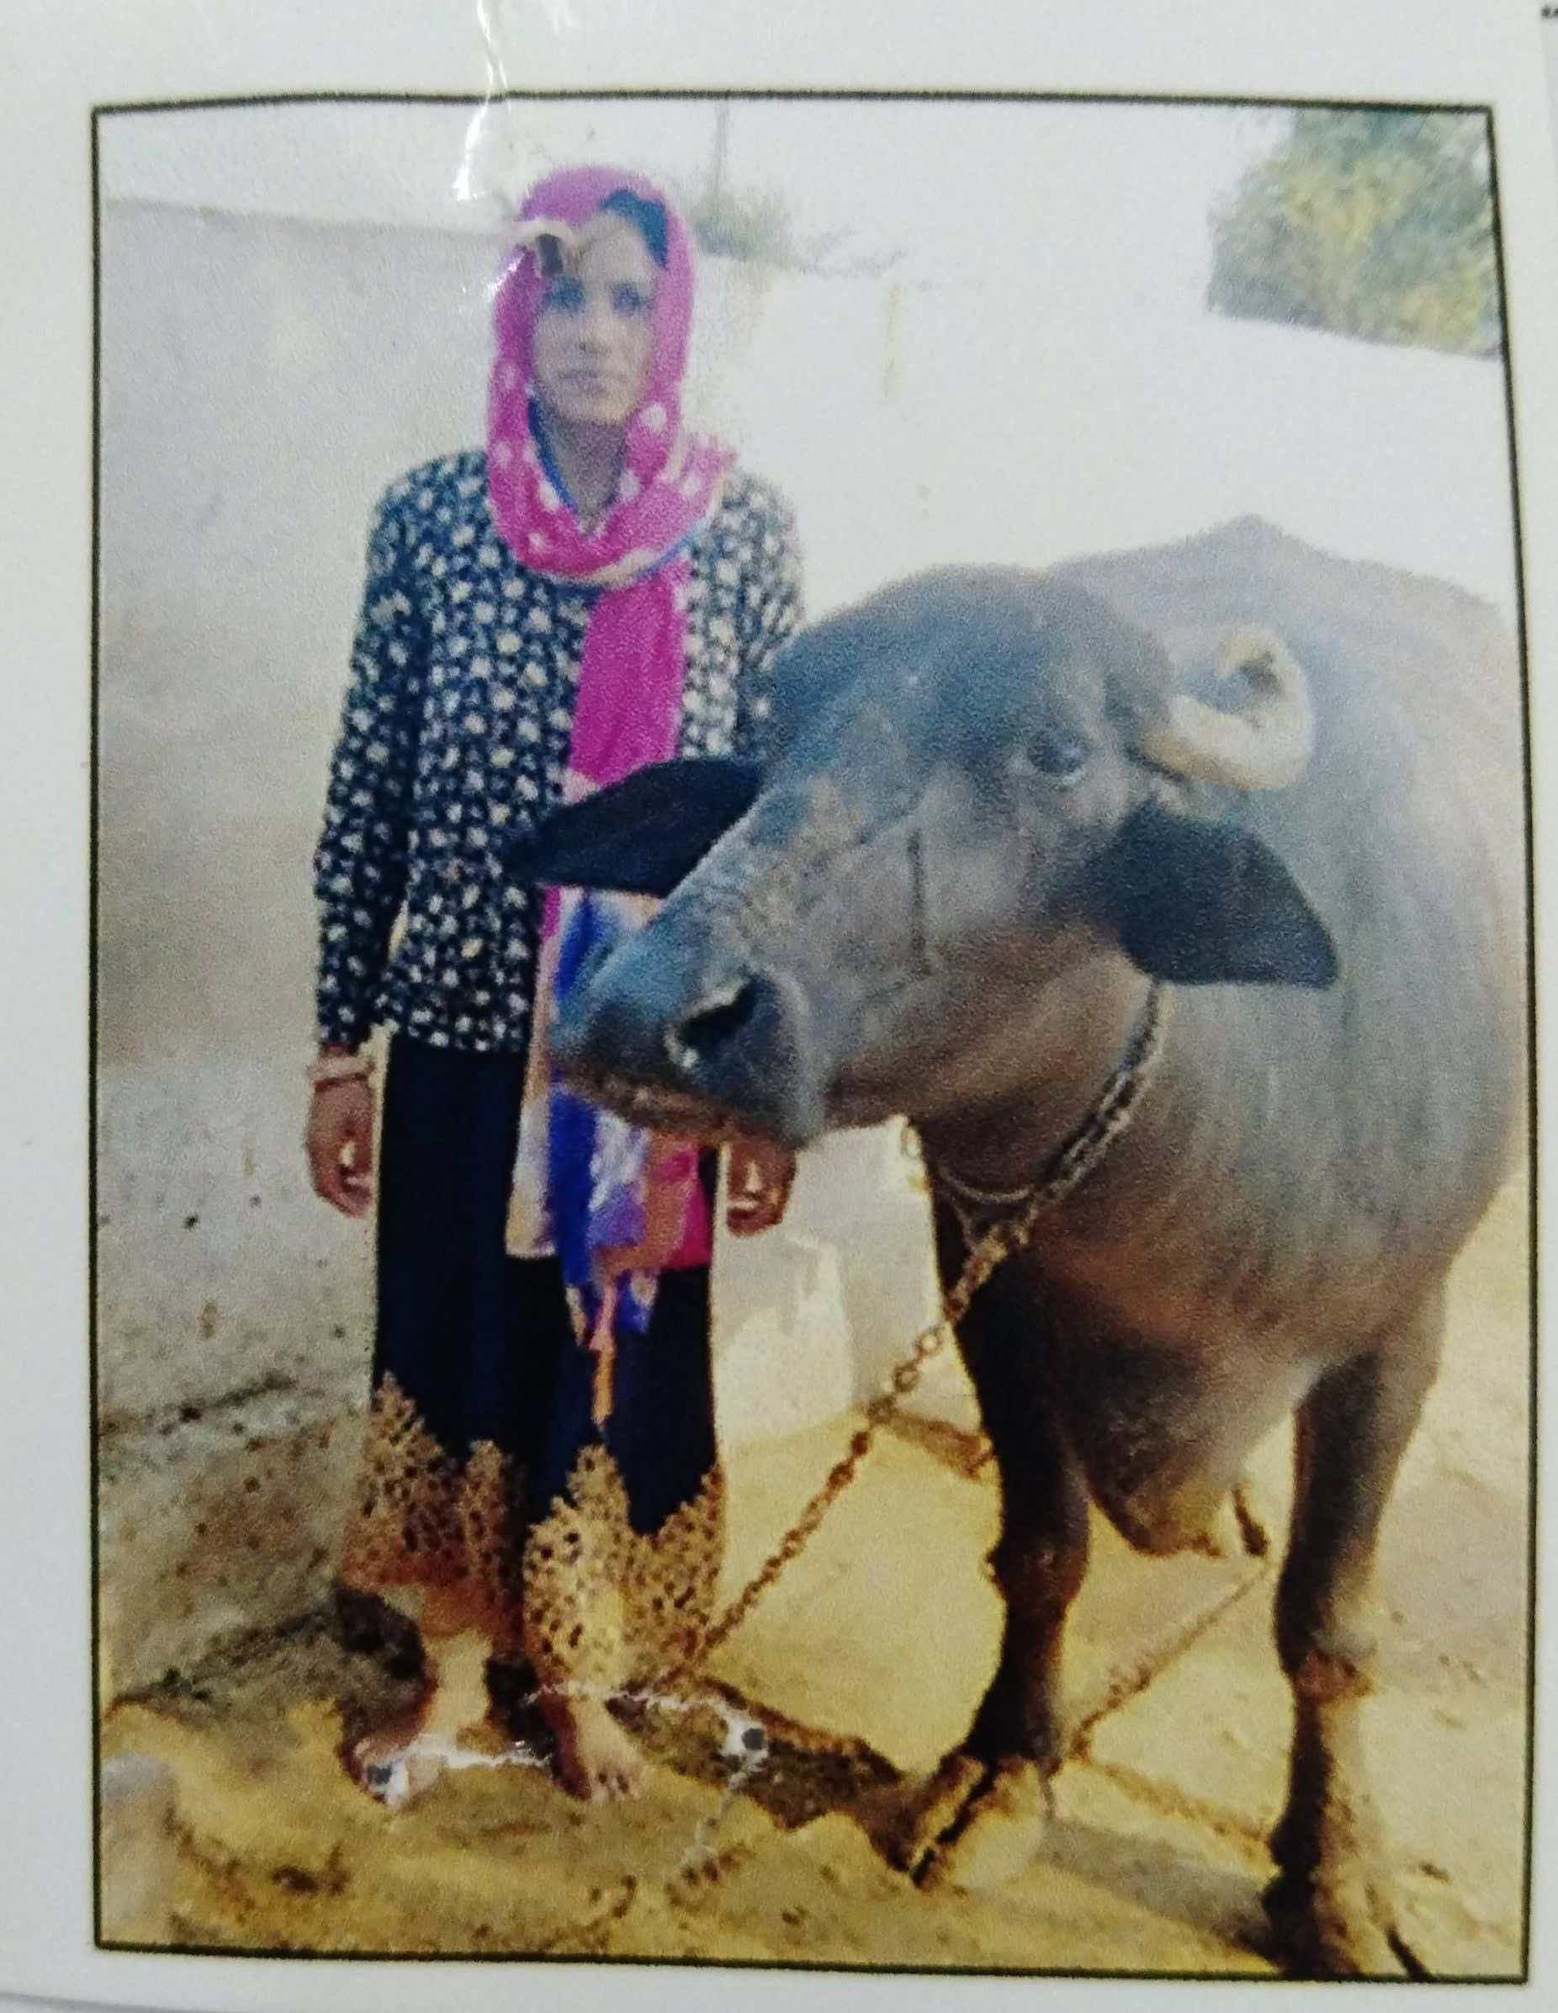

Smt. Sapna Kumari Jat daughter of Shri Radeshyam resides in district Karoli. She has purchased buffalo out of the loan taken from NBCFDC. Before taking loan her annual income was 20,000/- After taking loan her annual income increased to Rs. 40,000. Now she is able to meet her household expenses with the increased income. Her family members are satisfied with her work.

18.
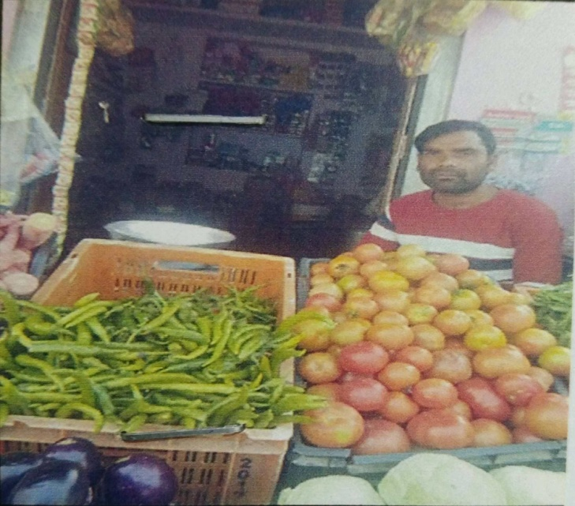

Shri Dhuji Ram Jat S/o Shri Uday Singh Jat resides in district Karoli. He opened parchoon shop out of the loan taken from NBCFDC. Before taking loan his annual income was 20,000/-. After taking loan his annual income increased to 40,000/- Now he is able to meet his household expenses with the increased income. his family members are satisfied with her work.

19.
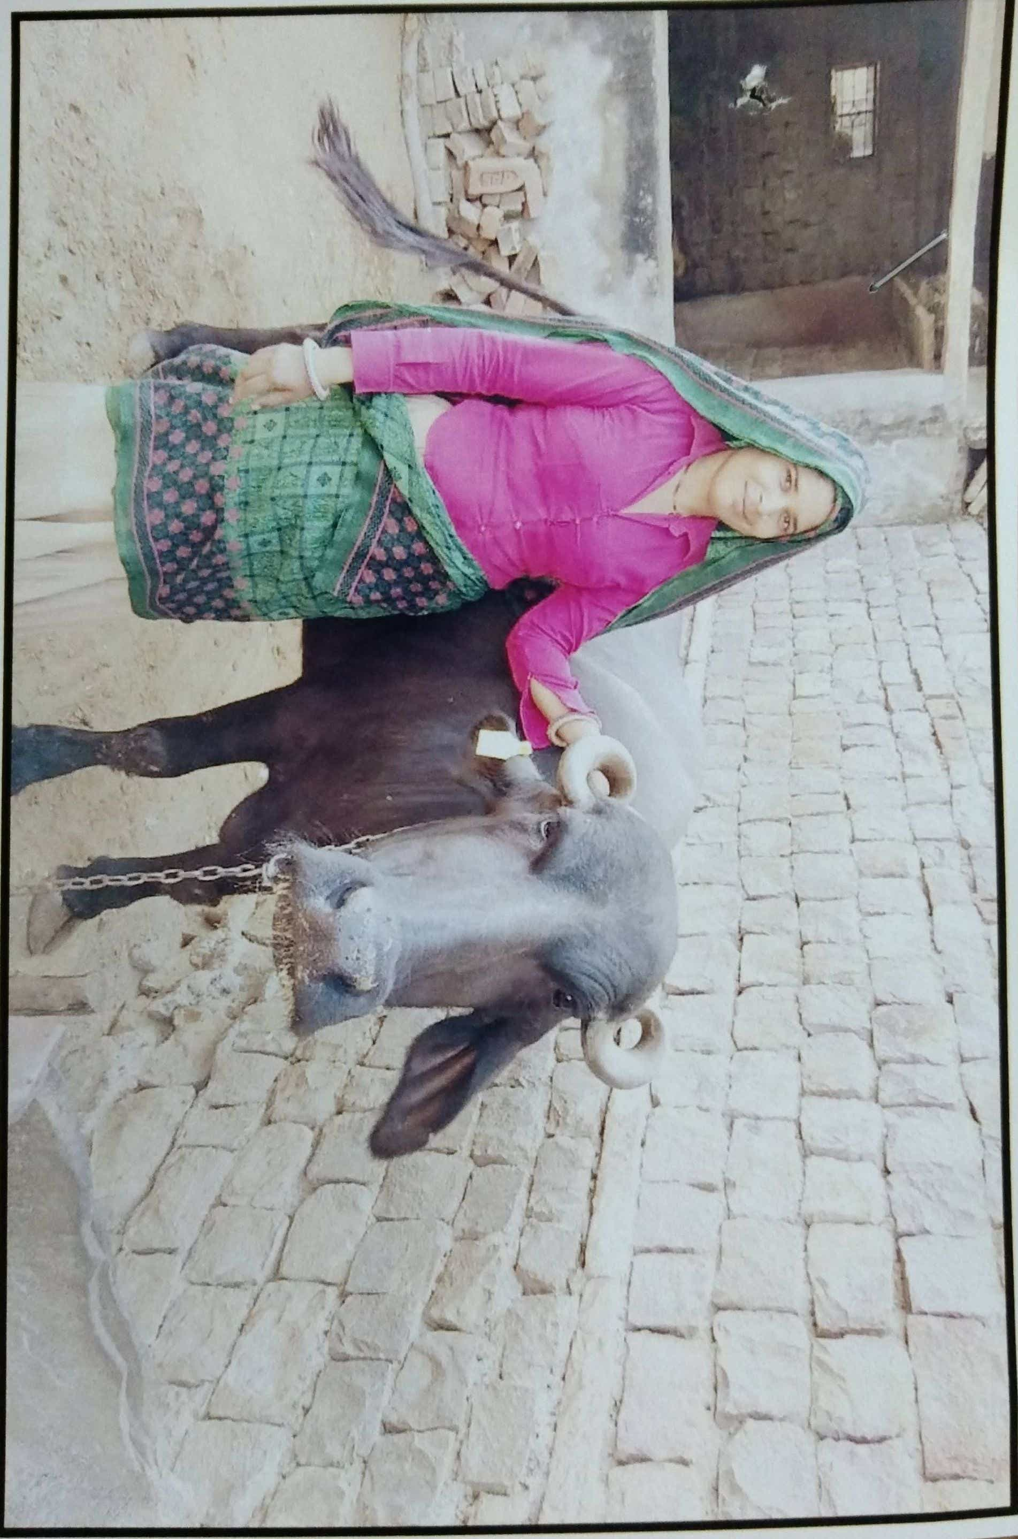
Smt. Saroj wife Shri Ajeet Singh Gurjar resides in district Karoli. She has purchased buffalo out of the loan taken from NBCFDC. Before taking loan her annual income was 48,000/- After taking loan her annual income increased to Rs. 60,000/-. Now she is able to meet her household expenses with the increased income. Her family members are satisfied with her work.

20.

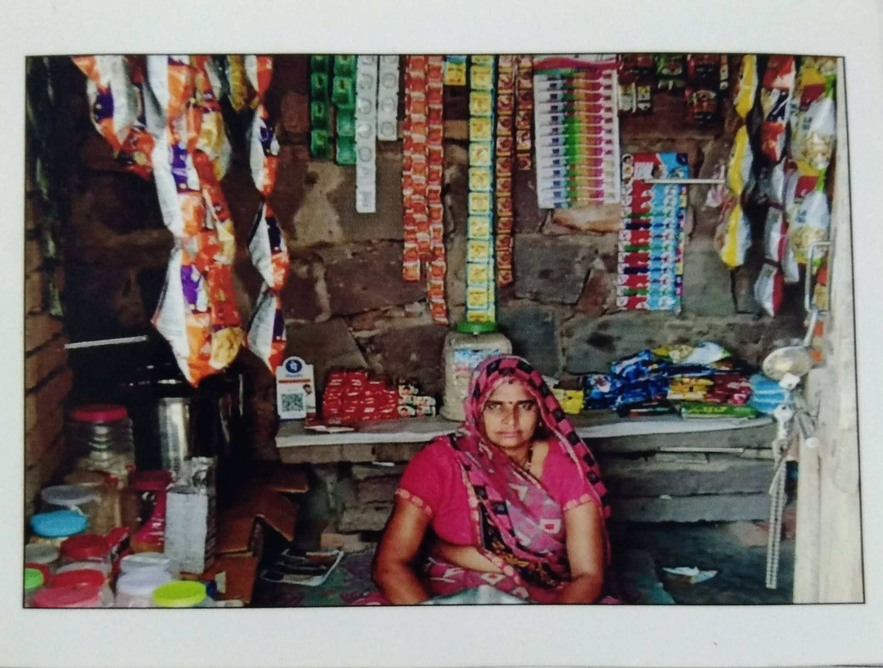

Smt. Hema Jangid wife of Shri Raju Jangid resides in district Karoli. She opened parchoon shop out of the loan taken from NBCFDC. Before taking loan she was labourer and her annual income was Rs.30,000/-. After taking loan her annual income increased to 40,000/- Now she is able to meet his household expenses with the increased income. Her family members are satisfied with her work.

21.
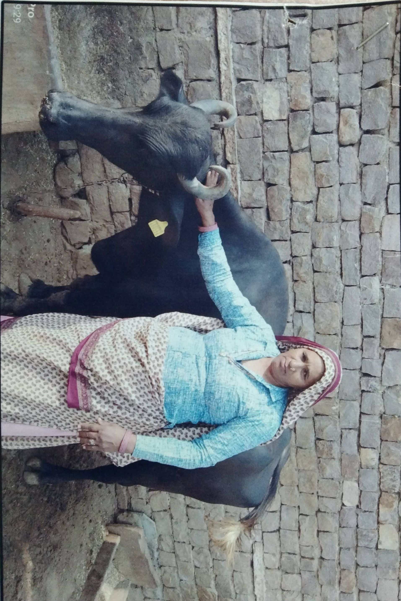
Smt. Sapna wife of Shri Ajad Singh resides in district Karoli. She has purchased buffalo out of the loan taken from NBCFDC. Before taking loan her annual income was 42,000/- After taking loan her annual income increased to Rs. 72,000/-. Now she is able to meet her household expenses with the increased income. Her family members are satisfied with her work.

22.

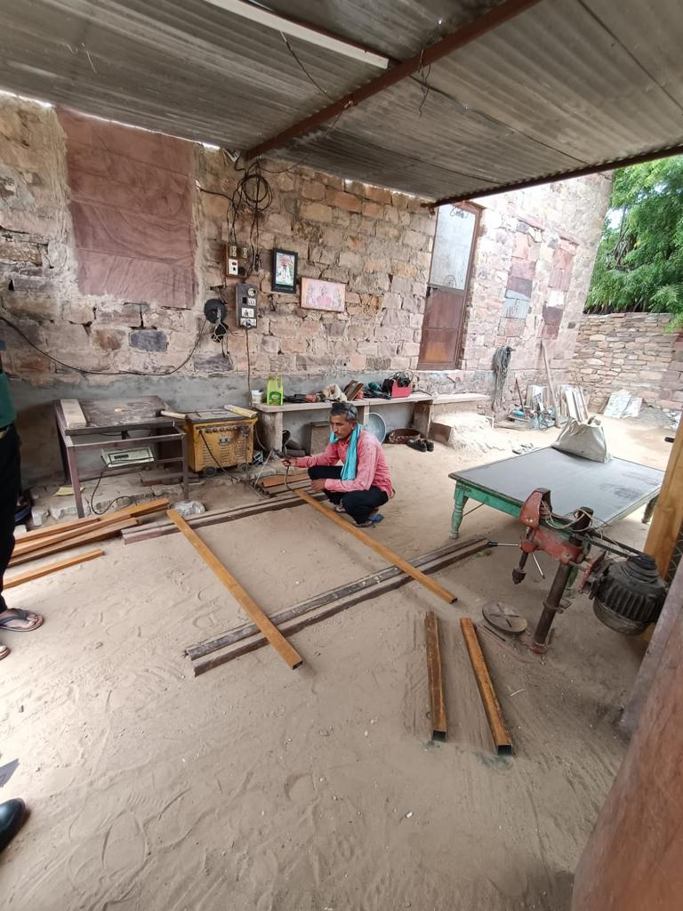

Sh. Mohit Tanwar from Jodhpur started his shop for carpentry work. Initially he was not aware about the loan scheme. His friend told him about the loan which can be taken up for starting one;’s own work from the NBCFDC. He took the look which helped him in purchasing the goods for his shop. After three months of opening his shop , his income level has gone up and he is able to lead a decent life. He is also able to meet the day to day expenses of his family which was a difficult task before starting this work.

23.
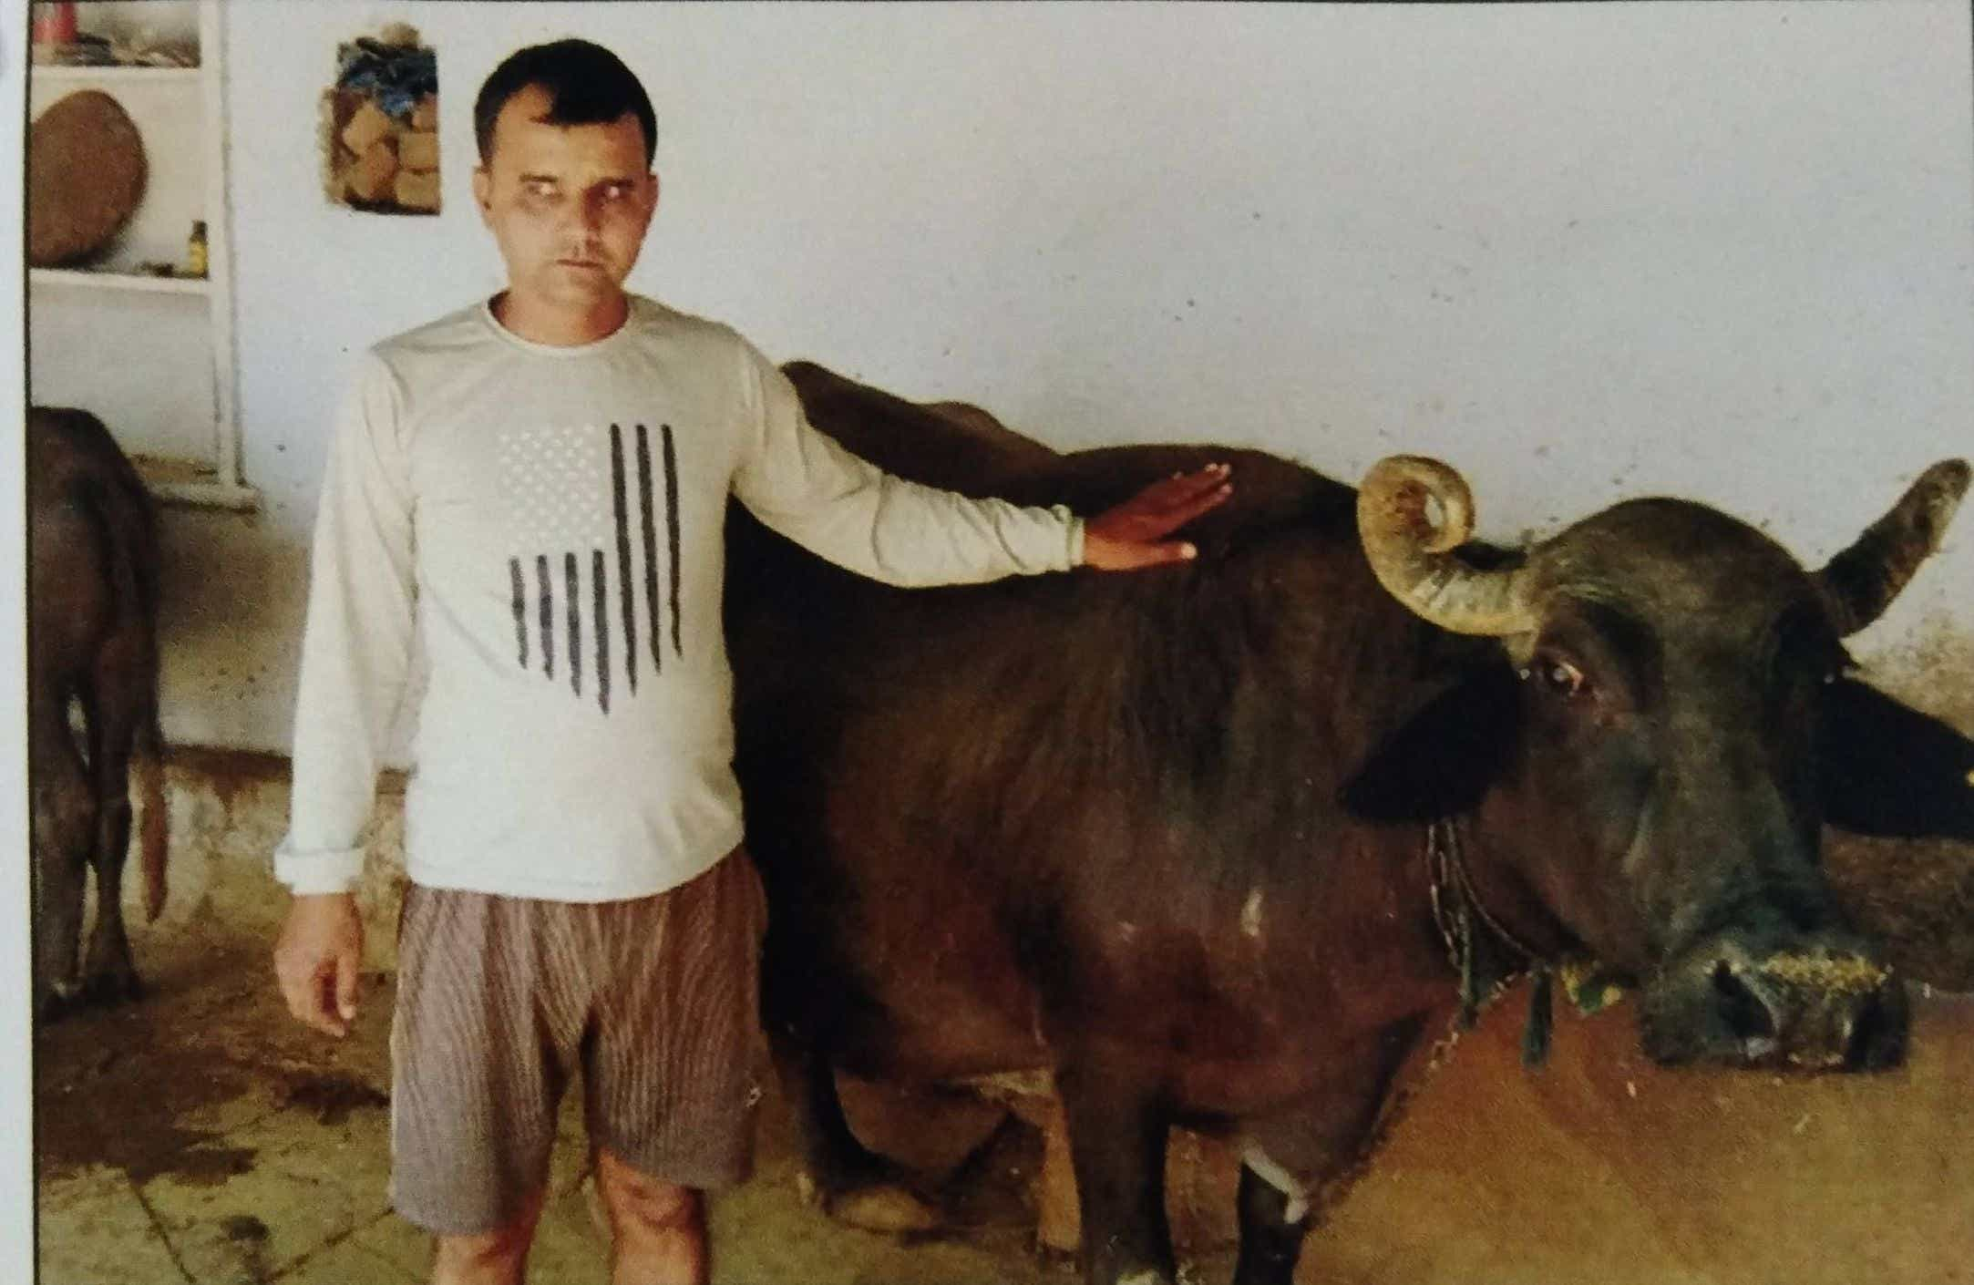

Shri Shive Kumar S/o Uday Singh resides in district Karoli. He purchased buffalo out of the loan taken from NBCFDC. Before taking loan he was unemployed. After taking loan his annual income increased to Rs. 50,000/-. Now he is able to meet his household expenses with the increased income. His family members are satisfied with her work.

24.
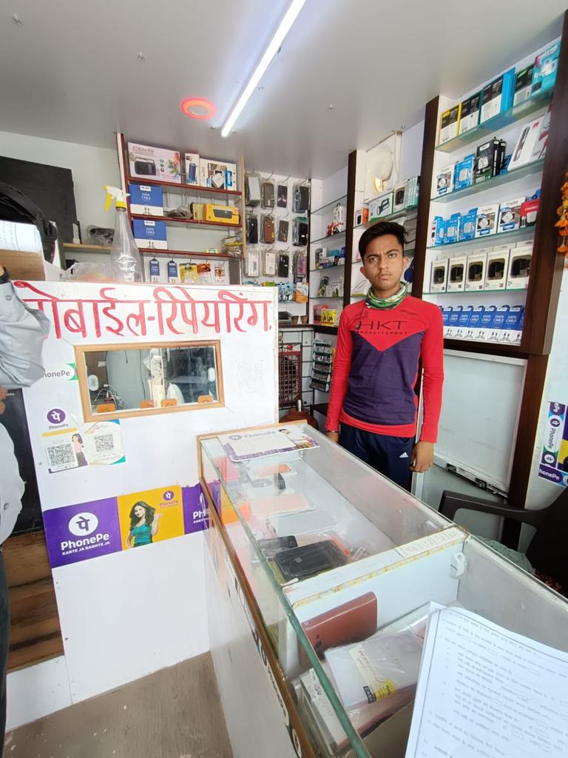

25.
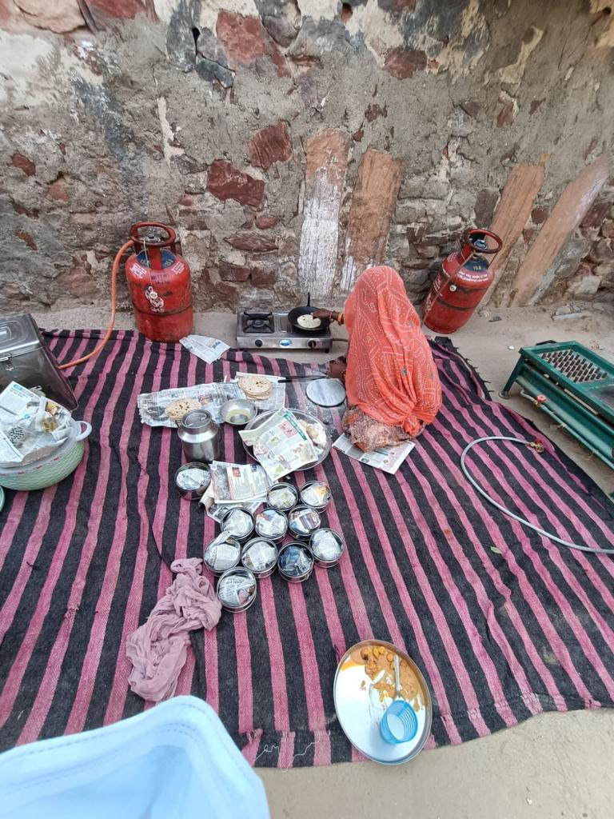

Sh Ashok in Jodhpur provides food services in the form of Dhaba to the villagers . He was unemployed before taking loan. After taking loan his income increased to Rs 80,000 per annum. He is satisfied with his gainful employment. He lives in a rental house. He is married and has 5 members in his family.

26

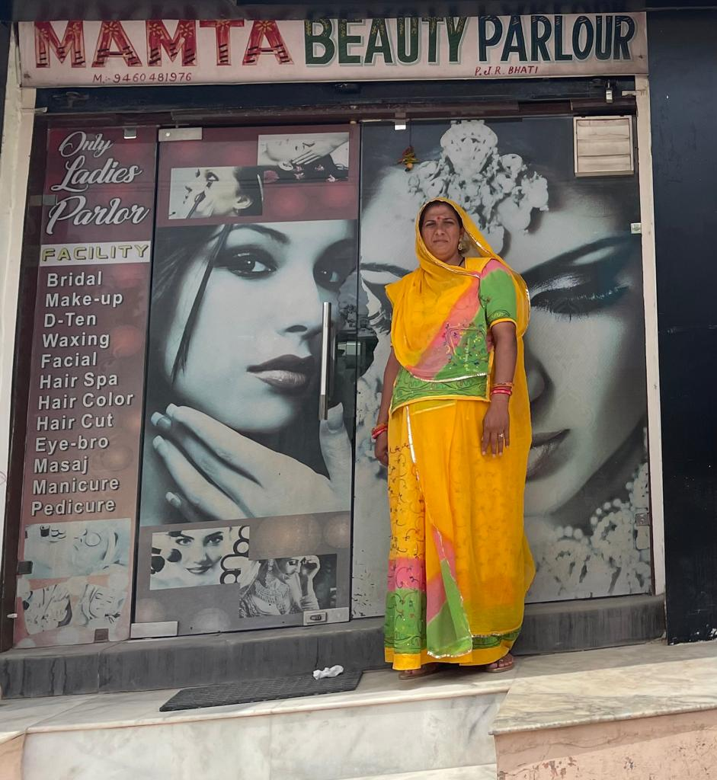

Smt Mamta Devi opened her beauty parlour. She was a housewife. Initially there were not many clients but now most of the women of nearby areas are coming to her parlour. As result of it her annual income has gone up. This has led to improvement on her standard of living.

27

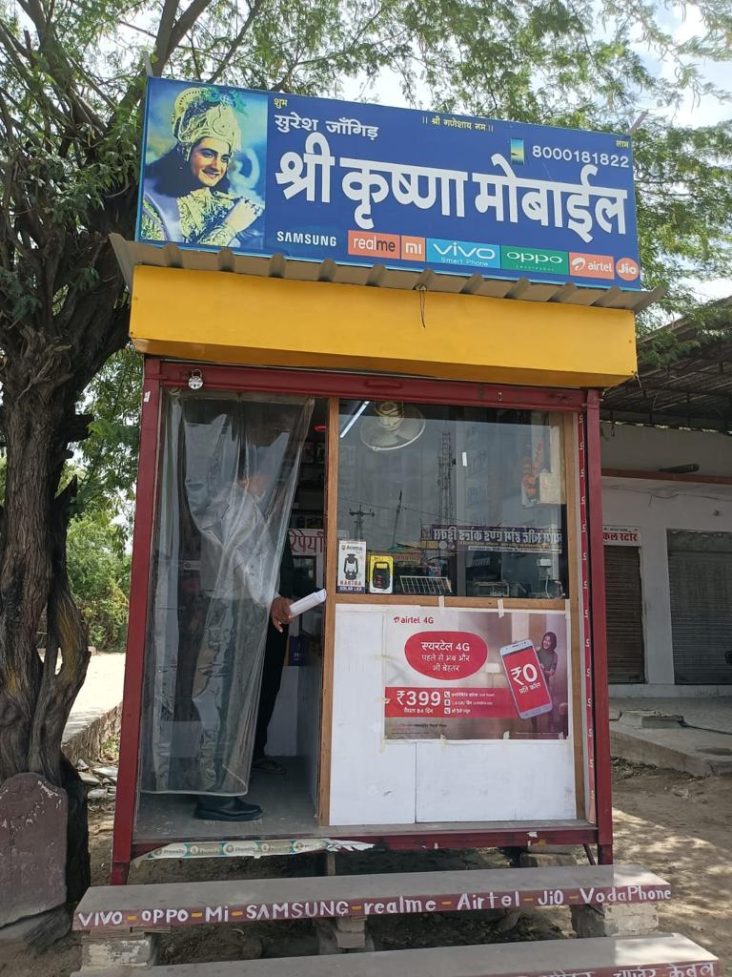

Sh Prakash Lakhra son of Sh Pukhrak Lakhra from Pali district started his own mobile repairing and accessories shop. He is a Post Graduate. His annual income before availaing loan was Rs 80,000. After availing loan his annual income increase to 160,000 Rs. He is happy with his work.
His family is also satisfied with the increase is income level.

28.

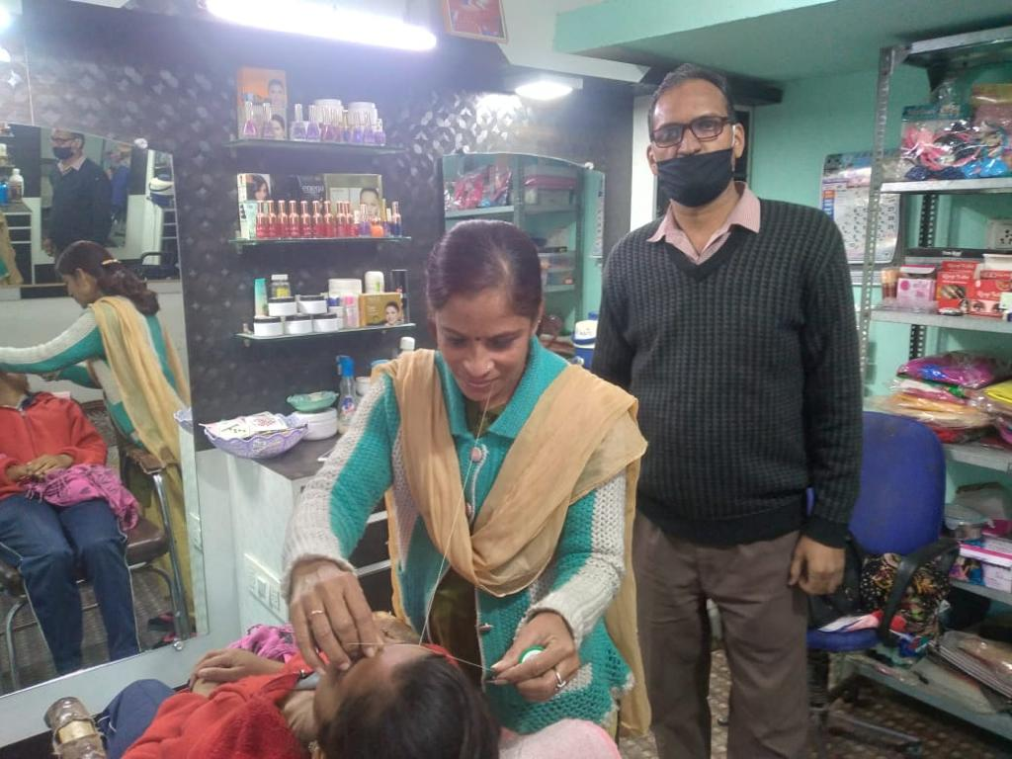

Ms Anjali daughter of h. Parmanand satiya resides in district Pali. She renovated her own Beauty Parlor shop.Her annual income was 180,000 before taking loan. After taking loan, her annual income increased to Rs 350,000. She is highly satisfied with the jump in her income.

29.

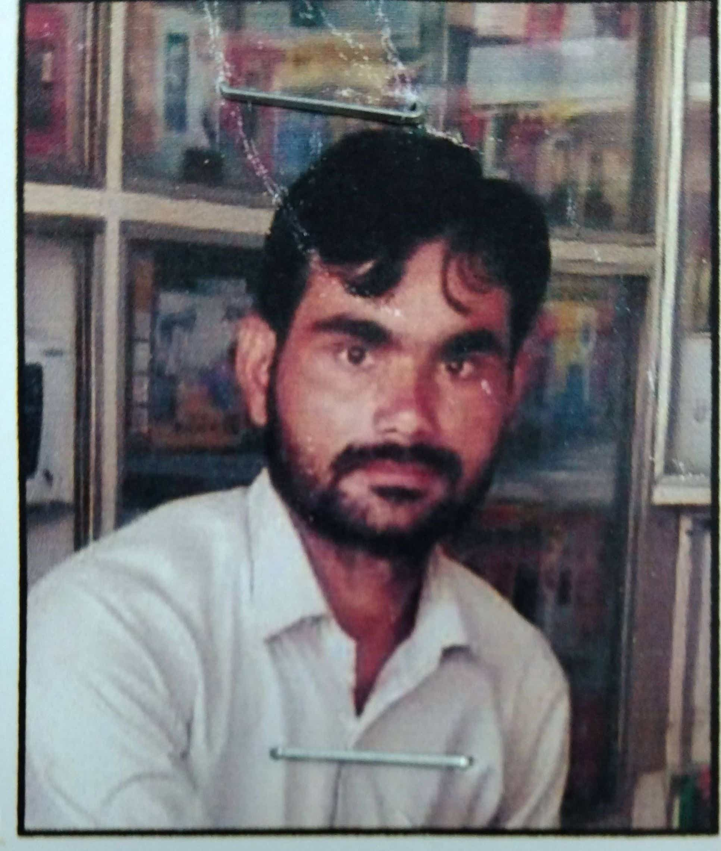

Shri Kuldeep Singh Dagur S/o Shri Bhagat Singh Dagur resides in district Karoli. He opened Mobile shop out of the loan taken from NBCFDC. Before taking loan he was unemployed. After taking loan his annual income increased to 40,000/- Now he is able to meet his household expenses with the increased income. His family members are satisfied with her work.

30.

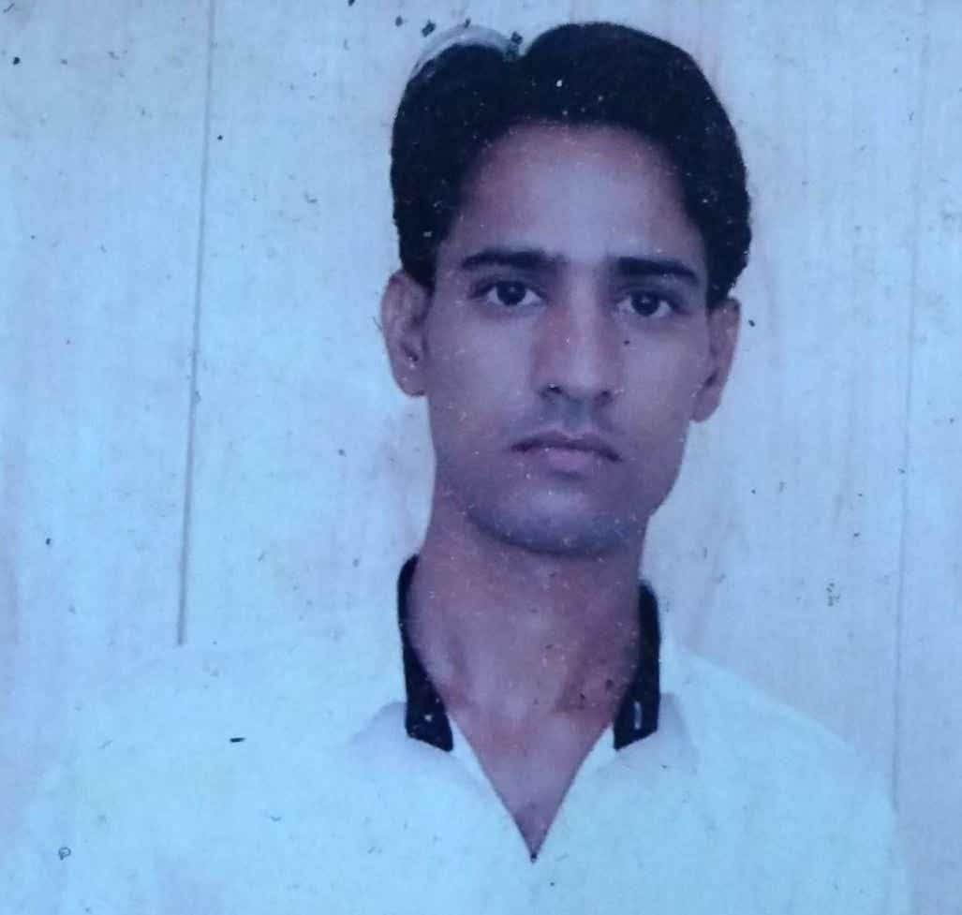

Shri Ramzan Gauri resides in district Nagore. He opened E-mitra centre out of the loan taken from NBCFDC. Before taking loan his annual income was Rs. 50,000/-. After taking loan his annual income increased to Rs. 60,000/- Now he is able to meet his household expenses with the increased income. His family members are satisfied with her work. He owns his own house.

ANNEXURES
QUESTIONNAIRE
Dr. Ambedkar Chair in Social Justice
INDIAN INSTITUE OF PUBLIC ADMINISTRATION

This Questionnaire has been requested to be filled by Beneficiaries of NBCFDC for the purpose of a Research Project. All the information will be used only for research purposes and will be kept confidential.

I. SOCIO - ECONOMIC INFORMATION

- Name of the Beneficiary :___________________________________________
- District :___________________________________________
- Gender : Male Female Others
- Age (in years) : 20-30 31-40 41-50 51-60
- Educational Status : Illiterate or only able to sign
Upto 8th Passed Upto 10th Passed
Upto 12th Passed Diploma Graduate
Post Graduate & Others
- Place : Rural Urban
- Type of Residence : Own House Rental House
- Marital status: Married Unmarried Widow Divorced Separated
- Occupation: _______________________________
- Nature of the family: Joint Nuclear
- Size of the family : Upto 3 members 4-5 members More than 5 Members

Q. No. | Particulars | Before Loan | After Loan
12. | Occupation
13. | Annual Family Income (In Rs.)
14. | Personal Assets
15. | Monthly Expenditure of your House hold
16. (A) | Any other loan (apart from NBCFDC)  (Please mark YES / No)
16. (B) | If yes in point 16 (A), (Please specify)

17. Do you have Aadhar Card: Yes No

- What type of assets did you purchase after getting the loan? :_______________________

- What type of Bank account do you have?
Jan Dhan Account Saving Bank Account

II. SCHEME RELATED INFORMATION
S.no | Particulars | Response
Name of the scheme in which Loan is availed
(General Term Loan/ Micro Finance Scheme / Mahila Samriddhi Yojna)
 | Please specify the nature of “sector” for which assistance is availed. (Agriculture and allied / Small business/ Transport Sector/ Service sector / Education)
How did you come to know about the NBCFDC current scheme?
(Advertisement /Family / Friends/Relatives/ From SCA officials/ Website / Other Beneficiary / if Others: Please Specify)
Are you aware of other schemes of the NBCFDC?
Yes/ No (If yes, please name the scheme)
 | Are you aware of maximum amount of loan sanctioned along with its interest rate to be paid under the NBCFDC scheme? (Yes / No)
 | Did you face any difficulties in getting Loan (yes / no)
 | If yes previous question, please specify

8. Did you received any skill training during last six months: Yes No
9. If yes, training received for which skill and from where:_______________________

10. Average time taken to obtain the loan from SCA after the date of application:
Up to 4 months 4-6 months more than 6 months

- Purpose of loan (Give Name of the Sanctioned Activity) …............................
- Have you utilized the loan for the intended purpose: Yes No
- If No, where utilized: ..………………………………………………………………………..
- Status of loan repayment: Regular Irregular Defaulter
- If Irregular or Defaulter (please specify the reason:
Failure of Business Diversion of Savings Loss of Asset Others
- Have you given employment to others?” Yes No
If yes, to how many persons (please specify the numbers):
- Sufficiency of loan amount: Yes No
If No, expected loan amount_________________

12. How did SCA disburse loans: Online Offline

13. Economic Status after receiving the loan: Less than 3.00 Lac p.a. More than 3.00 Lac p.a.

14. Feedback from the Beneficiary.

- BEST PRACTICES OF SCA (if any):_______________________________________________________

- WEAKNESS OF SCA (if any): ____________________________________________________________

- SUGGESTIONS/RECOMMENDATIONS (if any):________________________________________

SATISFACTION LEVEL WITH SCA & SOCIO - ECONOMIC IMPACT
Listed below are statements of various aspects regarding State Channelizing Agent (SCA) of NBCFDC. Please indicate the extent to which you are satisfied with each statement by ticking (√) a number that reflects your rating using a scale where 1 = highly dissatisfied , 2 = dissatisfied , 3 = neither satisfied nor dissatisfied , 4 = satisfied, 5 = highly satisfied.

S. No. | Statement | 1 | 2 | 3 | 4 | 5
 | Loan scheme
 | Assistance and guidance provided by SCA
 | Interest Rates
 | Loan sanctioning/ Disbursement system
 | Behavior of the employees during the lending process
 | Size of monthly installments
 | Repayment period
 | Time Taken for loan approval
 | Easy Query Handling
 | Overall services

Impact of NBCFDC schemes on the lives of beneficiaries:

Please rate by ticking ( √) a number Please note: where 1= Notable Decrease, 2= Moderate Decrease, 3 =Unchanged, 4= Moderate Increase, 5= Notable Increase

S. No. | Statement | 1 | 2 | 3 | 4 | 5
 | Better education of the Children
 | Better housing
 | Change in social and financial status
 | Better access to the health facilities
 | Economic Impact
 | Better access of financial resources/ standard of living
 | Asset creation

