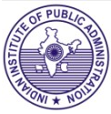

BOOK ALERT
(New Arrivals-Books)

(November- December, 2025)

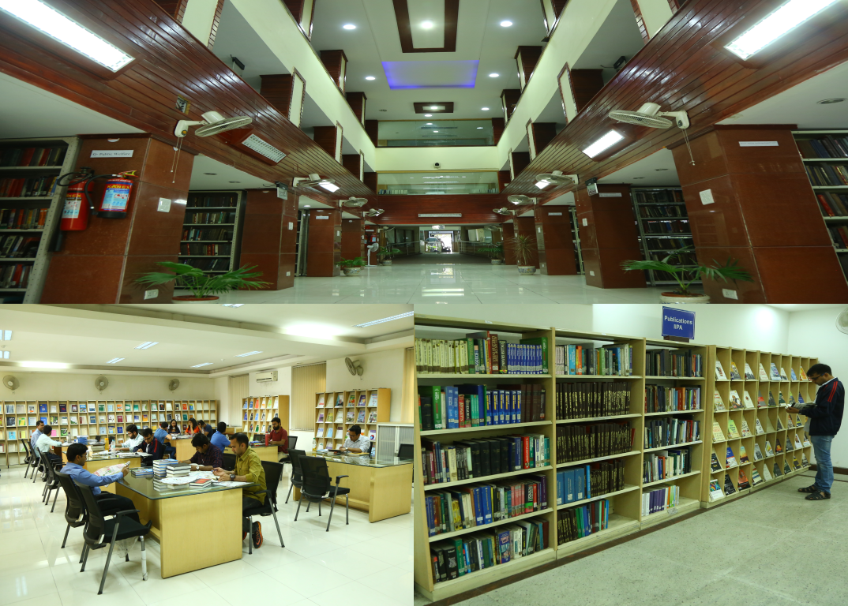

.

Library
Indian Institute of Public Administration
New Delhi

Book Alert is a monthly service offered by

the Library, Indian Institute of Public

Administration. It contains bibliographical

details of latest books added to the library

during the period.

COMPILED BY

SUNITA GAUTAM

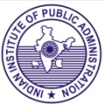

Indian Institute of Public Administration,
I.P. Estate, Ring Road, New Delhi-110002

1.
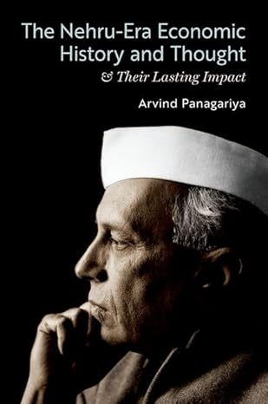

The Nehru-era economic history and thought & their lasting impact

Author: Arvind Panagariya
Publisher: New York: OUP, 2024 Description: 334p.
Accession no. 89441

The Nehru-Era Economic History and Thought & Their Lasting Impact examines the evolution of Nehru's economic philosophy with socialism, self-sufficiency, and heavy-industry development at its core. Through extensive archival research, Arvind Panagariya reconstructs and reinterprets this history, paying particular attention to the administrative processes deployed to implement policies, contemporary economic thought, and important historical events not adequately covered in the existing literature.

2.
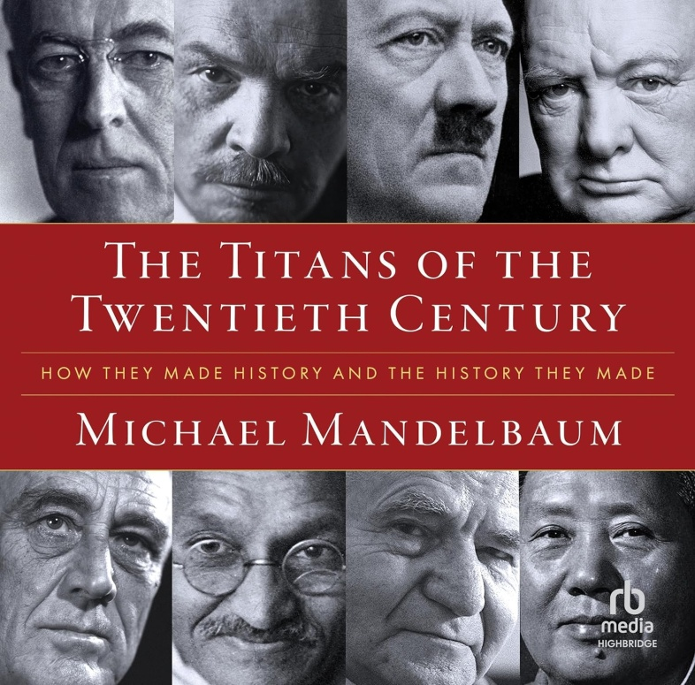

Titans of the twentieth century : how they made history and the history they made

Author: Michael Mandelbaum.
Publisher: New York: OUP, 2024 Description: 338p.
Accession no. 89442

The Titans of the Twentieth Century addresses an age-old question: what is the impact of individuals on history? The first half of the twentieth century offered political leaders enormous scope for changing the world. This book consists of essays about eight who, for better and for worse, did just that.
Individually, each chapter offers fresh and often surprising portraits of the twentieth century's titans. Collectively, the essays present a vivid and revealing portrait of a turbulent half-century that shaped the world of today.

3.
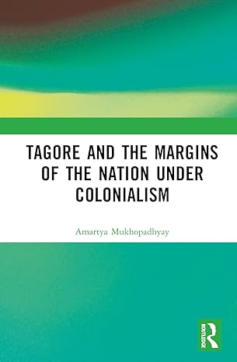

Tagore and the margins of the nation under colonialism

Author: Michael Mandelbaum.
Publisher: New York: OUP, 2024 Description: 206p.
Accession no. 89442

This book focuses on India’s anti-colonial politics which Rabindranath Tagore (1861–1941) brought into the mainstream of nationalist thinking. It browses through the entire corpus of Tagore’s writings in the genres of poetry, fiction, and essays, to glean both used and hitherto unused/un-translated writings that illumine Tagore’s gender consciousness and (proto)feminist thought and empathy, presenting it in a wholly new light.

4.
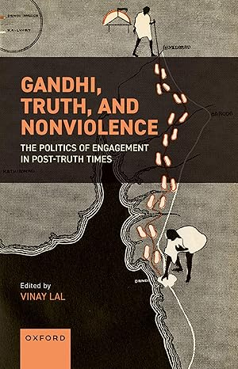

Gandhi, truth, violence and nonviolence

Author: Vinay Lal
Publisher: New York: OUP, 2025 Description: 346p.
Accession no. 89444

The essays delve into Gandhi's comprehensive dissection of political logic, his concept of neighbourly political bonds, his fearlessness and adeptness as a yogi.
The work also discusses the worldwide landscape of nonviolence, Gandhi's perspectives on Palestine, his legal work in South Africa, his dialogues with Tagore, the pursuit of his ethical goals, and the portrayal of his persona, as well as the ongoing relevance of his nonviolent resistance methods, as seen in India's anti-Citizenship Amendment Act protests.

5.
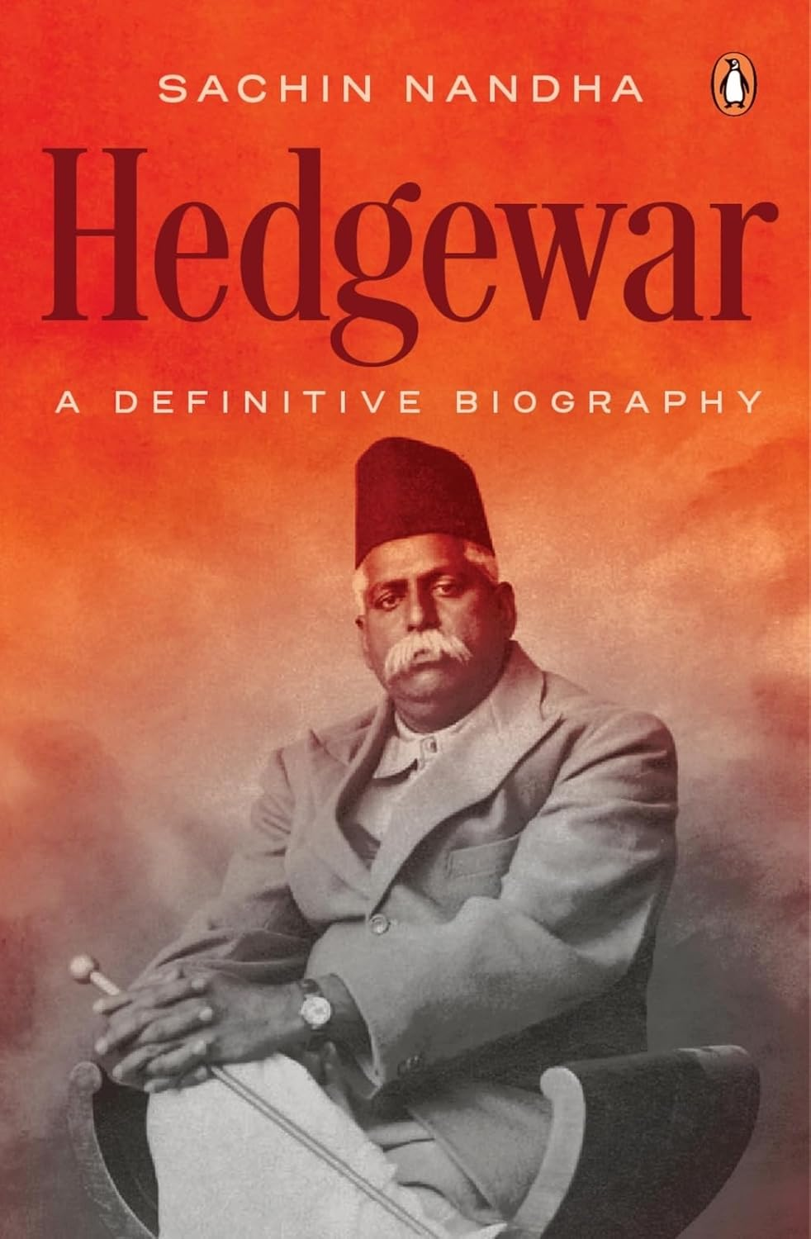

Hedgewar: a definitive biography

Author : Sachin Nandha
Publisher: Gurugram: Penguin, 2025
Description: 401p.
Accession no.: 89445

More than a biography, this work is a window into the labyrinth of India’s civilizational ethos, offering a nuanced perspective on the RSS’s origins and its impact on India today.
Hedgewar: A Definitive Biography is a must-read for those seeking to understand modern India’s complexities through the life of one controversial, yet extraordinary man.

6.
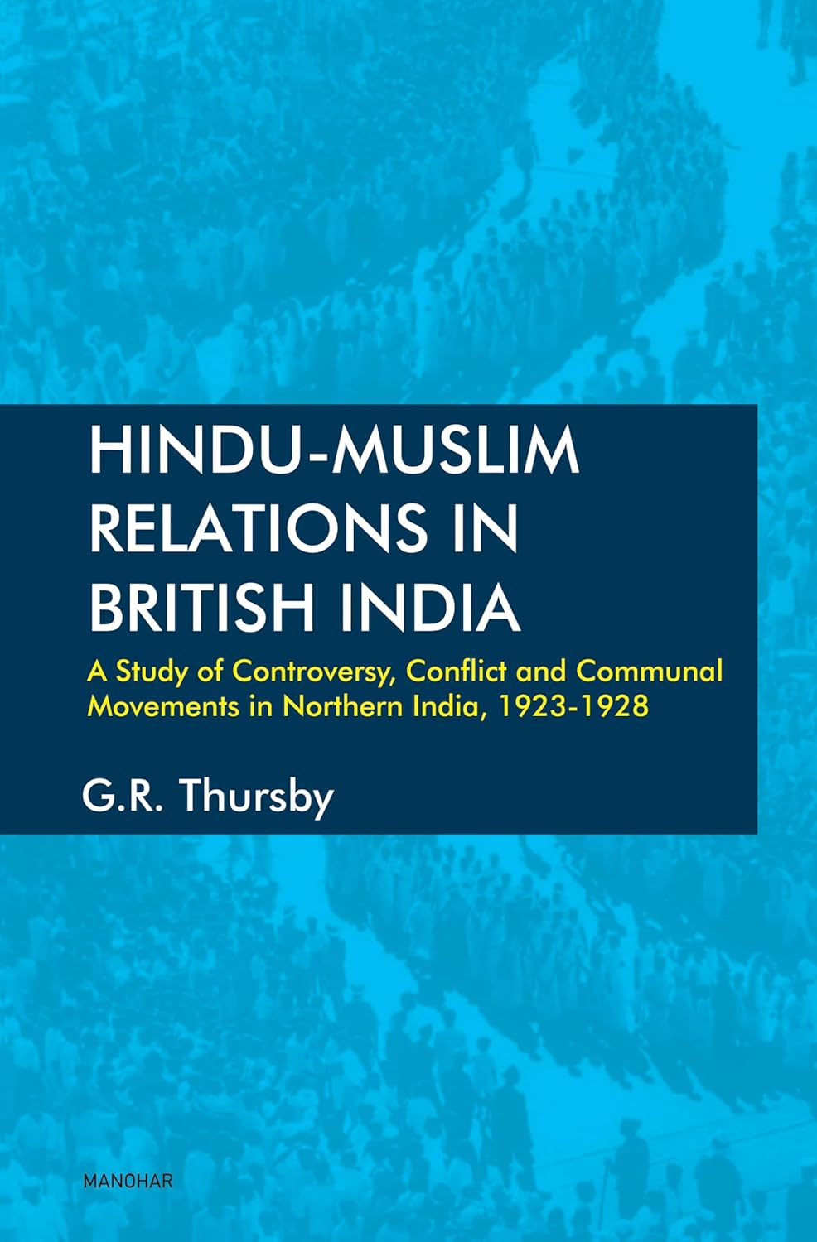

Hindu muslim relations in British India

Author : G.R. Thursby
Publisher: New Delhi: Manohar, 2025
Description: 194p.
Accession no.: 89446

Hindu-Muslim Relations in British India: A Study of Controversy, Conflict and Communal Movements in Northern India, 1923-1928

7.
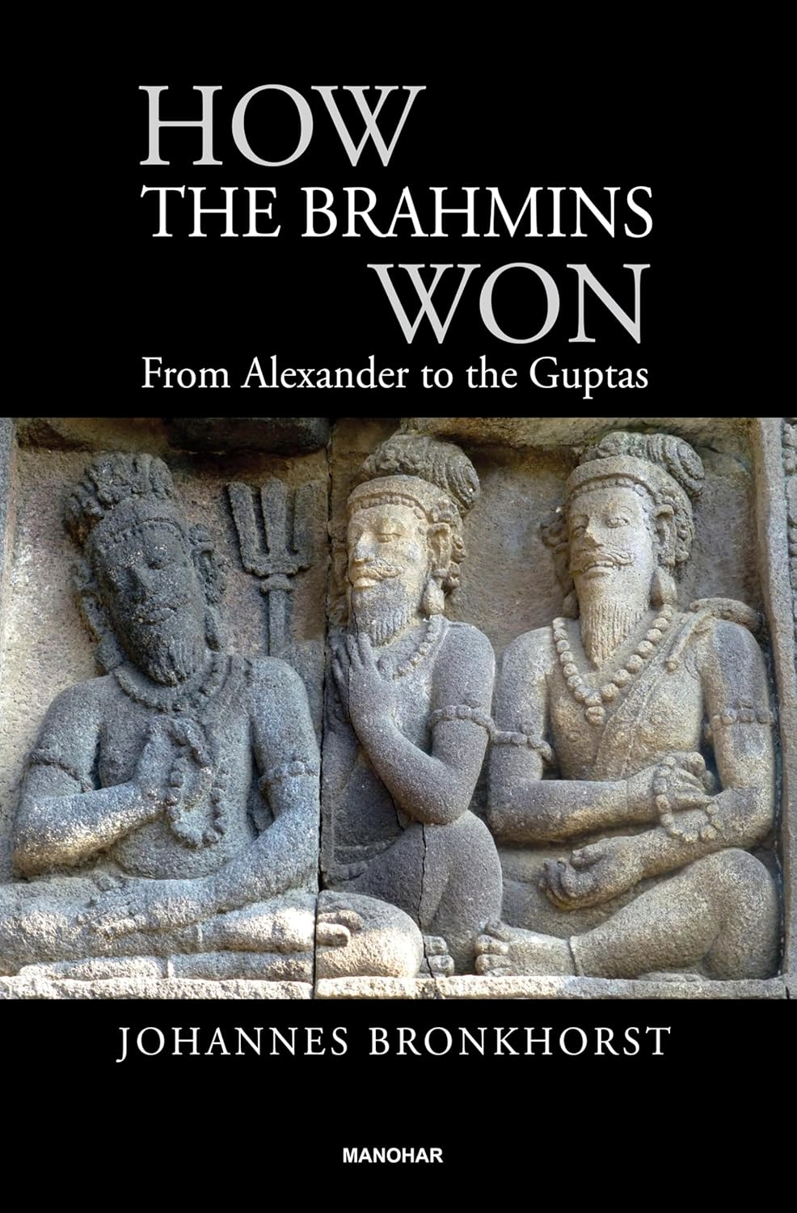

How the Brahmin’s won: from Alexander to the Gupta’s

Author : Johannes Bronkhorst
Publisher: New Delhi: Manohar, 2024
Description: 572p.
Accession no.: 89447

This is the ﬁrst study to systematically confront the question how Brahmanism, which was geographically limited and under threat during the ﬁnal centuries BCE, transformed itself and spread all over South and Southeast Asia.
Brahmanism spread over this vast area without the support of an empire, without the help of conquering armies, and without the intermediary of religious missionaries.

8.
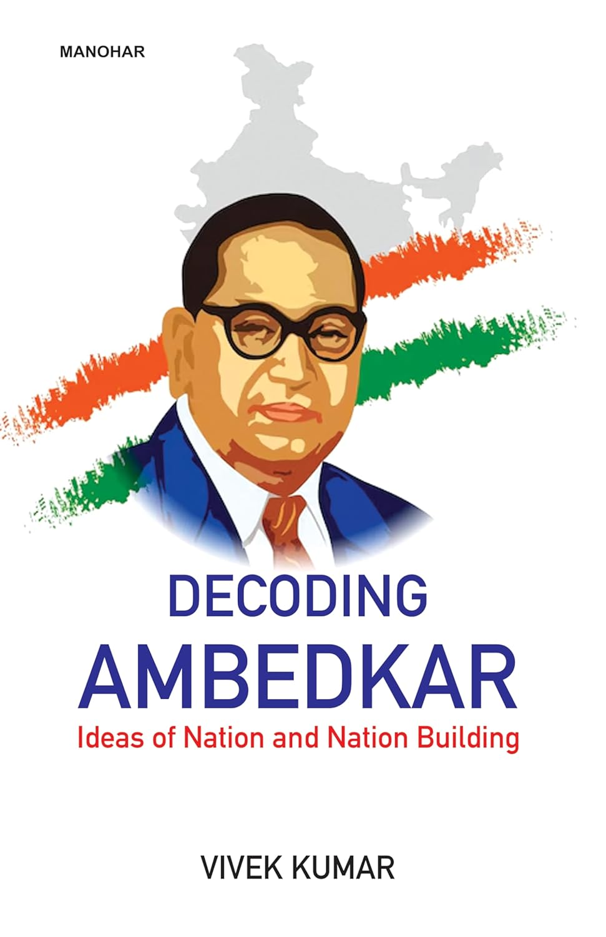
Decoding Ambedkar: ideas of nation and nation building

Author : Vivek Kumar
Publisher: New Delhi: Manohar, 2025
Description: 172p.
Accession no.: 89448

The book sets out a discourse on Dr. B.R. Ambedkar’s vast horizon of knowledge production. Through the essays in the book, the author has tried to deconstruct the reductionist approach adopted by mainstream academia, intelligentsia, and the Indian media to understand Ambedkar.
It has recorded his erasures from various academic texts on sociology, history, literature, and creative fields like feature films.

9.
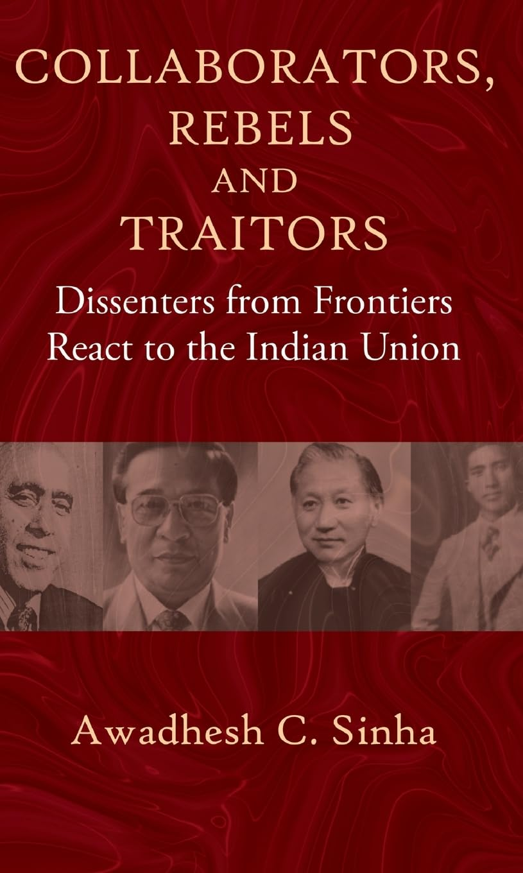

Collaborators, rebels and traitors

Author : Awadhesh C. Sinha
Publisher: New Delhi: Manohar, 2024
Description: 310p.
Accession no.: 89449

This book delves into the status of three regions: Kashmir, Sikkim, and the province of Assam in 1947. In Kashmir, Sheikh Abdullah had emerged as a charismatic leader before it was raided by Pakistan. It explores how Sikkim was accorded the status of an India-protectorate stage in 1950.

The Naga National Council, led by Z.A. Phizo, resorted to armed uprisings in the 1950s in Naga Hills, followed by M.N.F. and Laldenga thereafter.

10.
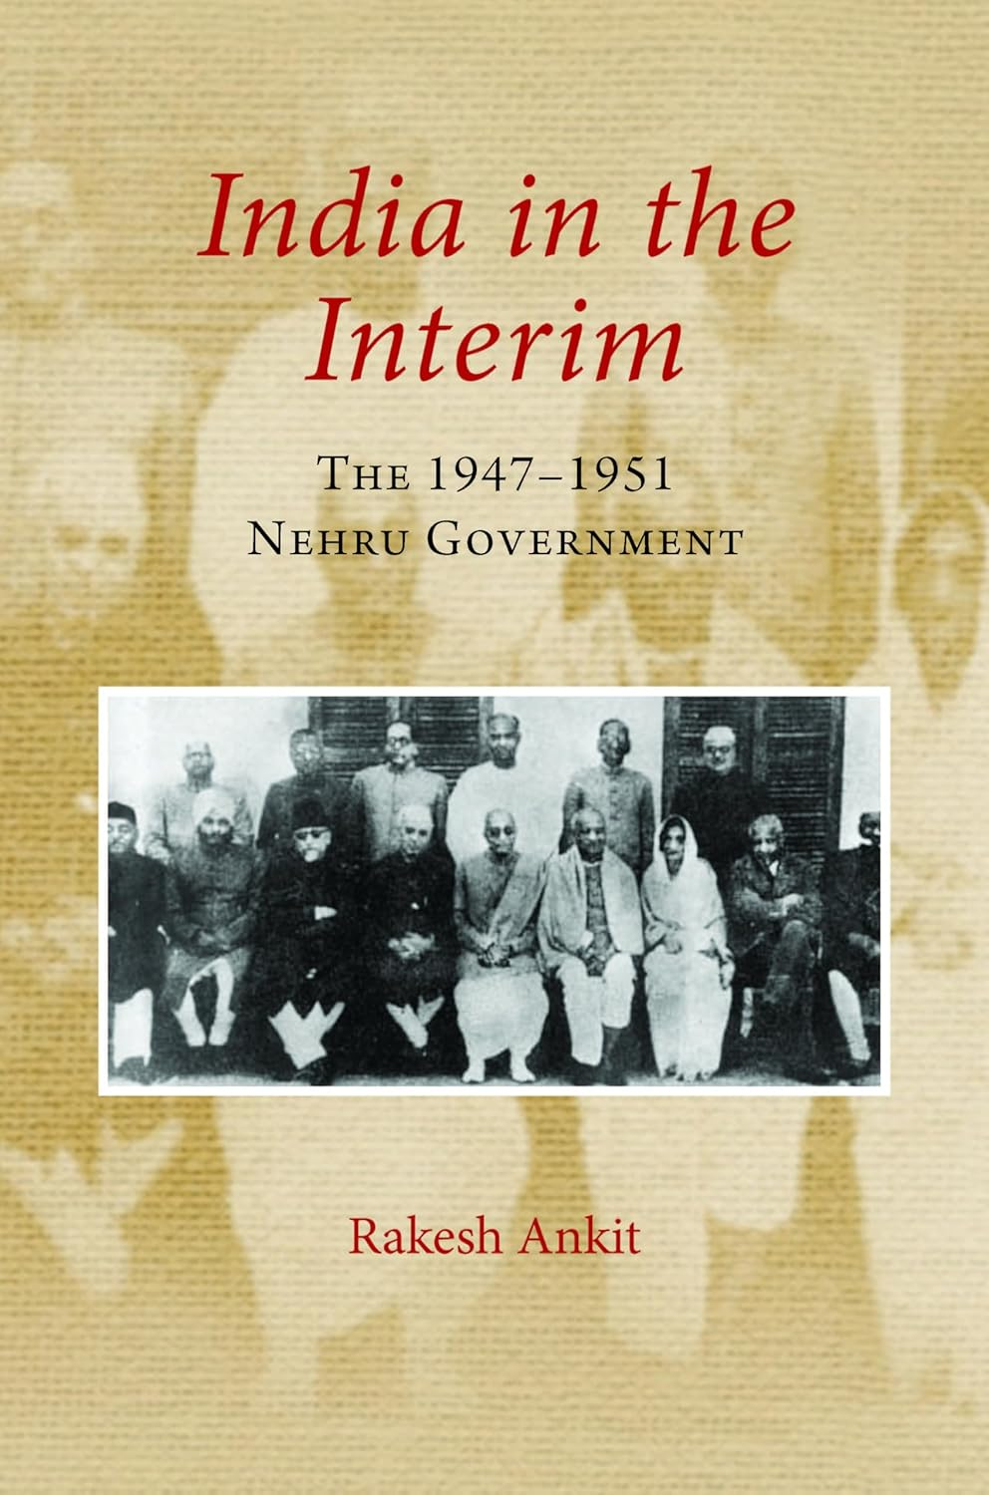
India in the interim: the 1947-1951 Nehru Government

Author : Awadhesh C. Sinha
Publisher: New York: Cambridge, 2024
Description: 256p.
Accession no.: 89450

This book looks at the governmental interregnum from August 1947 to the start of the first general election in October 1951, and is a narrative of some of its intermediate moments in light of contemporary politics.
It is a multi-track chronicle, which draws attention to its discrete, if not determining, impact on the following decade of consolidation.

11.
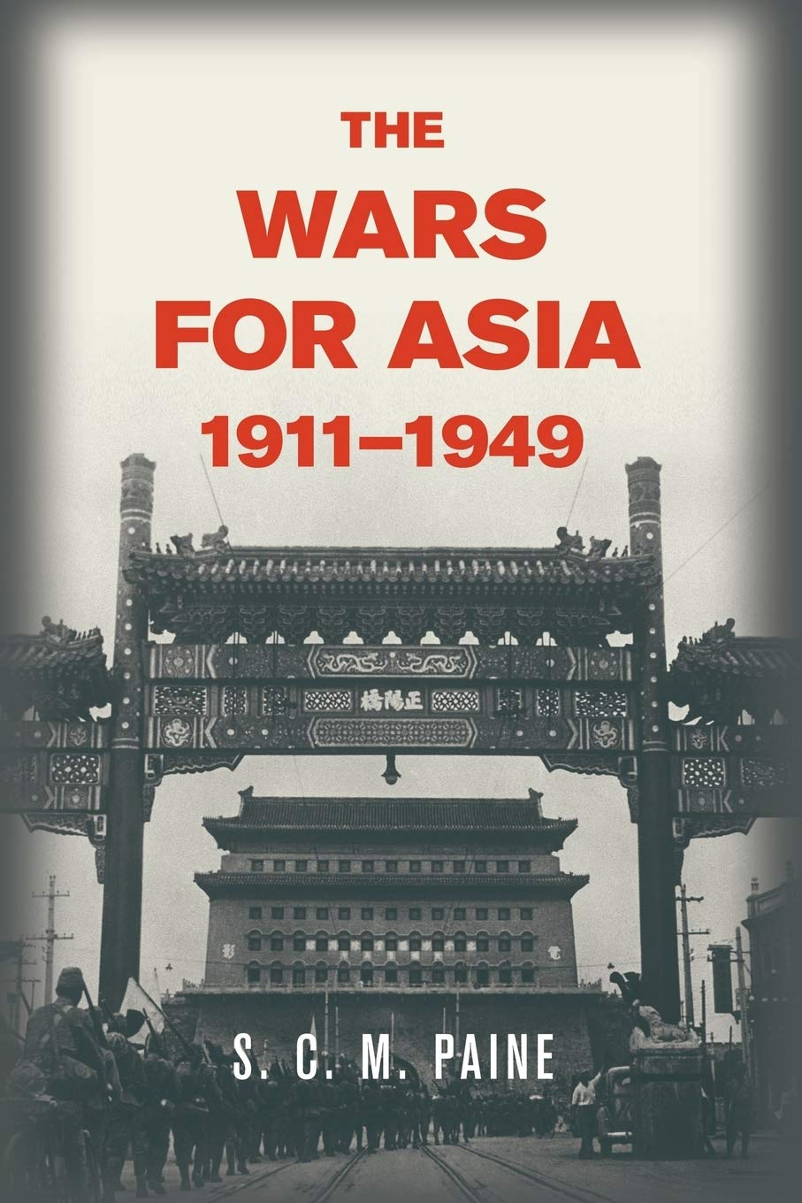

The wars for Asia 1911- 1949

Author : S.C.M. Paine
Publisher: New York: Cambridge, 2014
Description: 487p.
Accession no.: 89451

The Wars for Asia, 1911–1949 shows that the Western treatment of World War II, the Second Sino-Japanese War, and the Chinese Civil War as separate events misrepresents their overlapping connections and causes.
The long Chinese Civil War precipitated a long regional war between China and Japan that went global in 1941 when the Chinese found themselves fighting a civil war within a regional war within an overarching global war.

12.

The meaning of Mariah Carey

Author : Mariah Carey
Publisher: London: Pan Books, 2020
Description: 348p.
Accession no.: 89452

This book is composed of my memories, my mishaps, my struggles, my survival and my songs. Unfiltered. I went deep into my childhood and gave the scared little girl inside of me a big voice.
I let the abandoned and ambitious adolescent have her say, and the betrayed and triumphant woman I became tell her side.Writing this memoir was incredibly hard, humbling and healing.

13.
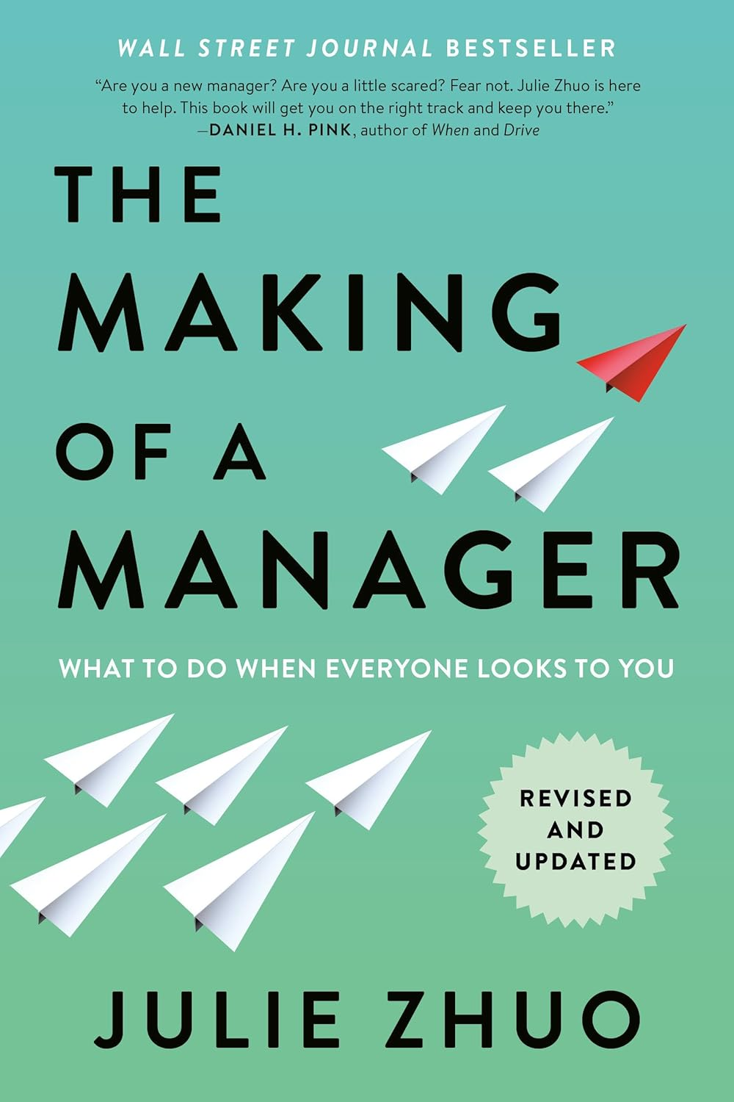

The making of a manager: what to do when everyone looks to you

Author : Julie Zhuo
Publisher: London: Penguin, 2019
Description: 276p.
Accession no.: 89453

In this revised and updated edition of The Making of a Manager, new managers will discover the transformative insights and practical examples that made the original an instant classic, along with essential new guidance for today’s challenges—including how to build trust and maintain morale during downturns and layoffs, and how to foster culture and connection while managing remote teams.

14.
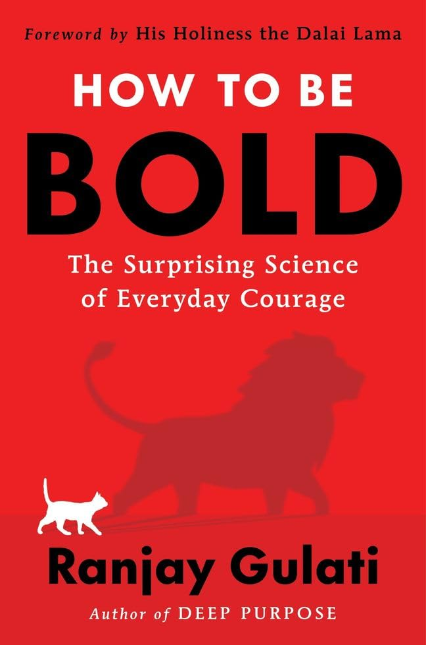
How to be bold: the surprising science

Author : Rajay Gulati
Publisher: Dublin: Harper Collins, 2025
Description: 285p.
Accession no.: 89454

In How to Be Bold, Ranjay Gulati offers a powerful playbook for becoming bolder and braver than we ever thought possible. Rather than leaving brave deeds to mythological heroes and resigning ourselves to apathy or cowardice, we can train ourselves to step up and act in the face of uncertainty.

The key, Gulati argues, is to adopt ways of thinking that allow us to neutralize or moderate our fears.

15.


If anyone builds it, everyone dies: the case against superintelligence AI

Author : Eliezer Yudkowsky
Publisher: London: Bodley, 2025
Description: 259p.
Accession no.: 89455

The scramble to create superhuman AI has put us on the path to extinction but it s not too late to change course. Two pioneering researchers in the field, Eliezer Yudkowsky and Nate Soares, explain why artificial superintelligence would be a global suicide bomb and call for an immediate halt to its development.

16.
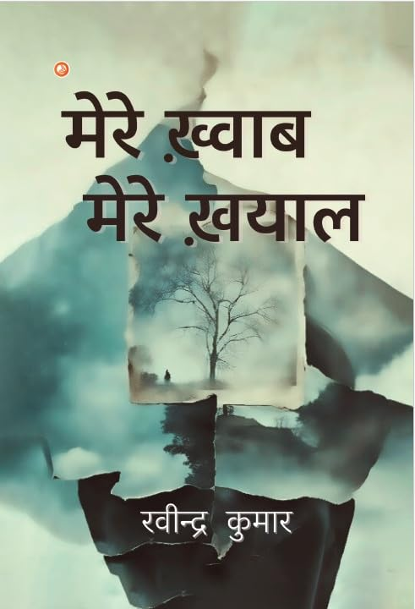

Mere khwab mere khyal

Author : Ravindra Kumar
Publisher: Chattisgarh: Orange Books,
Description: 274p.
Accession no.: 89456

17.
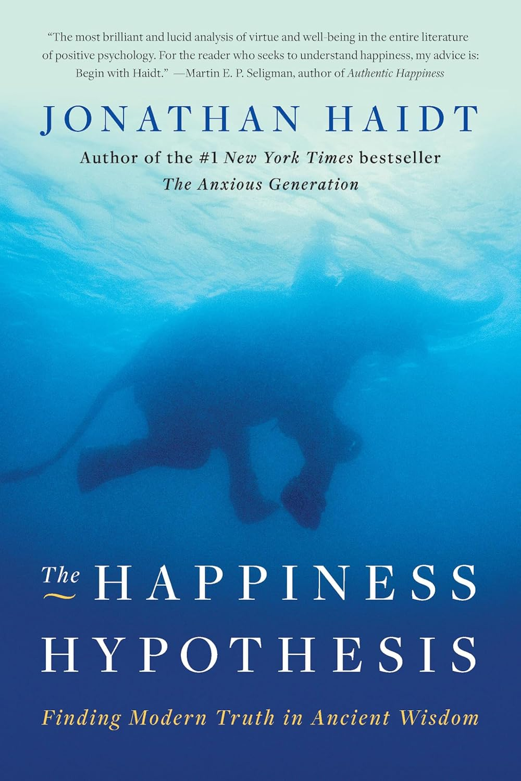

The Happiness hypothesis: finding modern truth in ancient wisdom

Author : Jonathan Haidt
Publisher: Dublin: Dublin, 2006
Description: 297p.
Accession no.: 89457

In his widely praised book, award-winning psychologist Jonathan Haidt examines the world's philosophical wisdom through the lens of psychological science, showing how a deeper understanding of enduring maxims-like Do unto others as you would have others do unto you, or What doesn't kill you makes you stronger-can enrich and even transform our lives.

18.
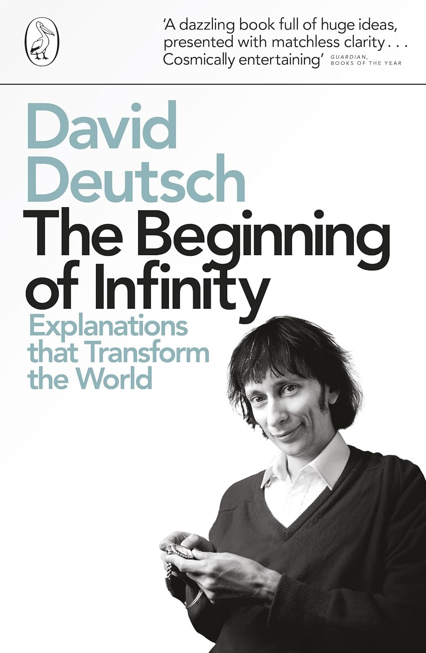

The beginning of infinity: explanations that transform the world

Author : David Deutsch
Publisher: London: Penguin, 2012
Description: 487p.
Accession no.: 89458

In this profound and seminal book, David Deutsch explores the furthest reaches of our current understanding, taking in the Infinity Hotel, supernovae and the nature of optimism, to instill in all of us a wonder at what we have achieved - and the fact that this is only the beginning of humanity's infinite possibility.

19.
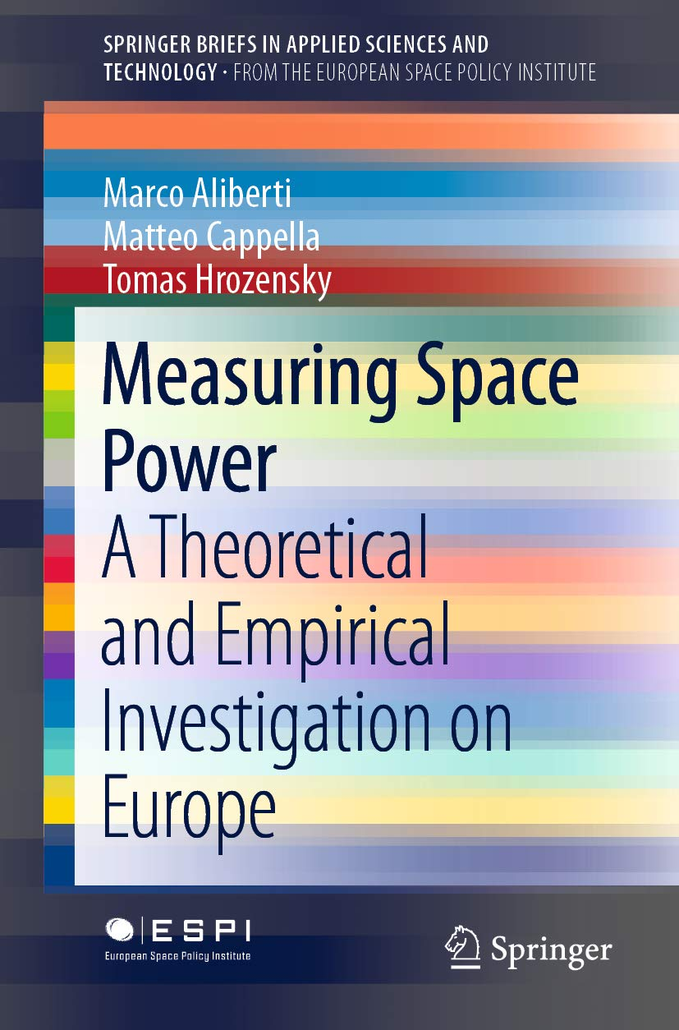

Measuring space power: a theoretical and empirical investigation on Europe

Author : Marco Aliberti
Publisher: Switzerland: Springer, 2012
Description: 115p.
Accession no.: 89459

20.
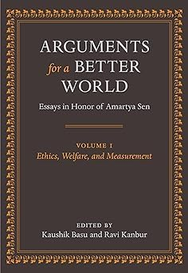

Arguments for a better world: essays in honor of Amartya Sen

Author : Kaushik Basu and Ravi Kanbur
Publisher: New York: OUP, 2009
Description: 602p.
Accession no.: 89460

This volume of essays, written in honor of Amartya Sen, covers the range of contributions that Sen has made to knowledge. They are written by some of the world's leading economists, philosophers and social scientists, and address topics such as ethics, welfare economics, poverty, gender, human development, society, and politics.

21.
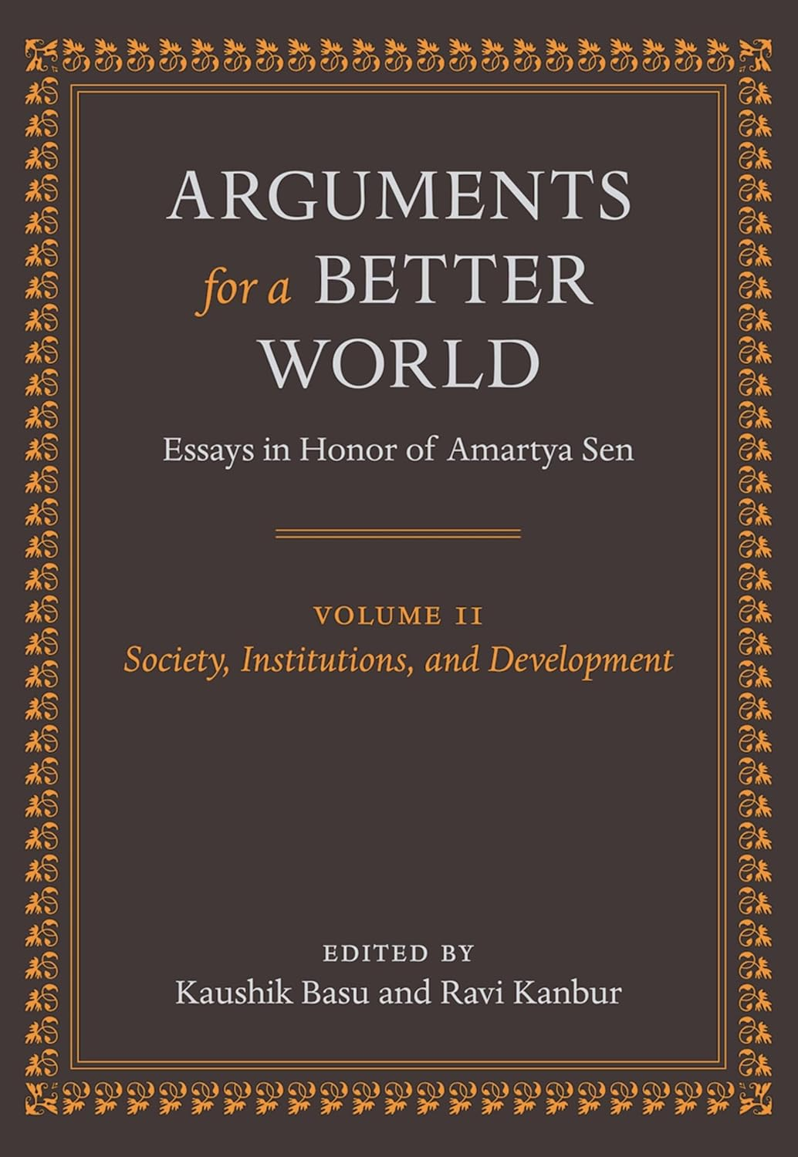

Arguments for a better world: essays in honor of Amartya Sen

Author : Kaushik Basu and Ravi Kanbur
Publisher: New York: OUP, 2009
Description: 630p.
Accession no.: 89461

The second volume covers the topics of Human Development and Capabilities; Gender and Household; Growth, Poverty and Policy; and Society, Politics and History. It is a fitting tribute to Sen's own contributions to the discourse on Society, Institutions and Development.

22-24.
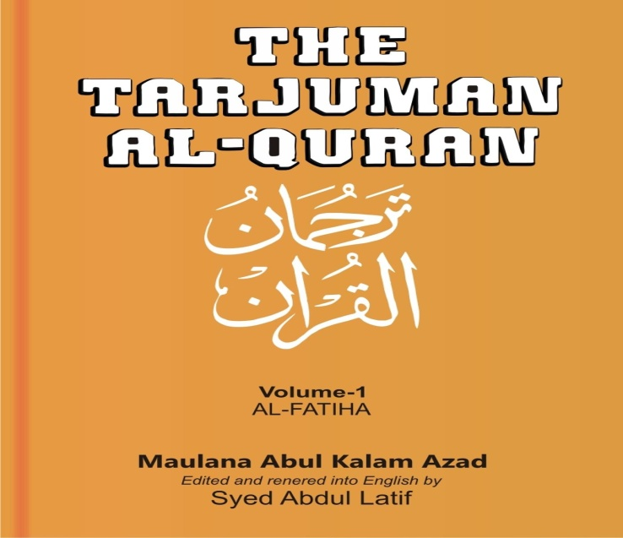

The Tarjuman Al- Quran

Author : Maulana Abul Kalam Azad
Publisher: New Delhi: Kitab Mahal, 2009
Description: 224p.
Accession no.: 89462, 89463, 89464

25.
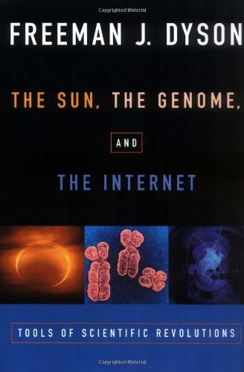

The sun, the genome and the Internet

Author : Freeman J. Dyson
Publisher: New York: OUP, 1999
Description: 124p.
Accession no.: 89465

In this visionary look into the future, Freeman Dyson argues that technological changes fundamentally alter our ethical and social arrangements and that three rapidly advancing new technologies--solar energy, genetic engineering, and world-wide communication--together have the potential to create a more equal distribution of the world's wealth.

26.
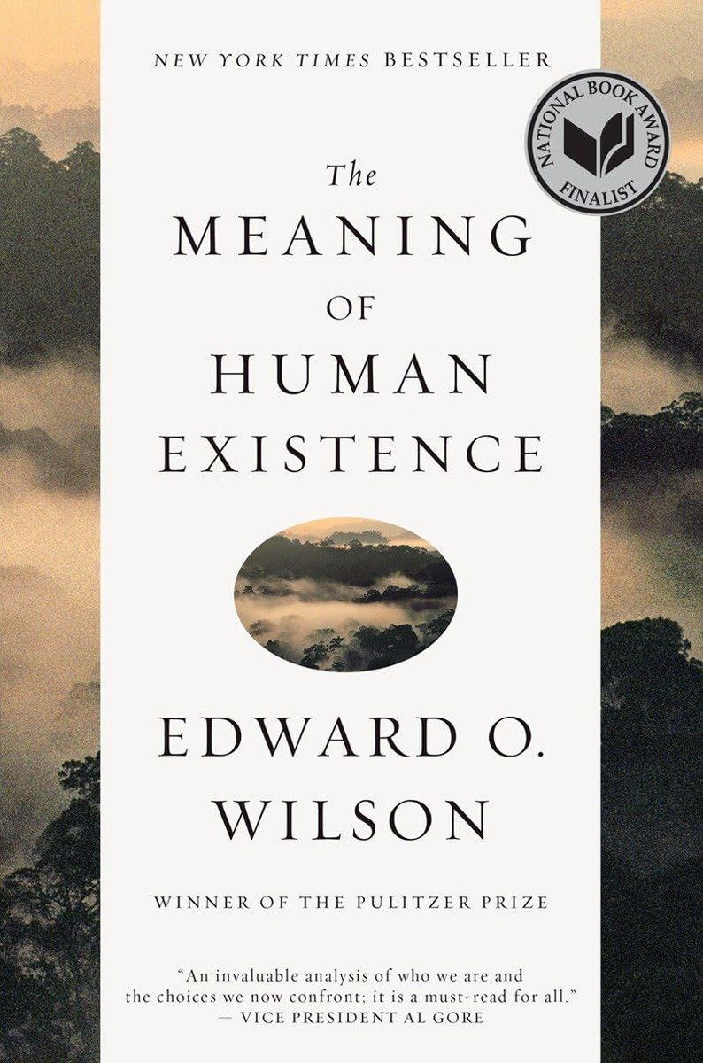

The meaning of human existence

Author : Edward O. WilsonFreeman J. Dyson
Publisher: New York: Liveright, 2014
Description: 208p.
Accession no.: 89466

The human epoch that began in biological evolution and passed into pre-, then recorded, history is now more than ever before in our hands. Yet alarmed that we are about to abandon natural selection by redesigning biology and human nature as we wish them, Wilson soberly concludes that advances in science and technology bring us our greatest moral dilemma since God stayed the hand of Abraham.

27.


DNA: the story of the genetic revolution

Author : James Watson
Publisher: London: Penguin, 2017
Description: 595p.
Accession no.: 89467

Along with Francis Crick, James Watson was the discoverer of the double helix structure of the DNA molecule, realising both how it was able to reproduce itself and how, through its immense variety, it was able to pass on genetic instructions from one generation to the next.

28.
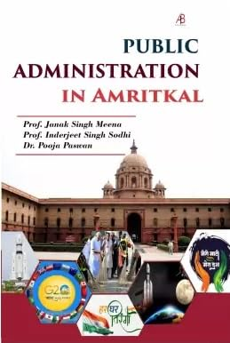

Public administration in Amritkal

Author : Janak Singh Meena
Publisher: Delhi: ABS, 2024
Description: 301p.
Accession no.: GR25666

In India, Amrit Kaal (literally the nectar period regarded as auspicious for pursuing ambitious goals) refers to the period 2022 to 2047, when India would have completed 100 years of independence. In the 21st century, being literate in the nuances of public policies involving both the domestic and international aspects has become essential for informed participation for all the stakeholders in India.

29.
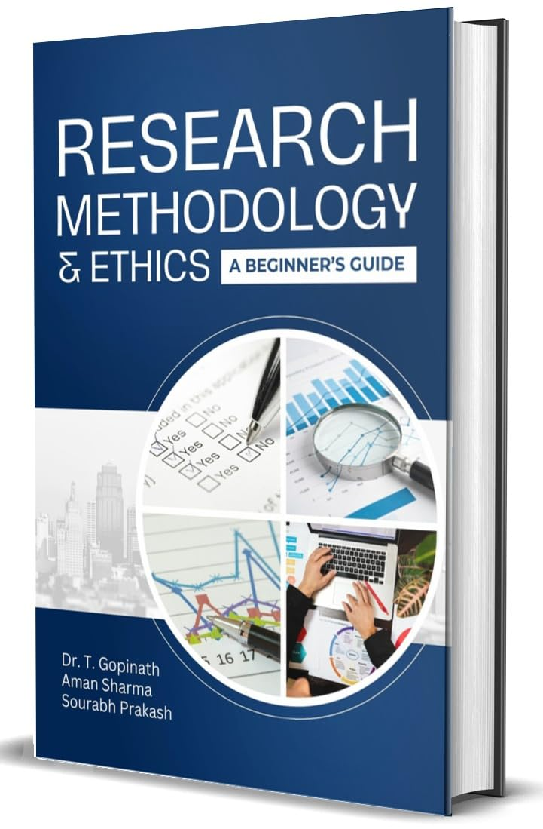
Research methodology & ethics: a beginner’s guide

Author : T. Gopinath
Publisher: Chandigarh: Abhishek,2024
Description: 246p.
Accession no.: GR25669

Research Methodology: A Step by Step Guide for Beginners has been written specifically for those with no previous experience of research or research methodology. An essential reading for undergraduate and postgraduate students in the social sciences and are interested in research. This Book Research Methodology & Ethics : A Beginner's Guide is designed To illuminate that path for those embarking on their research journey for the first time.

30.
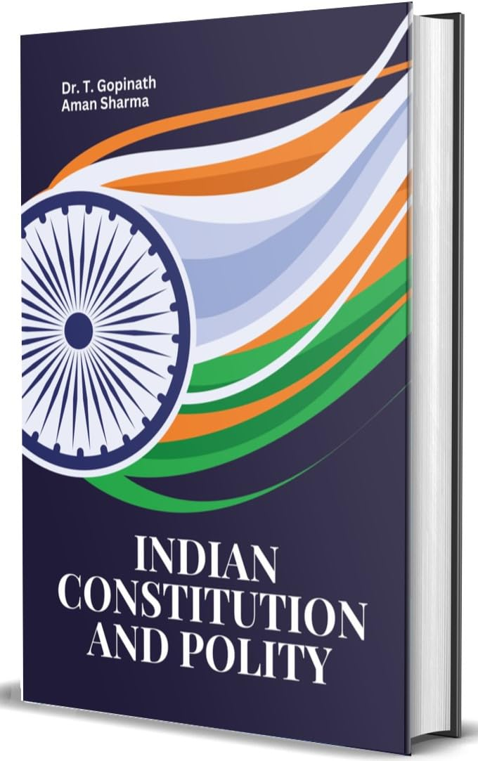

Indian constitution and polity

Author : T. Gopinath
Publisher: Chandigarh: Abhishek,2024
Description: 309p.
Accession no.: GR25670

The indian constitution stands as a monumental achievement, embodying the aspirations and values of a diverse and pluralistic society. As the supreme law of the land, it lays down the framework for governance, delineating the powers and functions of various institutions while safeguarding the rights and freedoms of its citizens. This book, indian constituion and polity: The Framework of india's Governance,seeks to explore the intricate and evolving relationship between the Constitution and the polity it shapes.

31.
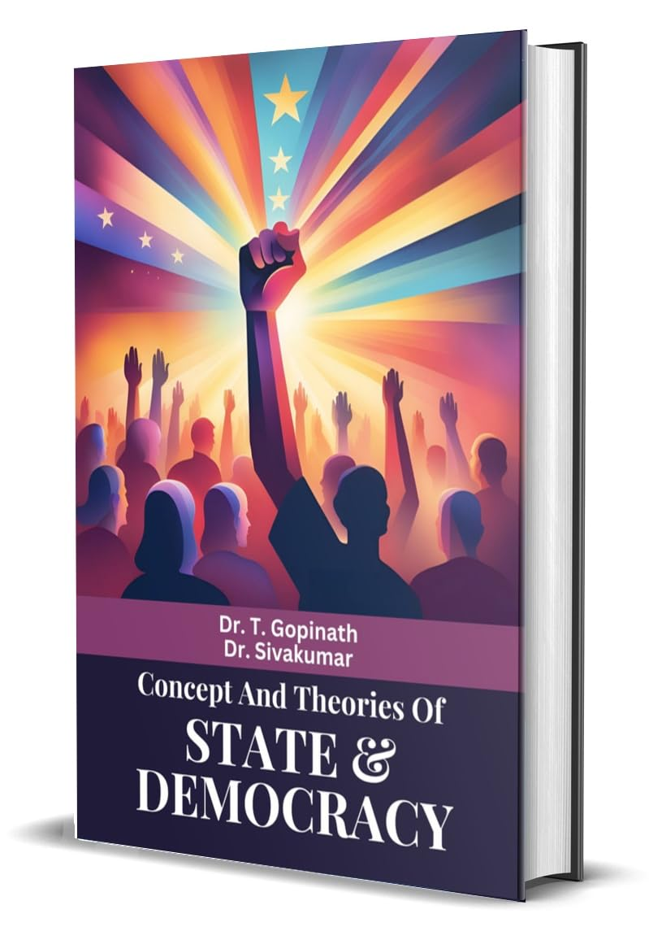

Concept and theories of state & democracy

Author : T. Gopinath
Publisher: Chandigarh: Abhishek,2024
Description: 239p.
Accession no.: GR25672

In a era marked by rapid political, social, and technological transformations, understanding the foundational concepts and book "concept and theories of State and Democracy" delves into the intricate dynamics that define the state, exploring its origin, nature, and essential characteristics. it elucidates the state's role through established institutions and legal frameworks. By examining the principles of sovereignty, legitimacy, and the monopoly of force, complextites of international relations.

32.
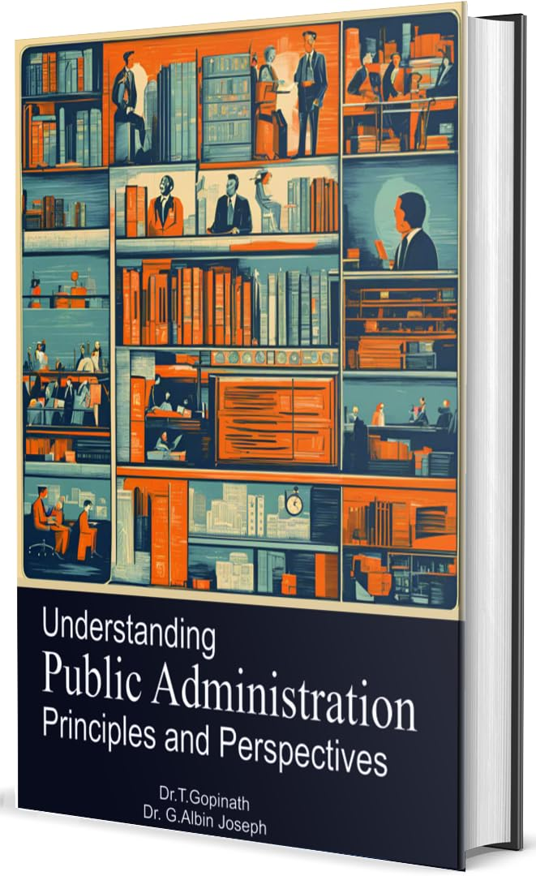

Understanting public administration: principles and perspectives

Author : T. Gopinath
Publisher: Chandigarh: Abhishek,2024
Description: 237p.
Accession no.: GR25673

This book, "Understanding Public Administration: Principles and Perspectives, aims to provide a comprehensive and accessible exploration of the foundational concepts, contemporary issues, and evolving paradigms in the field of public administration. Drawing on arich array of theoretical frameworks and practical examples, it seeks to illuminate the multifaceted nature of public administration and its critical impact on society.

33.
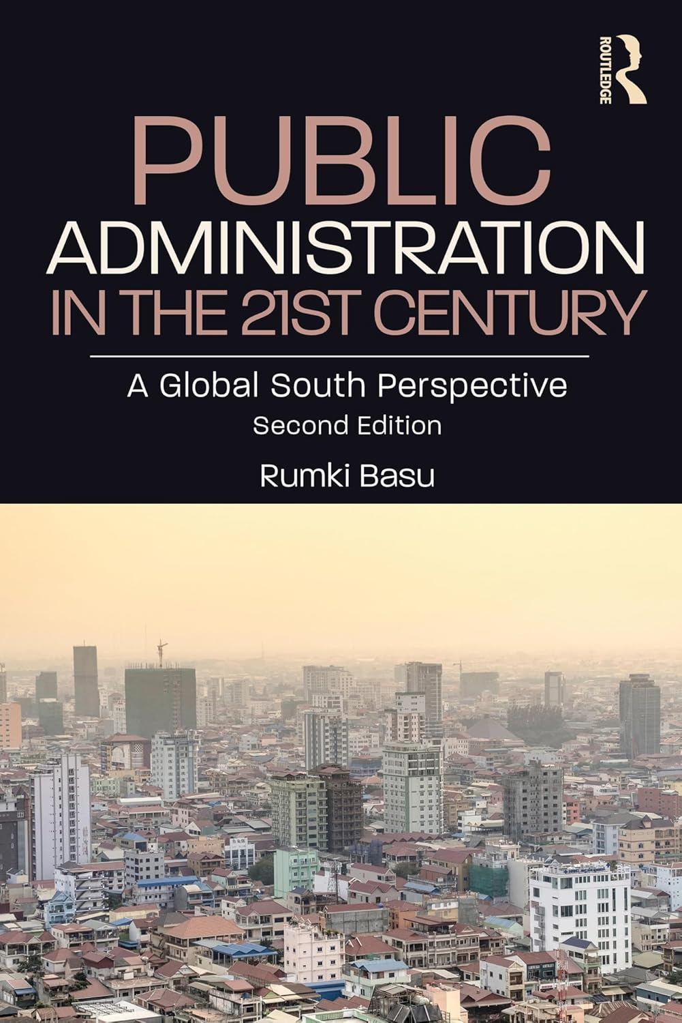

Public administration in the 21st century: a global South perspective

Author : Rumki Basu
Publisher: New York: Routledge, 2025
Description: 183p.
Accession no.: GR25693

In the second edition, the volume brings into focus lessons on policy and governance learnt from the Global South in building administrative capacities in post-Covid-19 times.
An essential read on the mandates and challenges for the state regarding the rising South, this book will be indispensable to scholars and researchers of politics, especially governance and public policy, sociology and development studies. It will also be of interest to bureaucrats, NGOs and government officials.

34.
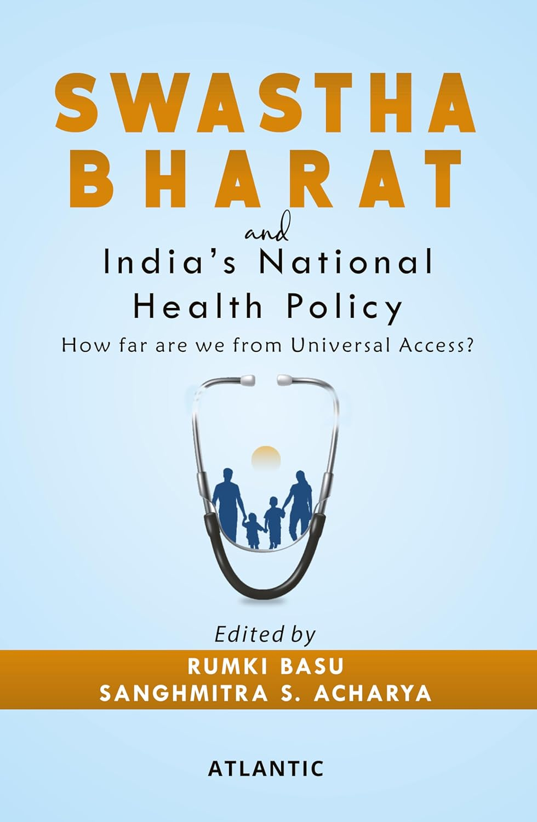

Swastha Bharat and India’s National Health Policy

Author : Rumki Basu
Publisher: New Delhi: Atlantic, 2025
Description: 399p.
Accession no.: GR25690

Compiled from select essays presented at the two-day conference on Health Policy in India by the Centre for Public Policy and Governance in July 2022, Swastha Bharat and India's National Health Policy: How far are we from Universal Access? is a state-of-the-art policy book for post-COVID India. The book reflects the worries of the average citizen whose out-of-pocket health expenditure is one of the highest in the world.

35.
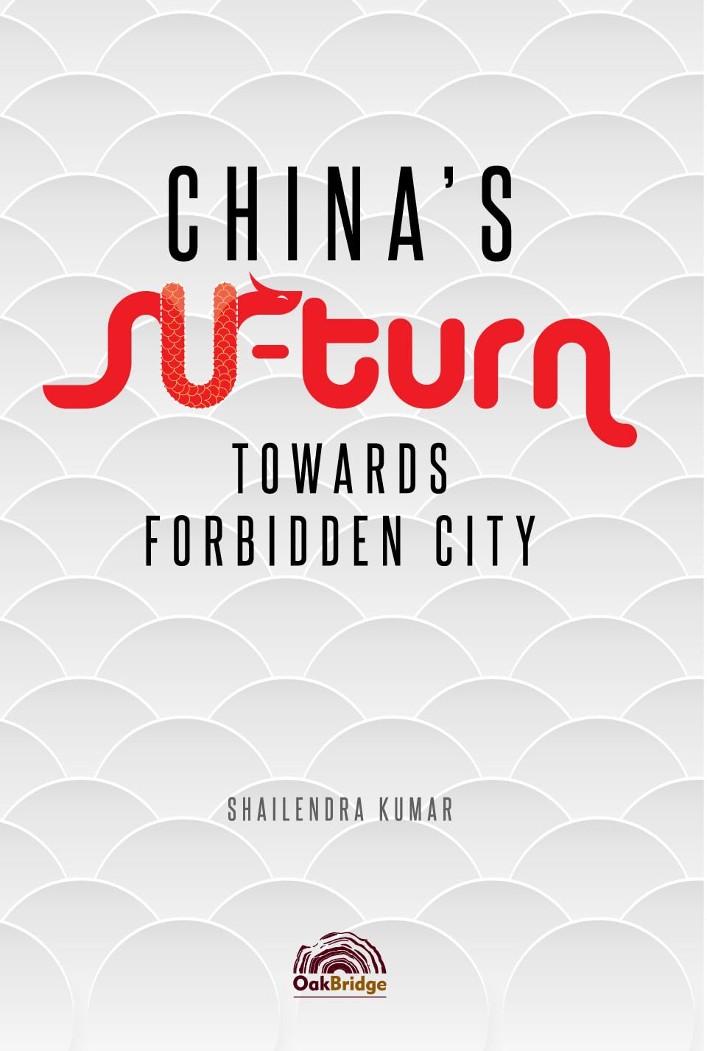

China’s u-turn: towards forbidden city

Author : Shailendra KumarRumki Basu
Publisher: Gurugram: Oak Bridge, 2024
Description: 243p.
Accession no.: GR25694

This hardcover book delves into the nation's pivotal shift towards the iconic Forbidden City, offering a captivating exploration of its cultural and political significance. Meticulously researched and endorsed by esteemed figures like Shri Harivansh Narayan Singh, Justice A K Patnaik, Justice Shiva Kirti Singh, Shri N Venkataraman, and Prof Ashwani Kumar, this literary masterpiece promises to enlighten readers with its profound insights. Unveil the mysteries that lie within the hallowed walls of the Forbidden City and gain a deeper understanding of China's remarkable transformation.

