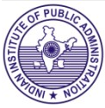
BOOK ALERT
(New Arrivals-Books)
( JULY, 2023)

Available for issue from August, 2023



.

Library
Indian Institute of Public Administration
New Delhi

Book Alert is a monthly service offered by

the Library, Indian Institute of Public

Administration. It contains bibliographical

details of latest books added to the library

during the period.

COMPILED BY

SUNITA GAUTAM

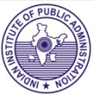

Indian Institute of Public Administration,
I.P. Estate, Ring Road, New Delhi-110002

CONTENTS

SUBJECT | Sr. No.  1  2  3-4  5-6  7  8-9  10-12  13-14  15  16  17  18-19  20-22
  Biography
  Constitutional Law
  Defense Studies
  Economic Development
  Economic Policy
  Education
  Energy Resources
  Environment
  Fiction
  History
  Human Resource Management
  International Relations
  Leadership

BIOGRAPHY

1.



The Chancellor: the remarkable Odyssey of Angela Merkel

Author: Marton Kati
Publisher: London: Harper Collins, 2021
Description: 344p.
Accession No. 89105

‘An intimate, insightful portrait of an extraordinarily private leader’ WALTER ISAACSON From the bestselling author of Enemies of the People. An intimate and deeply researched account of the extraordinary rise and political brilliance of the most powerful – and elusive – woman in the world.

At once a riveting political biography, an intimate human portrait and a revelatory look at successful leadership in action, The Chancellor brings forth from the shadows one of the most extraordinary women of our time.

CONSTITUTIONAL LAW
2.

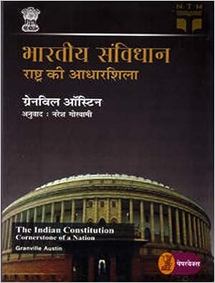

Bhartiya samvidhaan: rashtra ki aadharshila

Author: Granville Austin
Publisher: New Delhi: Vaani, 2017
Description: 536p.
Accession No. GR24741 (Hindi)

यह तात्कालिकता और वर्णनात्मकता से आक्रान्त एक ऐसा लेखन था जिसमें एक दस्तावेज़ के रूप में संविधान की ऐतिहासिक पूर्व-पीठिका, संविधान सभा की उग्र बहसों के आग्रह-दुराग्रह और चिन्ताएँ अनुपस्थित थीं। इस तरह ग्रेनविल ऑस्टिन की इस रचना ने भारत में संवैधानिक अध्ययन की धारा को एक नया परिप्रेक्ष्य प्रदान किया।

DEFENSE STUDIES
3.

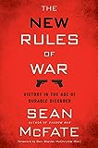

The new rules of war: victory in the age of durable disorder

Author: Sean McFate
Publisher: New York: Harper Collins, 2019
Description: 318 p.
Accession No. 89109

Some of the principles of warfare are ancient, others are new, but all described in The New Rules of War will permanently shape war now and in the future.

The New Rules of War is an urgent, fascinating exploration of war—past, present and future—and what we must do if we want to win today from an 82nd Airborne veteran, former private military contractor, and professor of war studies at the National Defense University.

McFate’s new rules distill the essence of war today, describing what it is in the real world, not what we believe or wish it to be.

4.

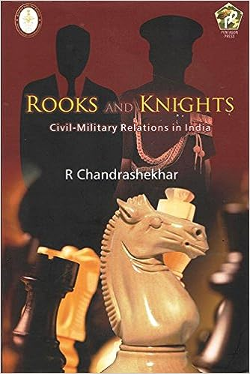

Rooks and knights: civil-military relations in India

Author: R. Chandrashekhar
Publisher: New Delhi: Pentagon Press, 2017
Description: 170p.
Accession No. GR24747

It is axiomatic that in a democracy, the nation’s Armed Forces are subordinate to its elected Government. But a Nation’s Armed Forces are `Forces’ that exude and represent national power and are no ordinary subordinate agencies.

The primary structures of control of India’s Armed Forces evolved under the British Rule. The course of evolution of these structures from the days of the East India Company and the Raj, their adaptation to conform to the requirements of a democracy, post-independence developments and the course this process needs to take to meet future requirements are some of the fascinating aspects of an absorbing subject this book attempts to explore.

ECONOMIC DEVELOPMENT

5.

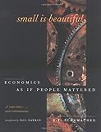

Small is beautiful : economics as if people mattered : 25 years later ... with commentaries

Author: E.F Schumacher
Publisher: Point Roberts, Wash: Hartley & Marks, 1999
Description 286 p.
Accession No. 89102

How does our economic system impact the way we live? Offering a crucial message for the modern world struggling to balance economic growth with the human costs of globalization.

Small Is Beautiful puts forward the revolutionary yet viable case for building our economies around the needs of communities, not corporations.

6.

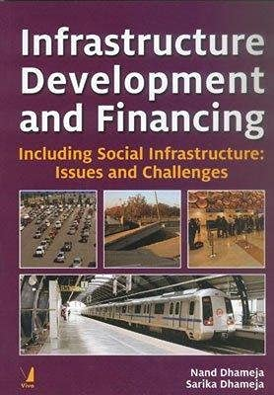

Infrastructure Development and Financing: Including Social Infrastructure: Issues and Challenges

Author: Nand Dhameja and Sarika Dhameja
Publisher: New Delhi: Viva Books, 2016
Description: 307p.
Accession No. GR24749

Infrastructure is an umbrella term for many activities referred to as ‘social overhead capital’ and includes public utilities, public works, communication, and transport. It also includes social infrastructure and is gaining importance with growing urbanisation.

The study is a comprehensive one as it covers different segments of infrastructure like, education, prison privatisation, power and transport sectors. Though higher education in India has expanded over the years and it has great potential and opportunities in terms of export of higher skill services, it is in crisis due to falling quality, unemployable graduates and dismal performance

ECONOMIC POLICY

7.

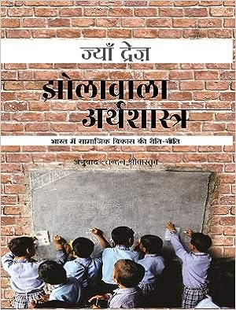

Jholawala arthashastra

Author: Jean Dreze
Publisher: New Delhi: Vaani, 2020
Description: 376p.
Accession No. GR24740 (Hindi)

Drèze’s insights on India’s “unfashionable” issues – hunger, poverty, inequality, corruption, and conflict – are all on display here and offer a unique perspective on the evolution of social policy over roughly the past two decades.

“Jholawala” has become a disparaging Term for activists in the business media. This book affirms the learning value of collective action combined with sound economic analysis. In his detailed introduction, Drèze persuasively argues for an approach to development economics where research and action become inseparable interconnected. This is a book as much for economists as for every reading citizen.

EDUCATION

8.

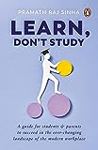

Learn, don't study

Author: Pramath Raj Sinha
Publisher: Gurugram: Penguin Random House, 2023
Description: 158p.
Accession No. 89098

The professional world isn't as straightforward as it once was, especially in India. The modern workplace is changing rapidly.
Today's students and their parents need new guides and frameworks to make decisions about what educational opportunities to pursue and what to focus on as they embark on their professional journeys.
In Learn, Don't Study, drawing on his experiences of over twenty-five years in the field of education, Pramath Raj Sinha has put together the best and most practical advice available for youngsters who are facing some of the most important and challenging choices of their professional lives.

9.

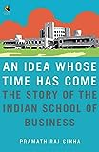

An idea whose time has come: the story of the Indian School of Business

Author: Pramath Raj Sinha
Publisher: Gurugram: Penguin Random House, 2011
Description: 210p.
Accession No. 89101

Ten years ago, the founders of the Indian School of Business, Hyderabad articulated a vision that was as daunting to execute as it was simple to state: to build a world-class business school in India.

An Idea Whose Time Has Come traces the ISB’s eventful history and also examines the reasons that account for the institute’s success. What emerges is a tale of perseverance and dedication, of challenges met and rewards reaped, and of an unshakeable idea that was painstakingly transformed into an invincible institution. It is no wonder that the ISB continues to attract thousands of confident, purposeful men and women every year and moulds them into talented professionals.

ENERGY RESOURCES

10.

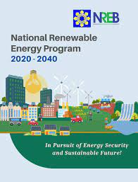

National Renewable Energy Program 2020-2040 : In Pursuit of Energy Security and Sustainable Future

Publisher: Philippines: National Renewable Energy Board, 2020
Description: 91p.
Accession No. GR24742

Consistent with the objectives of the RE Act, the NREP 2020-2040 seeks to significantly increase RE's share in the country's power generation mix by 2040, which would also help us reduce our greenhouse gas emissions (GHG) in the coming years.

11.


Philippines energy plan 2020-2040: Towards a Sustainable and Clean Energy Future

Publisher: Philippines: Department of Energy, 2020
Description: 252p.
Accession No. GR24743

It will mean a more energy-secured and resilient Philippines. It will mean the use of more locally available clean energy fuels such as solar, wind, hydro, geothermal and natural gas that will help create a healthy and safe environment for future generation.

12.

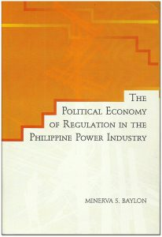

The political economy of regulation in the Philippine power industry

Author: Minerva S. Baylon
Publisher: Philippines: National College of Public Administration and Governance, 2010
Description: 395p.
Accession No. GR24744

The Philippine team has found that electricity governance in the Philippines needs much improvement, in all areas of governance: transparency and access to information, participation of all stakeholders especially the weaker stakeholders, accountability and mechanisms for redress, and in building the capacity of both institutions of government and of civil society. The final “scorecard” of governance in the Philippine electricity sector, based on the ratings by the Philippine team, is “low medium” to “medium”, with an average numeric score of 2.5.

ENVIRONMENT

13.

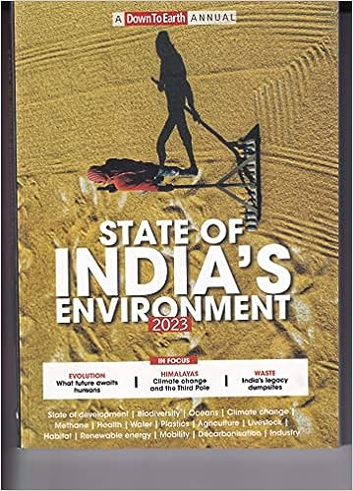

State of India's environment 2023

Author: Centre for Science and Environment
Publisher: New Delhi: Centre for Science and Environment, 2023
Description: 494p.
Accession No. 89100

The State of India's environment 2023, a "Down To Earth" annual, comes from one of India's foremost environmental think tanks, Centre for Science and Environment. It brings together a set of well-reasoned and crisply-written analyses, reportages, reviews and overviews on some of the most significant developments of recent times in fields ranging from water, mining and agriculture to governance, forests and climate change.

14.

Green consumerism green buying, consumption and waste disposal practices: a resource manual for homemakers

Author: Maneesha Shukul and Urvashi Mishra
Publisher: New Delhi: Indian Institute of Public Administration, 2015
Description: 101p.
Accession No. GR24750

This study investigates the impact of environmental responsibility on green consumption via the mediation of environmental concern and the moderation of price sensitivity. The questionnaire survey method was used to collect data from 680 Chinese consumers via an online questionnaire.

Environmental concern positively affects green consumption intention and plays a partial mediation role in the relationship between environmental responsibility and green consumption intention. Price sensitivity plays a negative moderation role in the relationship among environmental responsibility, environmental concern and green consumption intention. The theoretical and managerial implications of the findings were discussed.

FICTION

15.

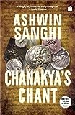

Chanakya's chant by Ashwin Sanghi

Author: Ashwin Sanghi
Publisher: Haryana: Harper Collins, 2022
Description: 454p.
Accession No. 89099

The year is 340 BC. A hunted, haunted Brahmin youth vows revenge for the gruesome murder of his beloved father. Cold, calculating, cruel and armed with a complete absence of accepted morals, he becomes the most powerful political strategist in Bharat and succeeds in uniting a ragged country against the invasion of the army of that demigod, Alexander the Great. Pitting the weak edges of both forces against each other, he pulls off a wicked and astonishing victory and succeeds in installing Chandragupta on the throne of the mighty Mauryan empire.
Can this wily pandit-who preys on greed, venality and sexual deviance-bring about another miracle of a united India? Will Chanakya's chant work again?

HISTORY

16.



From strength to strength

Author: John Henry Jowett

Publisher: London: Forgotten, 2018

Description: 131p.

Accession No. 89112

This work has been selected by scholars as being culturally important and is part of the knowledge base of civilization as we know it.
This work is in the public domain in the United States of America, and possibly other nations. Within the United States, you may freely copy and distribute this work, as no entity (individual or corporate) has a copyright on the body of the work.

HUMAN RESOURCE MANAGEMENT

17.

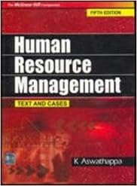

Human resource management: text and cases

Author: K Aswathappa
Publisher: New Delhi: Tata McGraw-Hill, 2008
Edition: 5th
Description: 723p.
Accession No. GR24748

This edition brings in many new developments in the area of HRM. A new running feature called Pause and Ponder, interspersed across the text, will motivate the readers to think about the real issue or concept which they have learnt in the preceding pages, before they move on to the next topic. This edition contains many new cases and examples, and up-to-date data.

INTERNATIONAL RELATIONS

18.

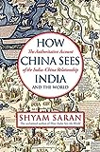

How China sees India: the authoritative account of the India- China relationship

Author: Shayam Saran
Publisher: New Delhi: Juggernaut, 2022
Description: 86p.
Accession No. 89103

As a work of history, How China Sees India and the World is superb and tells its story not just in big, bold strokes but also through entertaining nuggets such as the spread of the chopstick, or how the word ‘zen’ arose from ‘dhyan’.
As a work of political analysis, especially of contemporary China and India, it is erudite, acute and strongly argued, based on close readings of contemporary Chinese scholarship, CCP leadership speeches and writings, and through Saran’s own experiences as diplomat and Foreign Secretary.

19.

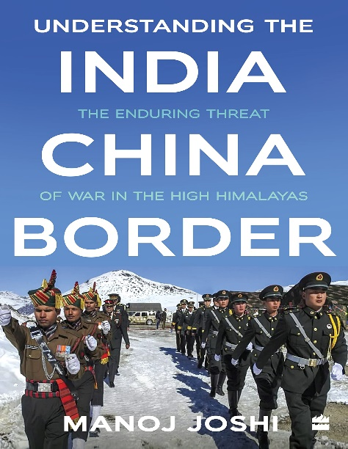

Understanding the India China border: the enduring threat of war in the high himalayas

Author: Manoj Joshi,

Publisher: Gurugram: Harper Collins, 2022

Description: 289p.

Accession No. 89108

In the summer of 2020, China and India came close to war. The nuclear-armed adversaries both amassed troops and equipment along their disputed border in eastern Ladakh. The two sides slugged it out with fists, stones and clubs next to a fast-flowing Himalayan stream, resulting in dozens of deaths and injuries, many from hypothermia.
This timely book, Understanding the India-China Border: The Enduring Threat of War in the High Himalayas, explains what is happening on 'the roof of the world', and why that matters for us all.

LEADERSHIP

20.

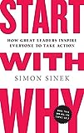

Start with why: how great leaders inspire everyone to take action

Author: Simon Sinek
Publisher: New York: Portfolio, 2009
Description: 246 p.
Accession No. 89106

Why do we do what we do? Why do we exist? Learning to ask these questions can unlock the secret to inspirational business. This title explains what it truly takes to lead and inspire and how you can learn how to do it.

21.

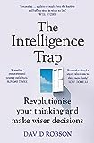

The intelligence trap: revolutionise your thinking and make wiser decisions

Author: David Robson
Publisher: London: Hodder & Stoughton, 2019
Description: 337p.
Accession No. 89110

How was a brilliant physics professor tricked into carrying 2kg of cocaine across the Argentinian border? Why do doctors misdiagnose 10 to 15% of their patients? Why do Nobel Prize winners spread fake news? We assume that smarter people are less prone to error. But greater education and expertise can often amplify our mistakes while rendering us blind to our biases. This is the 'intelligence trap'.

Drawing on the latest behavioural science and historical examples from Socrates to Benjamin Franklin, David Robson demonstrates how to apply our intelligence more wisely.

22.

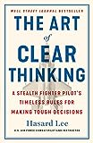

The art of clear thinking: a stealth fighter pilot's timeless rules for making tough decisions

Author: Hasard Lee
Publisher: London: Penguin, 2023
Description: 259p.
Accession No. 89111

The training to become a fighter pilot is among the most competitive and difficult in the world with fewer than one-in-a-thousand succeeding. Pushing a cutting-edge jet to its limits at over 1,000 mph means that every split-second decision can have catastrophic consequences.

Throughout his high-pressure career in the cockpit of the world's most advanced and expensive weapons systems, Hasard Lee learned to master skills at the apex of decision-making theory and practice.

