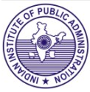
BOOK ALERT
(New Arrivals-Books)

( JANUARY 2026)

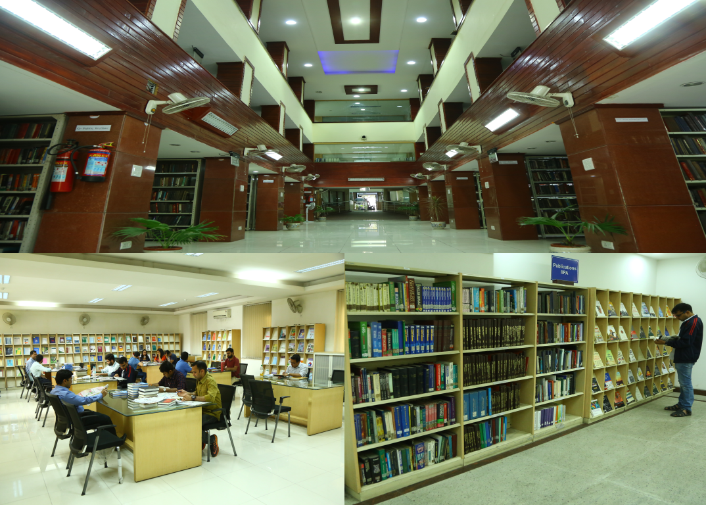

.

Library
Indian Institute of Public Administration
New Delhi

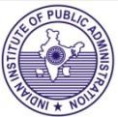Book Alert is a monthly service offered by the Library, Indian Institute of Public Administration. It contains bibliographical details and summary of latest books added to the library during the period.

COMPILED BY SUNITA GAUTAM

Indian Institute of Public Administration,
I.P. Estate, Ring Road, New Delhi-110002

1.
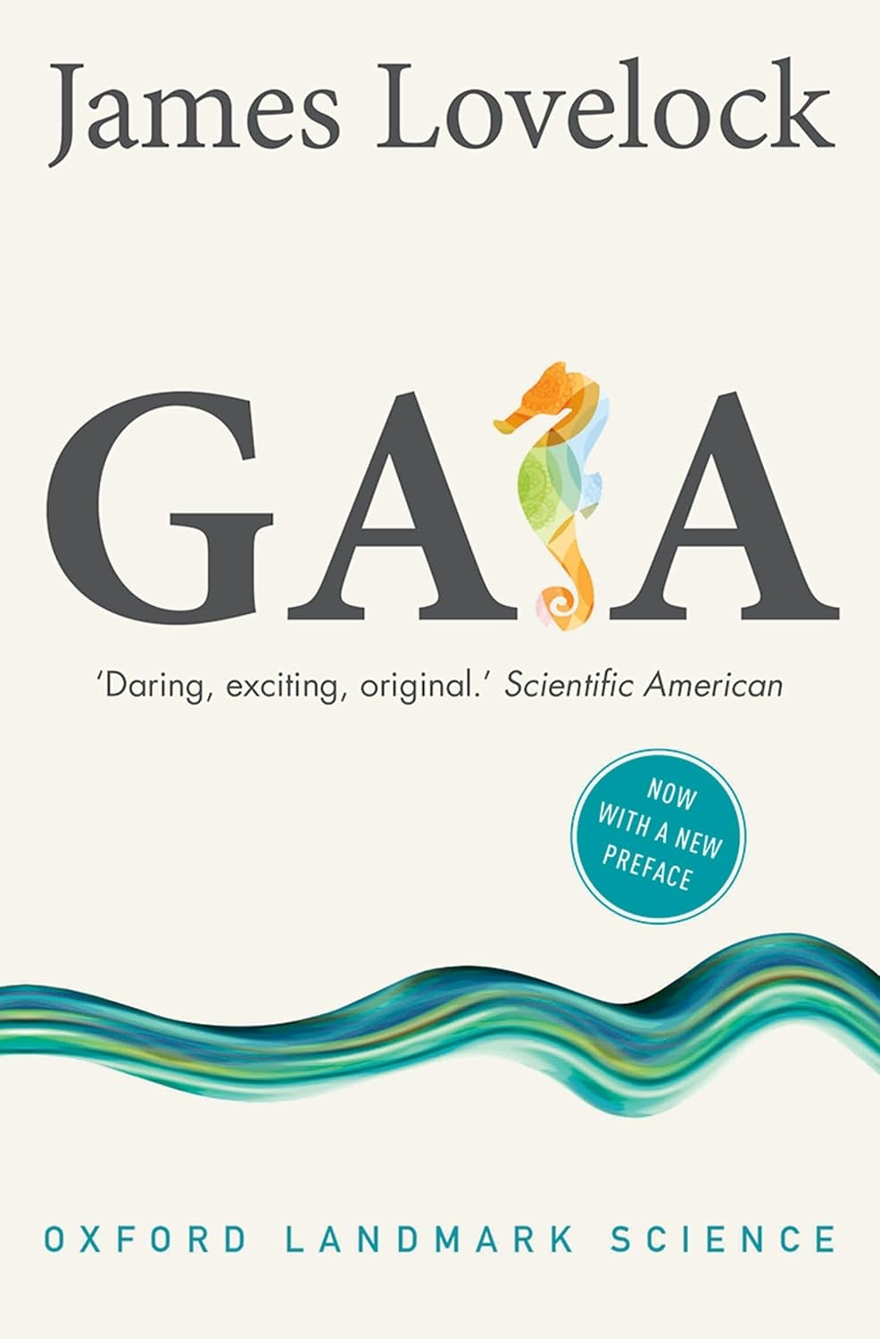

Gaia: a new look at life on earth

Author: James Lovelock
Publisher: Oxford: OUP, 2016 Description: 148p.
Accession no. 89468

Gaia, in which James Lovelock puts forward his inspirational and controversial idea that the Earth functions as a single organism, with life influencing planetary processes to form a self-regulating system aiding its own survival, is now a classic work that continues to provoke heated scientific debate.

2.
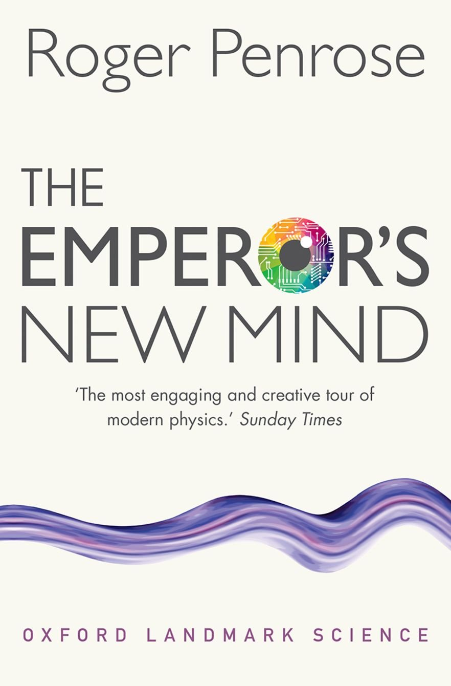

The Emperor’ new mind

Author: Roger Penrose
Publisher: Oxford: OUP, 2016 Description: 602p.
Accession no. 89469

In his bestselling work of popular science, Sir Roger Penrose takes us on a fascinating tour through the basic principles of physics, cosmology, mathematics and philosophy to show that human thinking can never be emulated by a machine.

3.
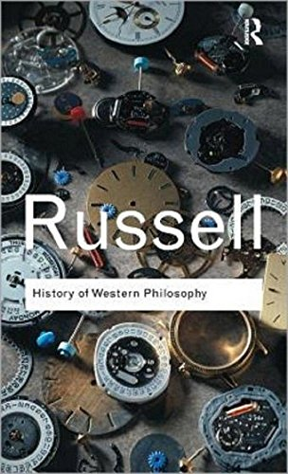

History of western philosophy

Author: Betrand Russell
Publisher: New York: Routledge Description: 778p.
Accession no. 89470

4.

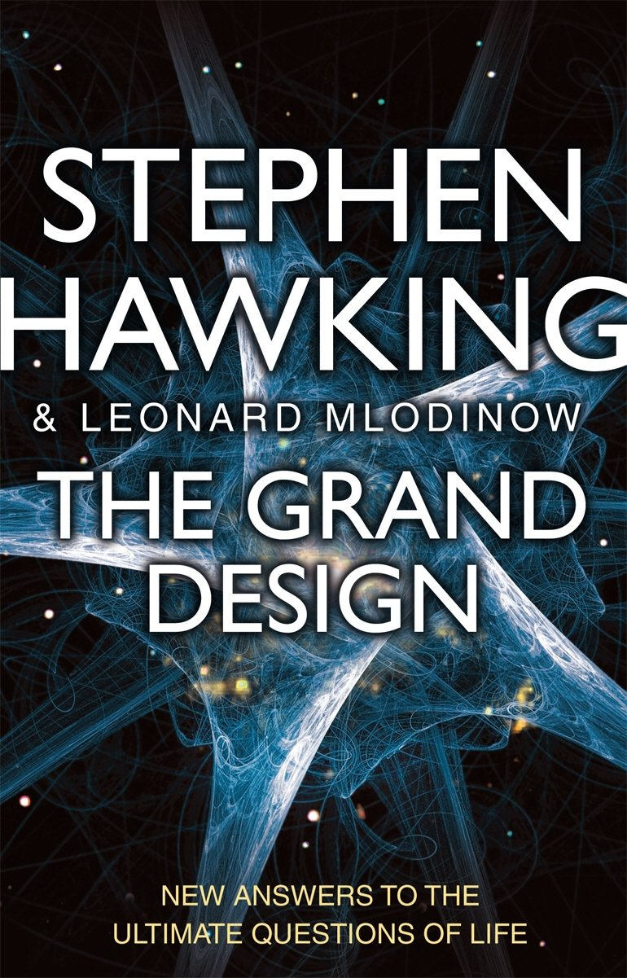

The Grand design: new answers to the ultimate questions of life

Author: Stephen Hawking & Leonard
Publisher: London: Transworld, 2010
Description: 251p.
Accession no. 89471

In The Grand Design, the most recent scientific thinking about the mysteries of the universe is presented in language marked by both brilliance and simplicity. Model dependent realism, the multiverse, the top-down theory of cosmology, and the unified M-theory - all are revealed here.

5.
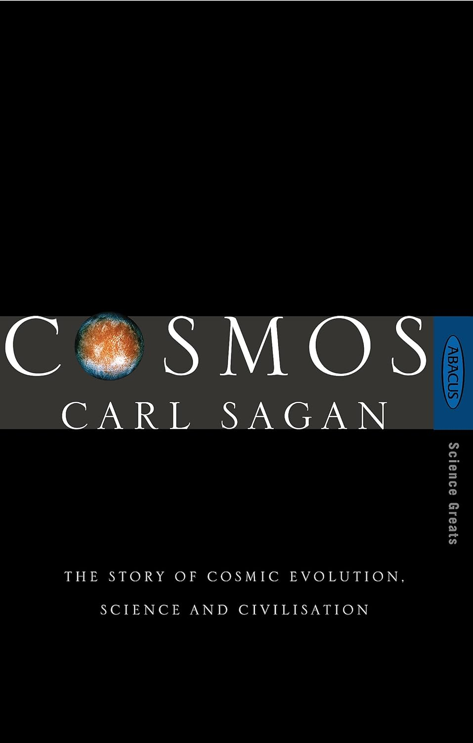

Cosmos: the story of cosmic evolution, science and civilisation

Author: Carl Sagan
Publisher: London: Abacus, 1995
Description: 251p.
Accession no. 89472

The story of fifteen billion years of cosmic evolution transforming matter and life into consciousness, of how science and civilisation grew up together, and of the forces and individuals who helped shape modern science. A story told with Carl Sagan's remarkable ability to make scientific ideas both comprehensible and exciting.

6.
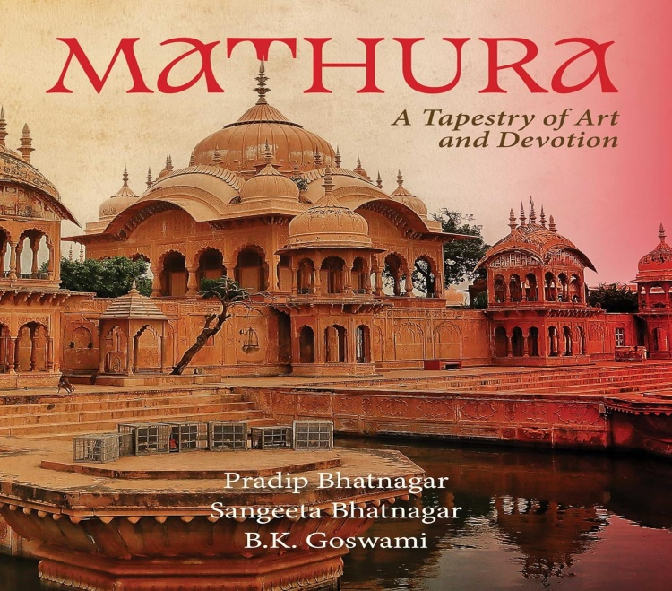

Mathura: a tapestry of art and devotion

Author: Carl Sagan
Publisher: New Delhi: Niyogi Books, 2025
Description: 168p.
Accession no. 89473

Embark on a visual odyssey of the colours of Krishna devotion, the dulcet hymns of Braj Bhasa guiding one through the air of peace and profundity in the by-lanes of Mathura, one of the oldest living cities of the world, lauding quotidian spirituality and a sincere pride in its cultural legacy.

This volume records the dynamic interplay of a city which has carved out a benign way of life in the interplay of devotion and artistry.

7.
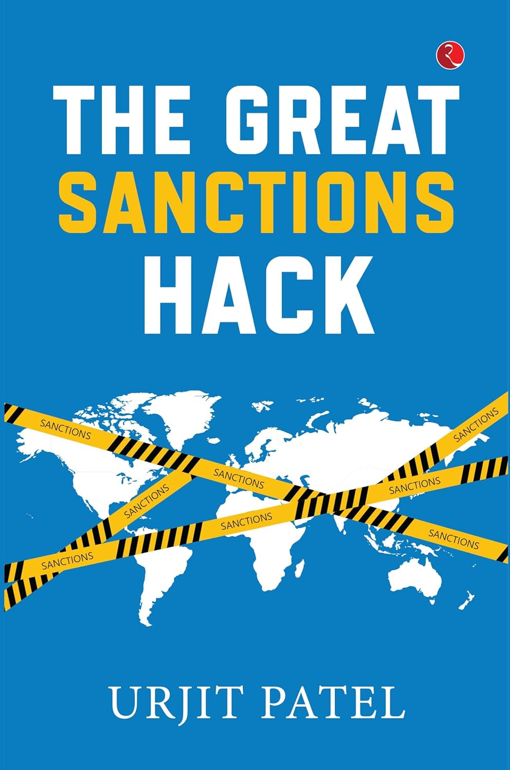

The great sanctions hack

Author: Urjit Patel
Publisher: New Delhi: Rupa, 2025
Description: 146p.
Accession no. 89474

In The Great Sanctions Hack, Urjit Patel, former Governor of the Reserve Bank of India, who now serves as Chairman of the National Institute of Public Finance and Policy, evaluates why the concept of sanctions needs a major overhaul. Their broader effects on global markets and unintended consequences for third parties must be considered.

8.
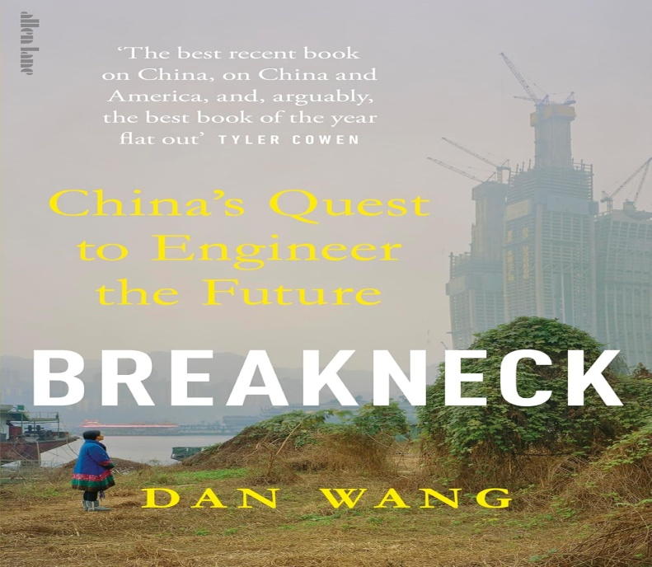

Breackneck: China’s quest to engineer the future

Author: Dan Wang
Publisher: London: Penguin, 2025
Description: 260p.
Accession no. 89475

In Breakneck, Wang blends political, economic, and philosophical analysis with reportage to reveal a provocative new framework for understanding China?one that helps us see America more clearly, too. While China is an engineering state, relentlessly pursuing megaprojects, the United States has stalled. America has transformed into a lawyerly society, reflexively blocking everything, good and bad.

9.
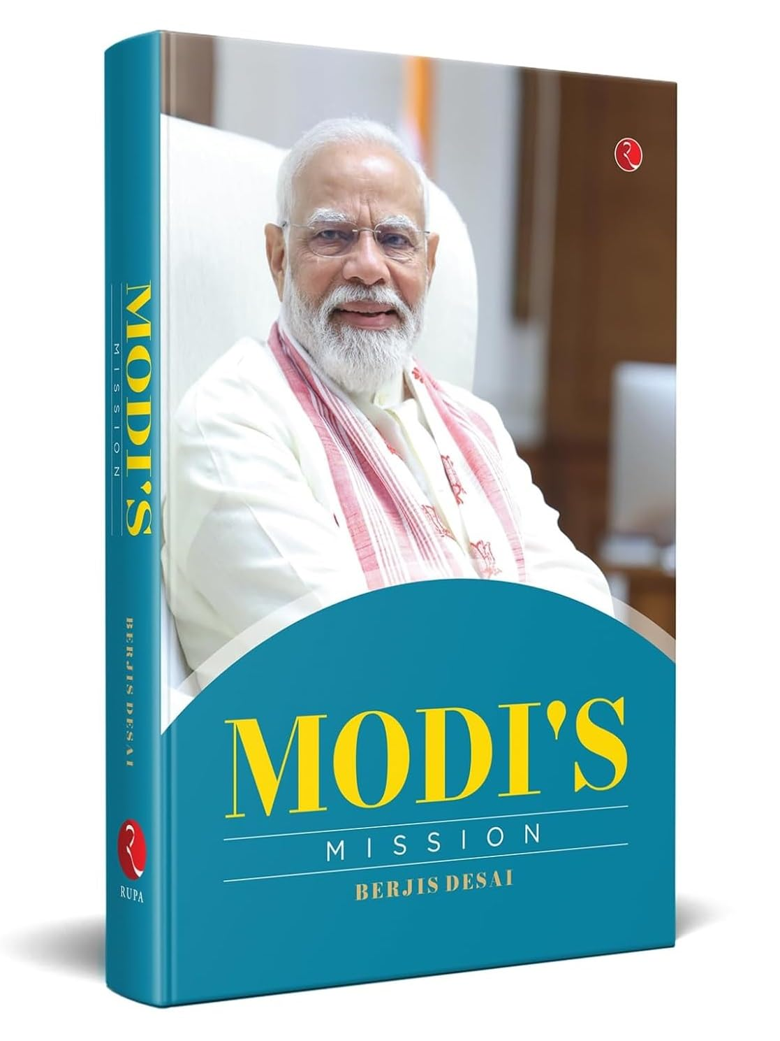

Modi’s mission

Author: Berjis Desai
Publisher: New Delhi: Rupa, 2025
Description: 248p.
Accession no. 89476

Modi’s Mission is not a biography—it is the story of an idea. Berjis Desai presents Narendra Modi as more than a politician: he is the instrument of a national awakening. From a childhood of poverty in Vadnagar to the Prime Minister’s Office, his journey is portrayed as destiny in motion—rooted in spirituality, shaped by the Sangh and defined by his glorious years steering Gujarat’s development that became a model for the nation.

10.


How not to age: the scientific approach to getting healthier as you get older

Author: Berjis Desai
Publisher: Pan Macmillan, 2023
Description: 628p.
Accession no. 89477

Put an end to premature aging and uncover the optimal diet for achieving the longest lifespan, from the bestselling author of How Not to Die and How Not to Diet. From Michael Greger, MD, founder of the hugely popular health website NutritionFacts, comes this comprehensive guide to anti-aging. Dr Greger delves into the role diet plays in the path to anti-aging and explores what kind of diet meets all the criteria to achieve ultimate longevity.

11.
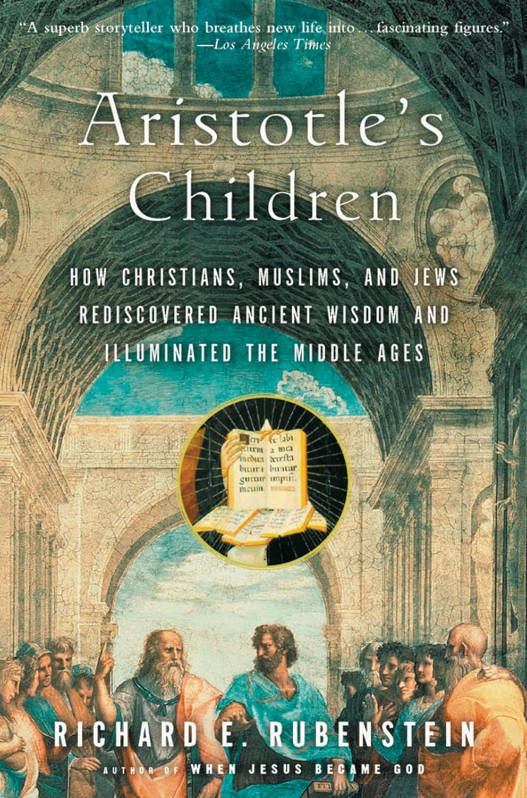

Aristotle’s children

Author: Richard E. Rubenstein
Publisher: New York: Harvest Book, 2003
Description: 368p.
Accession no. 89478

In Aristotle's Children, Richard Rubenstein transports us back in history, rendering the controversies of the Middle Ages lively and accessible-and allowing us to understand the philosophical ideas that are fundamental to modern thought.

12.
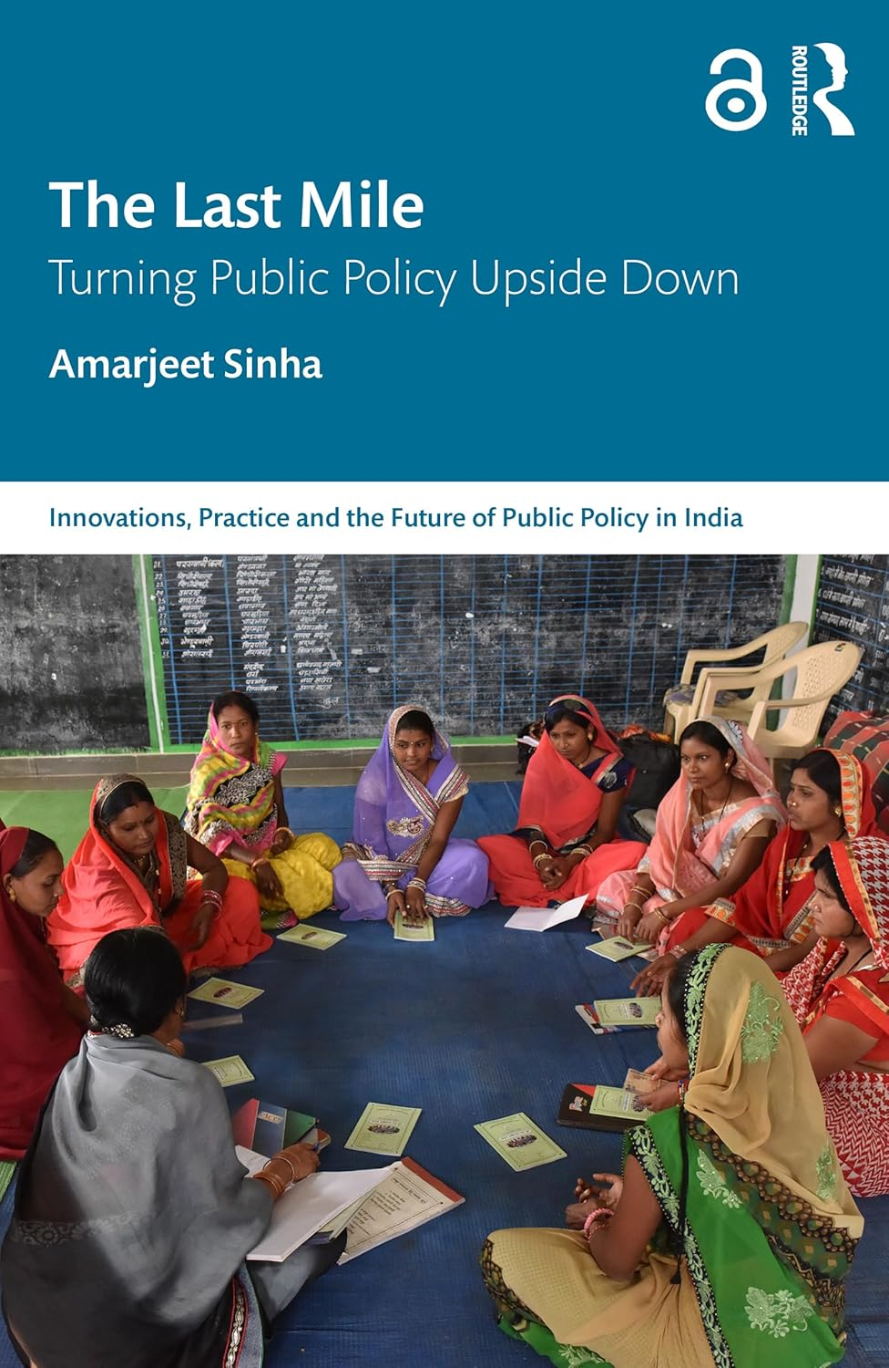

The Last mile: turning public policy upside down

Author: Amarjeet Sinha
Publisher: New York: Routledge, 2024
Description: 291p.
Accession no. 89479

The Last Mile explores the gaps and dichotomy between drafted policies and their implementation, and the last mile challenges which often make public services inaccessible to the poorest and most vulnerable sections of society. It provides an in-depth overview of the dynamics between communities, research and consultation and the implementation of policies for development.

13.
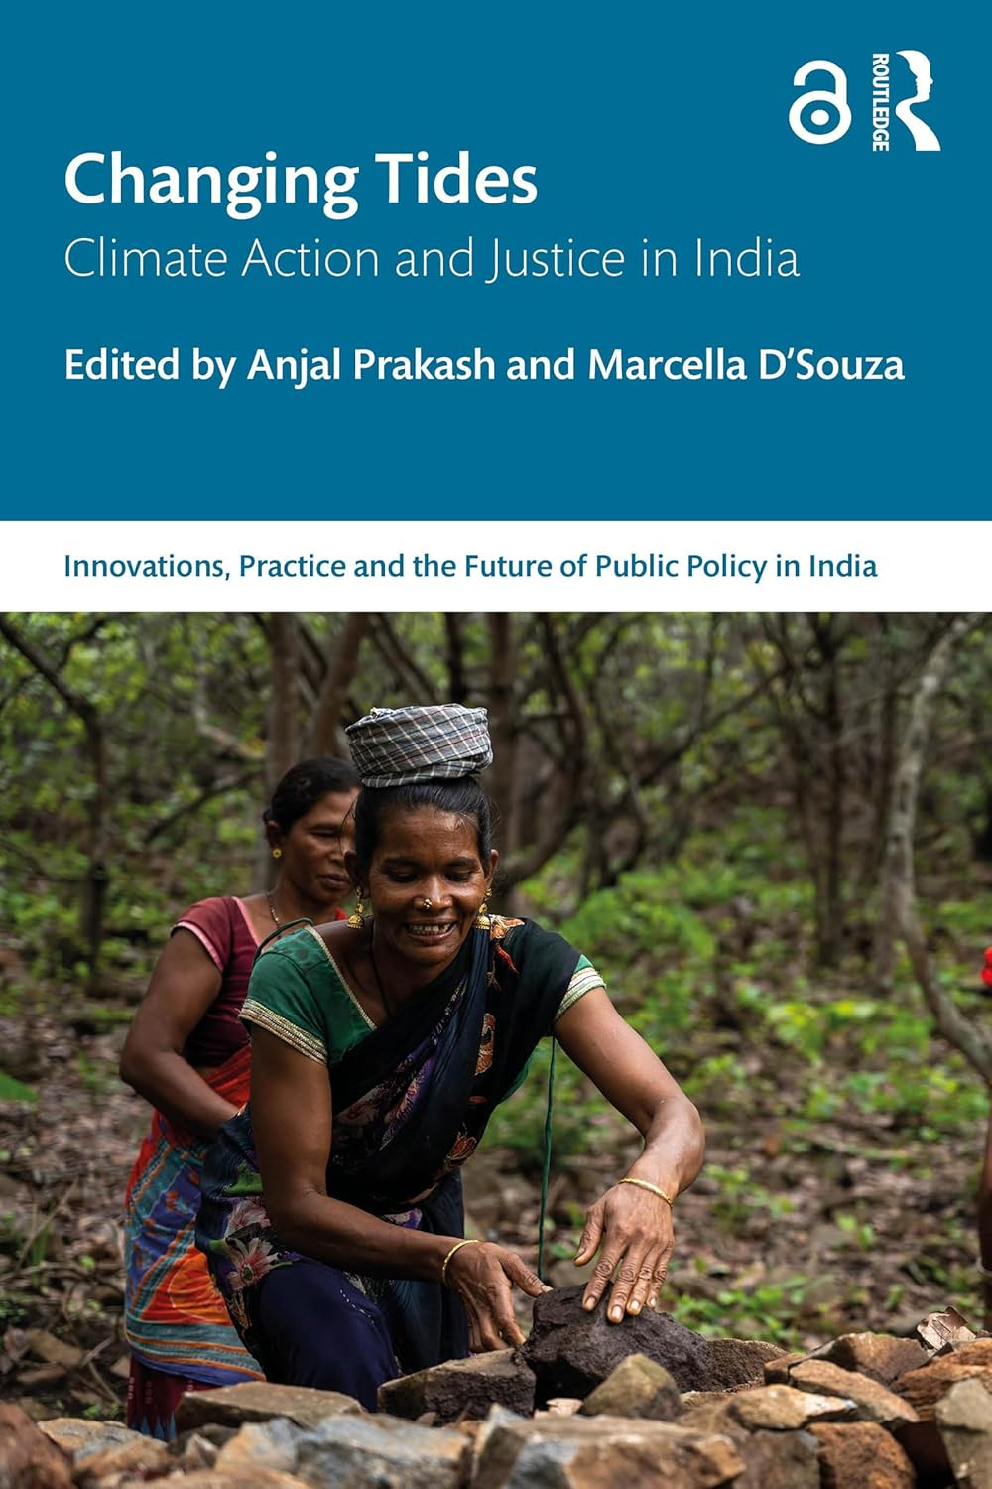

Changing tides: climate action and justice in India

Author: Anjal Prakash
Publisher: New York: Routledge, 2026
Description: 389p.
Accession no. 89480

This book explores climate action and justice in India, a country which has been facing extreme climate events and complex sociopolitical challenges arising from climate change. It offers diverse perspectives and insights into India's evolving climate landscape, policies, grassroots initiatives, and response to climate vulnerability and inequality.

14.
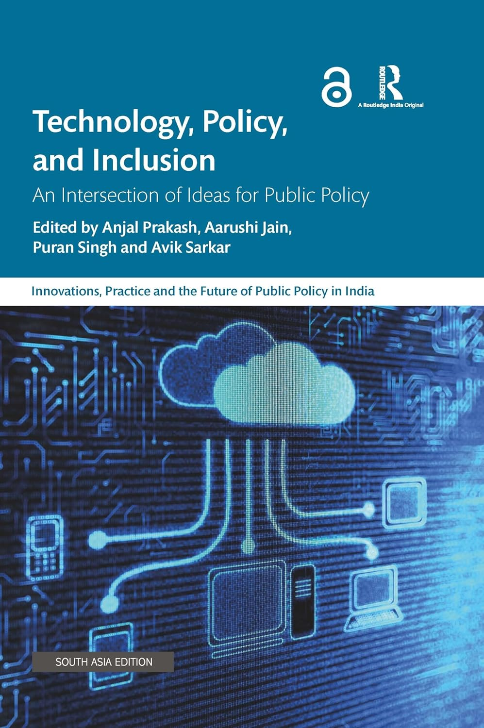

Technology, policy, and inclusion

Author: Anjal Prakash
Publisher: New York: Routledge, 2024
Description: 261p.
Accession no. 89481

Technology, Policy, and Inclusion looks at the intersections between public policy and technology in India. It explores the barriers in instituting effective governance and development and examines how these can be mitigated through technological interventions in developing countries.

15.
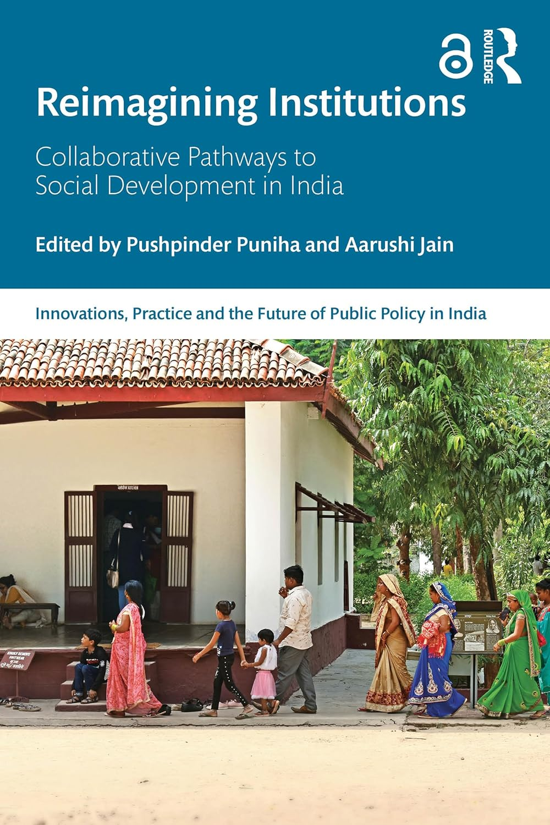

Reimagining institutions: collaborative pathways to social development in India

Author: Pushpinder Puniha
Publisher: New York: Routledge, 2026
Description: 449p.
Accession no. 89482

This book unpacks the complexities of social development in India, focusing on the institutional bottlenecks that hinder effective policy implementation.

Through a blend of empirical and evidence-based research, policy analysis, and real-world case studies, the book provides a comprehensive understanding of the mechanisms that drive – or obstruct – sustainable development in India.

